Physics Lab Wheel accelerating down Incline
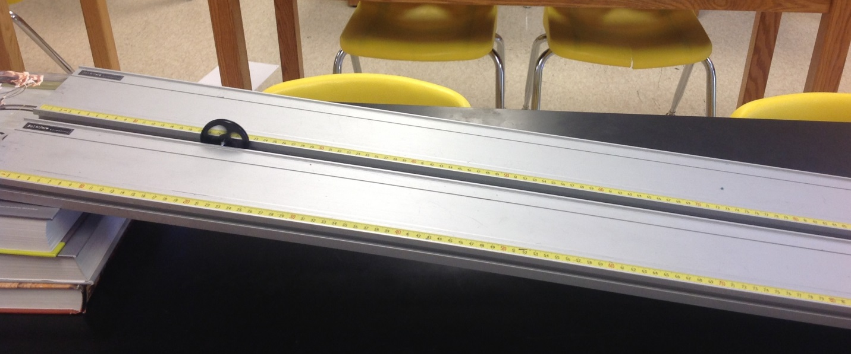
Set your ramp up as indicated in the photo above. Make sure that the spacing between the ramps is even and that your wheel will roll evenly down the length of the incline.
Using the sound from the metronome let the wheel go from rest at x_{o} = 0 and mark the location of the wheel every three seconds until it reaches the bottom of the ramp.
Measure the distances and record them along with the time in the table below.
t  (s) | x  (cm)

Make a position vs time graph of your data on the graph paper provided.

Describe the shape of the graph. Is the graph linear? Where have you seen graphs shaped like this before? What general mathematical equation is used to represent graphs like this? Write it down. That being said, is there a way to make this graph into a line? (Is it possible to look at the equation you just wrote and put it in the form of y = mx + b. You might also think about the kinematics equations you derived for homework.)

Produce a data table of the points you can graph to determine the acceleration of the wheel down the incline according to what you just figured out. Make the graph and determine the acceleration of the wheel down the ramp.

Can you find the instantaneous velocity of the wheel at each of the time increments you have listed above? Write the steps you will use below.

How can these velocities be graphed to determine the acceleration of the wheel down the incline? (What equation can be used and how does it conform the a linear function)

Produce a data table, make the graph, and determine the acceleration of the wheel down the ramp.

