Vertical movement problems Solutions
- T = ma + mg = (1500)(9.8 + 2.5) = 18450 N
- N = ma + mg = 55 kg)(9.8 N/kg) + 55 kg)(2.5 m/s/s) = 676.5 N
- ma = T – mg = (20,000 – 1500 kg )(9.8 N/kg)
a = 5300/1500 kg = 3.53 m/s/s
- Max mass at 2.5 m/s/s
ma = T – mg
ma + mg = T
2.5m + 9.8 m = 20,000 N
m = 20,000 N/12.3 = 1626 kg
- ma = mg – T
T = mg – ma = 1500 (9.8N/kg) – 1500 (5.5 m/s/s) = 6450 N
N = Fw’ = mg – ma = (55 kg)(9.8 N/kg) – (55 kg)(5.5 m/s/s) = 236.5 N
- ma = T – mg
a = (47.2 N – 39.2 N)/4 kg = 2.0 m/s/s
- ma = T – mg
ma + mg = T
2 m + 9.8 m = 60 N
11.8 m = 60
m = 5.08 kg

Elevator Problem 2005 1
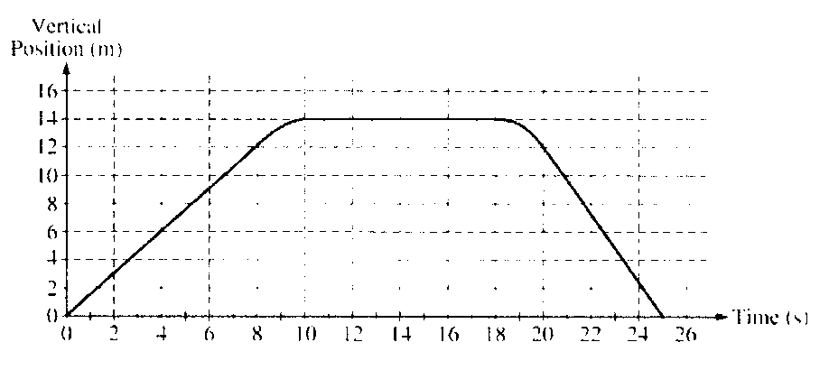
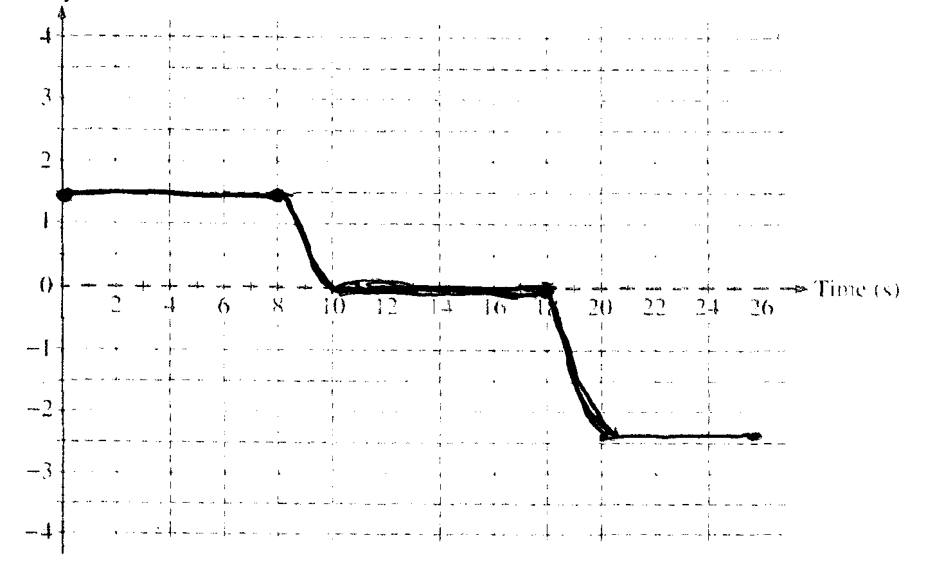
t = 0-8 is a constant velocity of (12 – 0)/8 = 1.5 m/s
t = 10 – 18 v = 0, (position does not change)
t = 20 – 25 constant v = (0 – 12)/5 = – 2.4 m/s
the segments will be connected because the motion is continuous

acceleration for period t = 8 – 10
t = 8 – 10 a = vf – vo/t = (0 m/s – 1.5 m/s)/ 2 s = – 0.75 m/s/s
direction of this acceleration

Passenger of mass 70 kg find F_{w}’ of Normal
a is down so let a be positive 0.75 m/s/s and write the forces statement so mg is greater than N
ΣF_{y} = ma = mg – N
N = mg – ma = (70 kg )(9.8 N/kg) – 70 kg)( 0.75 m/s/s) = 633.5
OR LET UP BE POSITIVE and write forces statement with N > mg
ΣF = ma = N – mg
ma + mg = N but here since up is positive, acc must be negative value
ma + mg = N
(70 kg)(– 0.75 m/s/s) + (70 kg)(9.8 N/kg) = N = 633.5 N

For t = 18-20 a = 2.4 – 0 / 2 = 1.2 m/s/s
ΣF_{y} = ma = mg – N
N = mg – ma = 70 kg (9.8 N/kg) – (70 kg)(1.2 m/s/s) = 602 N

