Forces problems
Vertical movement
- A large crate of mass 1500 kg is attached via a cable to the bottom of a helicopter. The helicopter will accelerate straight upward at 2.5 m/s/s. Determine the tension in the cable during the acceleration.
- The crew chief in the helicopter above has a mass of 55 kg and is standing on the floor of the helicopter while it accelerates upward. Determine the normal force acting on the crew chief as the helicopter accelerates upward.
- If the cable is tested to withstand 20,000 N of tension, determine the maximum upward acceleration that the helicopter can have and still lift the 1500 kg crate.
- What is the maximum mass that can be suspended by the cable if the helicopter accelerates upward at 2.5 m/s/s it the cable will break when the tension is over 20,000 N
- During the ascent, the engine for the helicopter blows a gasket and the helicopter begins to fall toward the earth. Due to stored energy in the rotor, the pilot is able to “auto-rotate” and keeps the helicopter level and descending at a rate of 5.5 m/s/s. Calculate the tension in the cable as well as the normal force, or apparent weight, of the crew chief during the time the helicopter plummets toward the ground.
- In an elevator, a student sets up an experiment to investigate the effects of acceleration. The student hangs a mass of 4.0 kg from the ceiling and measures the tension in the string while the elevator accelerates upward to be 47.2 N. Determine the acceleration of the elevator.
- If the string will break at a tension of 60. N, determine the maximum mass that can be suspended from the string if the elevator accelerates at the rate you found in problem 6 above.

Elevator Kinematics and forces
05-1
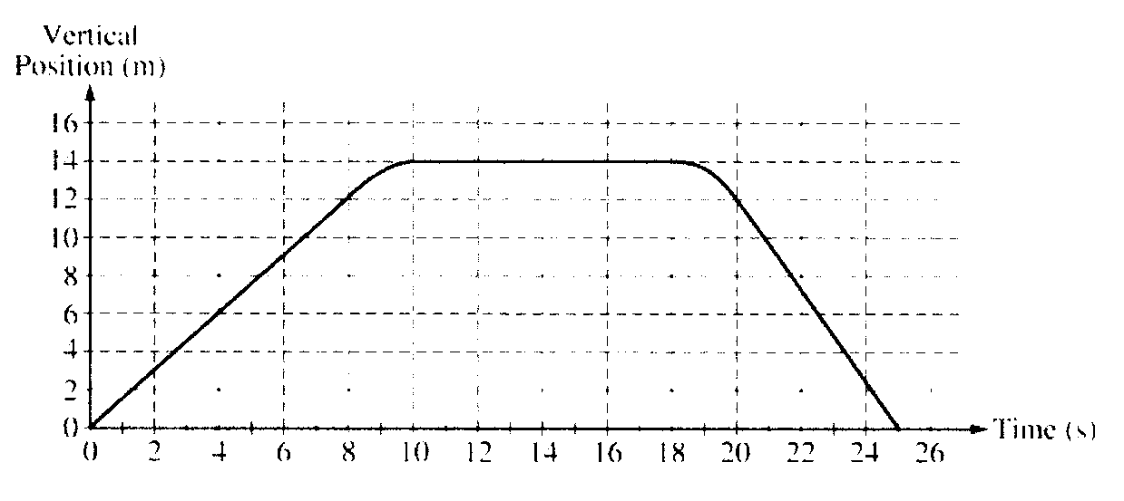
- The vertical position of an elevator as a function of time is shown above.
- On the grid below, graph the velocity of the elevator as a function of time.
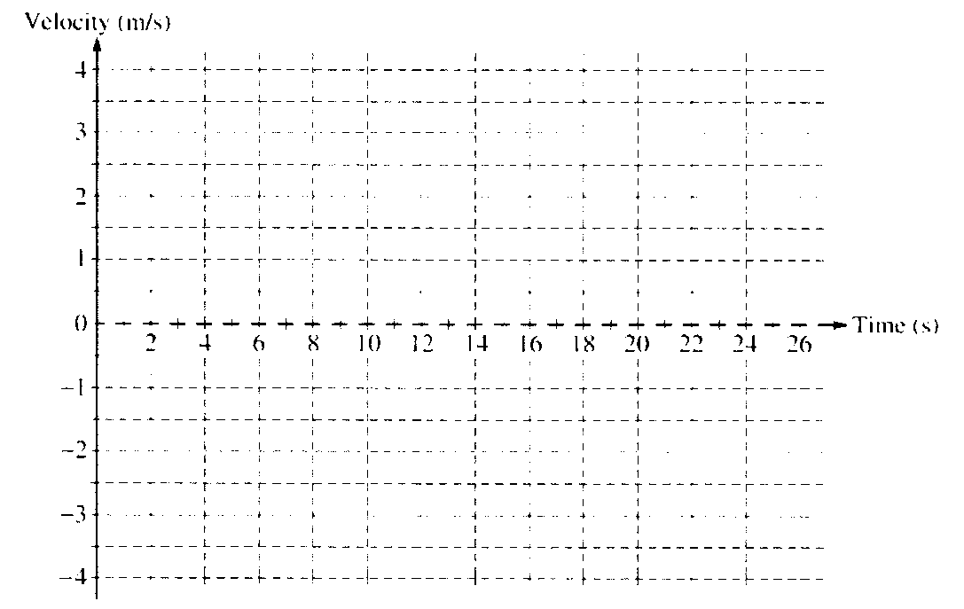

- The
- Calculate the average acceleration for the time period t = 8 s to t = 10 s
    - On the box below that represents the elevator draw a vector to represent the direction of this average acceleration.
- Suppose a passenger of mass 70 kg is in the elevator, calculate the apparent weight, Normal force, of the passenger from t = 8 to t = 10 s. make the same calculation for the period t = 18 – 20.

