Vector Addition problems
Show a graphical solution to adding the following vectors.
- 12 U E and 10 U N V_{r} = ____15.6 @ 40° (39.8)
- 15 W and 20 S V_{r} = 25 @ 217°
- 16 W and 18 N V_{r} = 24.0 @ 132 °

- 10 E, 4 N and 4 W V_{r} = ______________ θ ______
10 E and 4 W give a net of 6 E
6 E and 4 N yield Vr = 7.2 @ 34°

- 12 E and 15 S V_{r} = 19.2 @ – 51 ° Quad IV

Draw the resultant vectors in the following situations and determine the magnitude (length) and the direction (angle) of the resultant you drew using trigonometry to find components.
- 8 u E and 5.7 u at 45° v_{r} = _________________ θ________
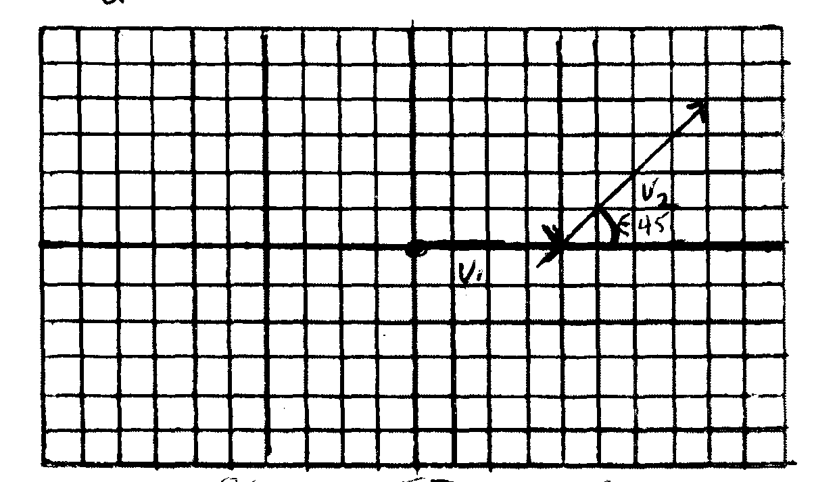

Vector | X component  (v)(cos θ) | Y component  (v)(
V₁ = 8 E | + 8 x | 0
V₂ = 5.7 @ 45° | Cos 45 )(5.7 = 4.0 x | Sin45)(5.7 = 4.0 y
Net x and y | 12 x | 4 y
V_{r (resultant} | 12.6 @ 18°

- 12 u W and 15 u at 127° v_{r} = _______________ θ _________
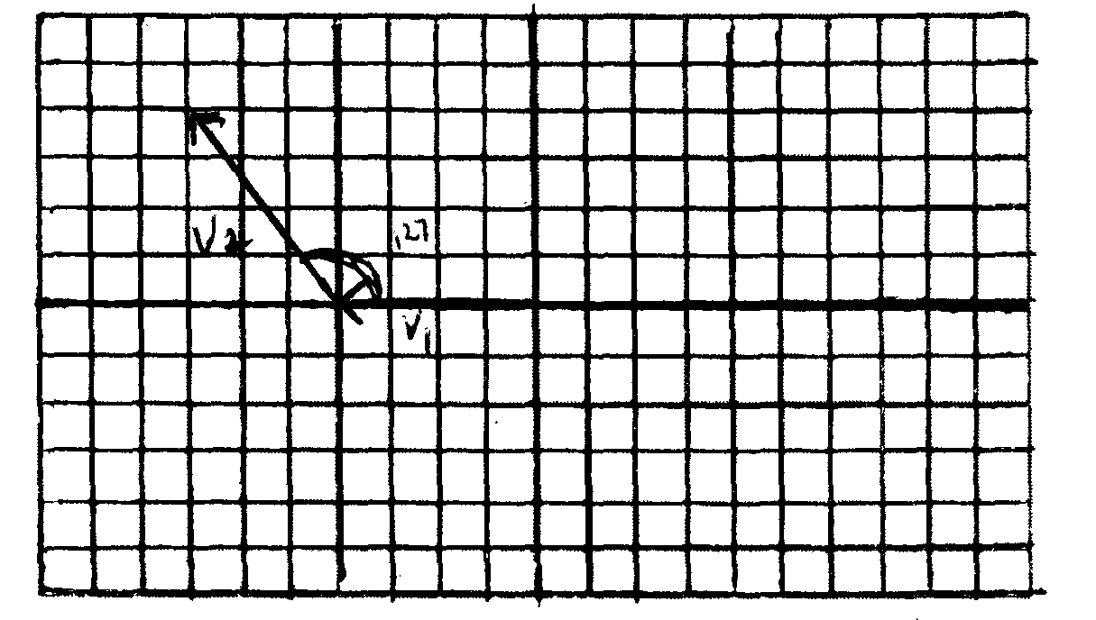
Vector | X component  (v)(cos θ) | Y component  (v)(
V₁ = 12 W | – 12 x | 0
V₂ = 15 @ 127 | Cos 127 (15) = – 9 x | Sin 127()15) = 12 Y
Net components | – 21 x | 12 Y
V_{r (resultant)} | 24.2 @ 150°

- 25 u E and 22.4 u at 117° v_{r} = ________________ θ __________
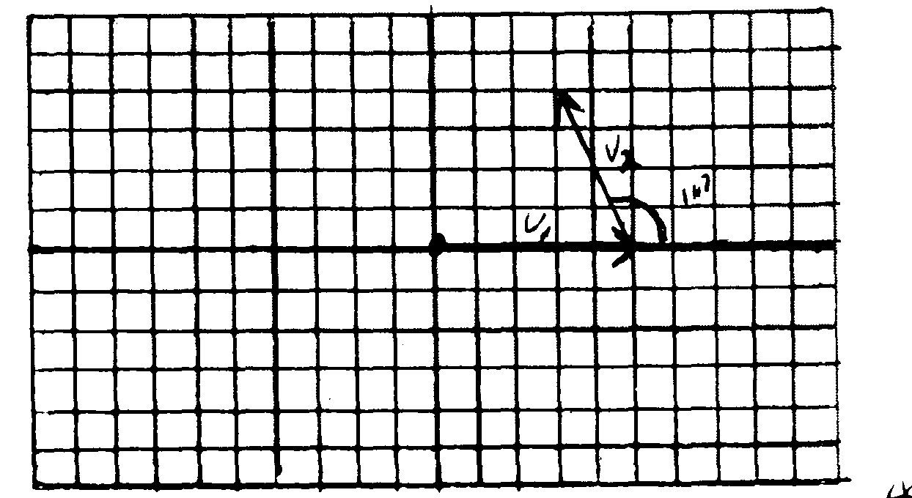
Vector | X component  (v)(cos θ) | Y component  (v)(
V₁ = 25 E | + 25 x | 0
V₂ = 22.4 @ 117° | Cos117)(22.4 =– 10.2 x | Sin117)(22.4) = 20.0 y
Net components | 14. 8 x | 20.0 y
V_{r (resultant)} | 24.9 @ 53.5°

