Vector Addition problems
Show a graphical solution to adding the following vectors.
- 12 U E and 10 U N V_{r} = ____
- 15 W and 20 S V_{r} =
- 16 W and 18 N V_{r} =

- 10 E, 4 N and 4 W V_{r} = ______________ θ ______

- 12 E and 15 S V_{r} = ____________ θ _________

Draw the resultant vectors in the following situations and determine the magnitude (length) and the direction (angle) of the resultant you drew using trigonometry to find components.
- 8 u E and 5.7 u at 45° v_{r} = _________________ θ________
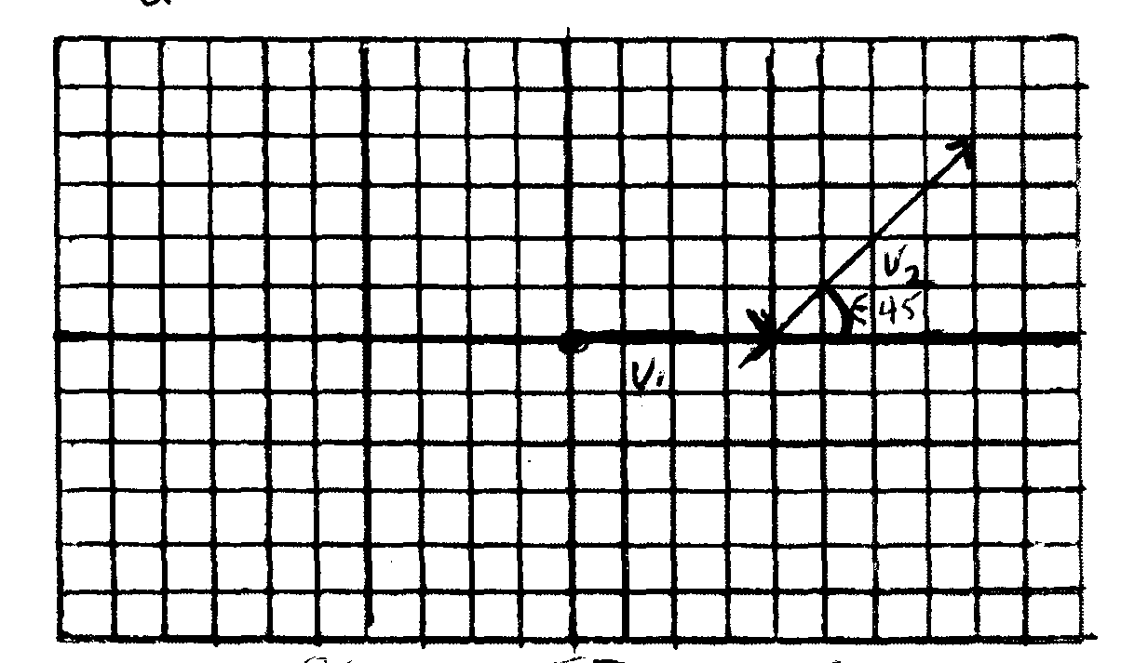

Vector | X component  (v)(cos θ) | Y component  (v)(
V₁ = 8 E
V₂ = 5.7 @ 45°
Net x and y
V_{r (resultant}

- 12 u W and 15 u at 127° v_{r} = _______________ θ _________
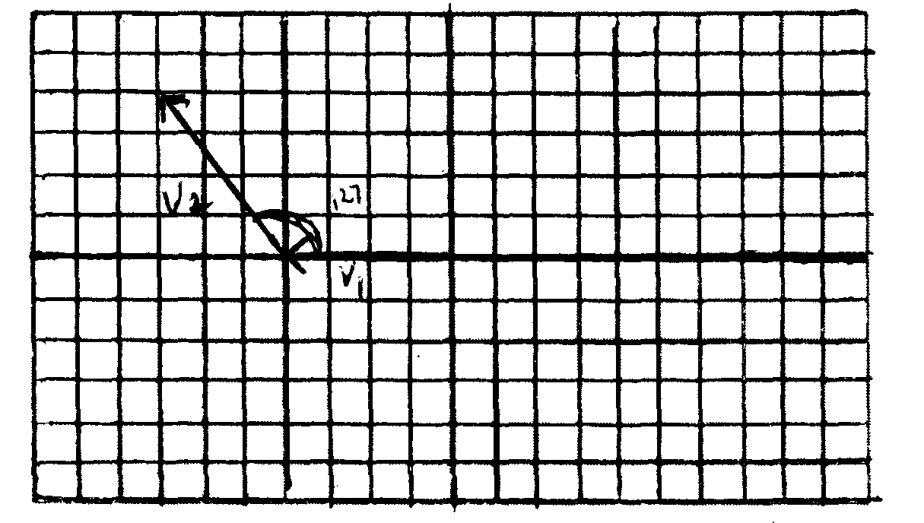
Vector | X component  (v)(cos θ) | Y component  (v)(
V₁ = 12 W
V₂ = 15 @ 127
Net components
V_{r (resultant)}

- 25 u E and 22.4 u at 117° v_{r} = ________________ θ __________
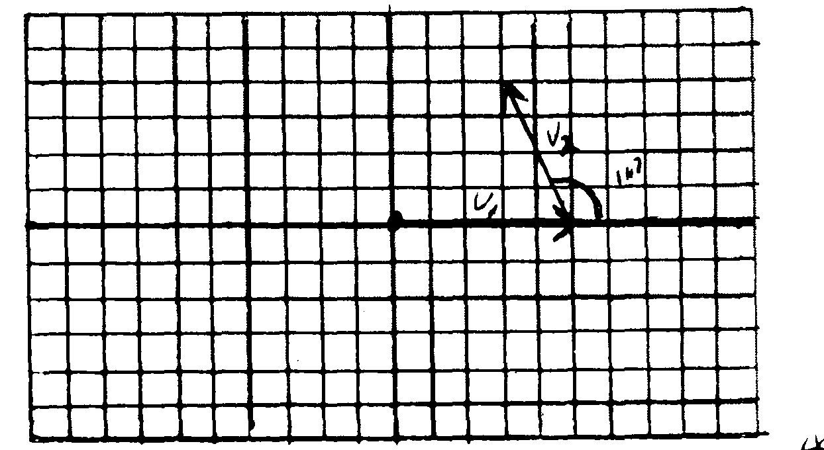
Vector | X component  (v)(cos θ) | Y component  (v)(
V₁ = 25 E
V₂ = 22.4 @ 117°
Net components
V_{r (resultant)}

