Vector addition
POGIL activity
During this activity, you will develop a method for adding two vectors together using the head to tail method of vector addition.
We will begin with adding two vectors that are perpendicular to each other,
For example what is the result of adding a vector that is 8 m east with a vector that is 10 m north (or +8x and + 10 y)
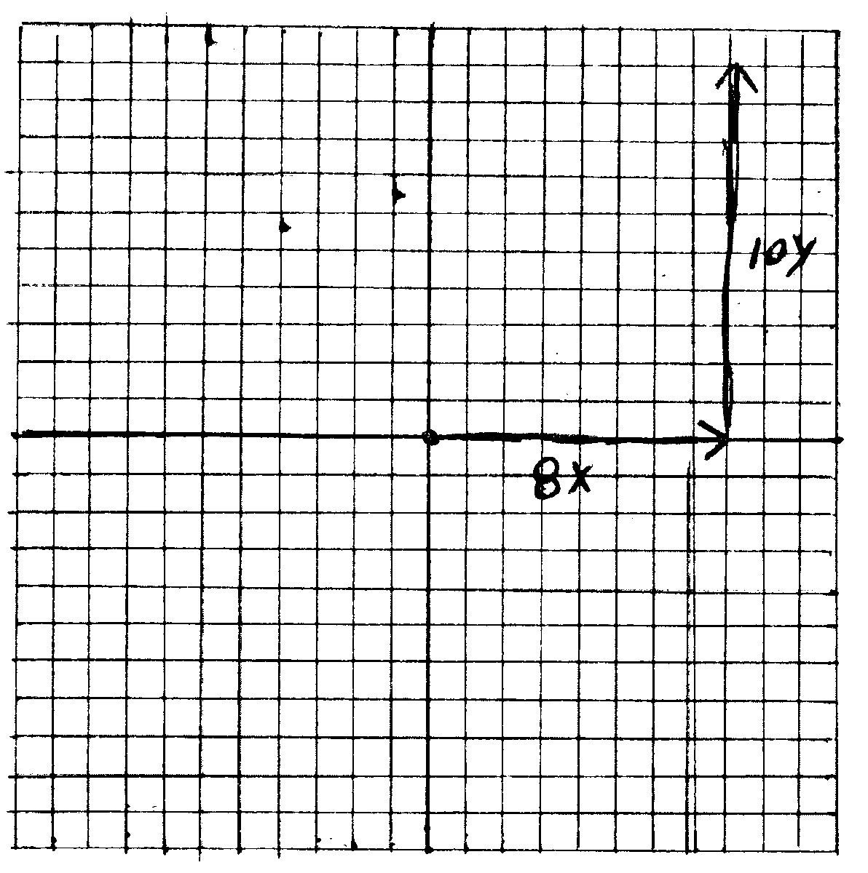
- Plot each of the vectors on your coordinate system (graph). It is usually easier if you plot the X (E or W) vector first. Make sure it is the proper length and put an arrow at the end where it stops. It should start on the origin.

- Plot the second vector so that it starts at the arrow of the first vector and be sure to put an arrow on the vector where it ends.

Your vectors should be perpendicular to each other.
To plot the resultant vector you need to draw a vector starting at the origin and ending at the arrow of the last vector you plotted, in this case the 10 N (+10 y vector.
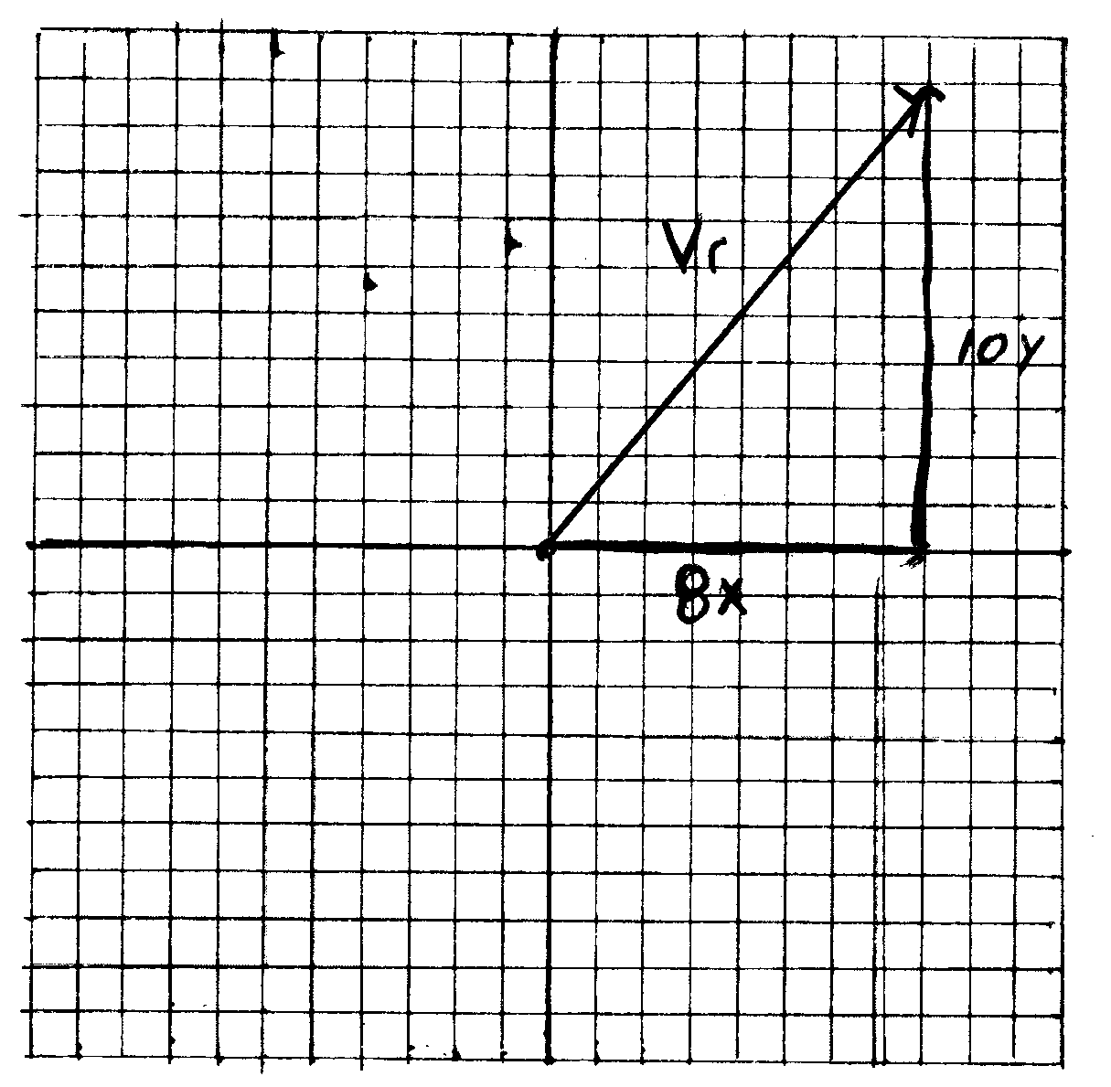

- You can determine the magnitude and direction of the resultant, v_{r}, by either one of two methods. Graphically or using trigonometry.
  - To find the resultant graphically, you must use a ruler to measure its length. On this graph, every half cm is equal to 1 unit.
  - To determine the angle, use a protractor to measure the angle between the positive x axis and v_{r}
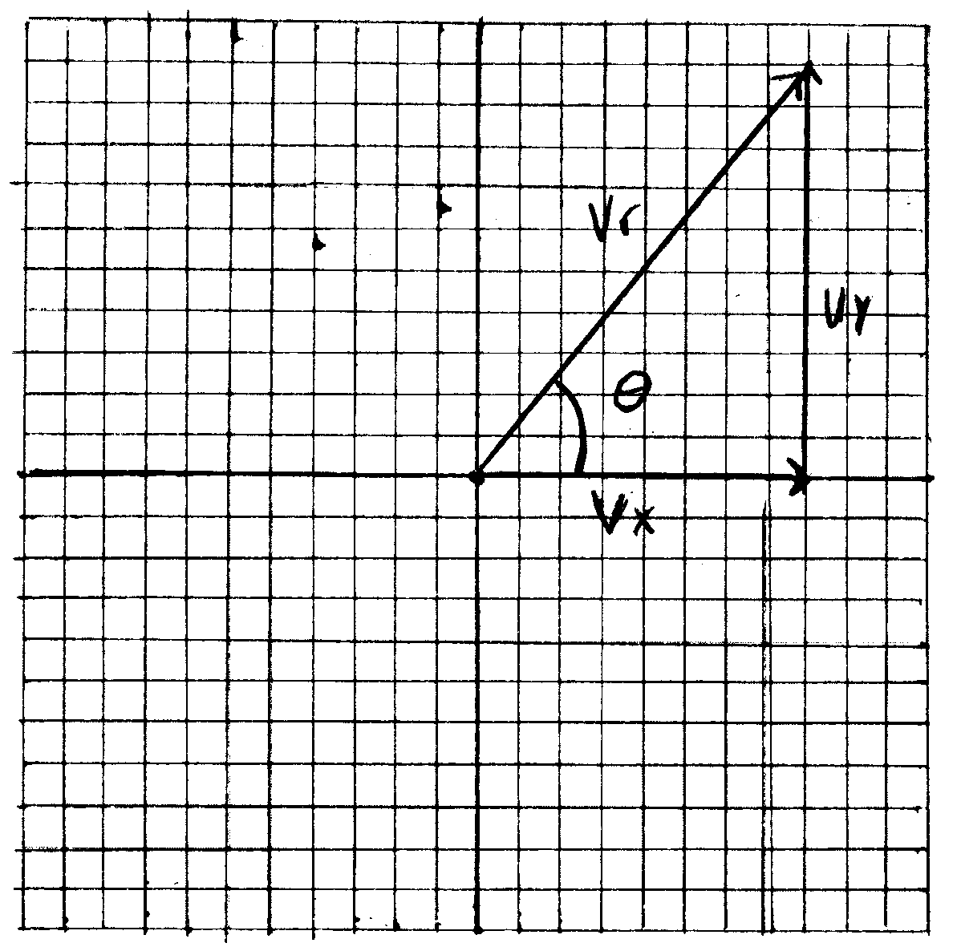

Magnitude ________________ Direction θ ______________

Mag = 12.8 units @ 51.3°

b) You can also use the Pythagorean Theorem and trigonometry to determine the magnitude and direction of the resultant.
v_{r}² = (v_{x}² + v_{y}²)^{1/2} so v_{r} = $\sqrt{64+100}$ = 12.8 units
To find the angle, look at the triangle above and determine which sides you know and their relationship to the angle.
(8 x is the adjacent side and 10 y is the opposite side)

Which trig function involves the opposite and adjacent sides of a right triangle?

tan θ = $\frac{opp}{adj}$ tan θ = 10/8 = 1.25
tan θ = 1.25 In order to find the value of the angle, we must use the inverse tangent function (tan⁻¹) on our calculator.
Make sure your calculator is in degree mode
On a TI 82, 83, or 84 push: (2nd) (tan) 10 ÷ 8 (enter) and you should get 51.3° for an answer.
On a TI 30 XA press: 10 ÷ 8 (=) (2nd) (tan) and you should get 51.3°

If the vectors are not in the first quadrant we follow the same process.
Find the resultant of two vectors:
10 W (– 12 x) and 6 N (+ 6 y)
Plot the vectors:
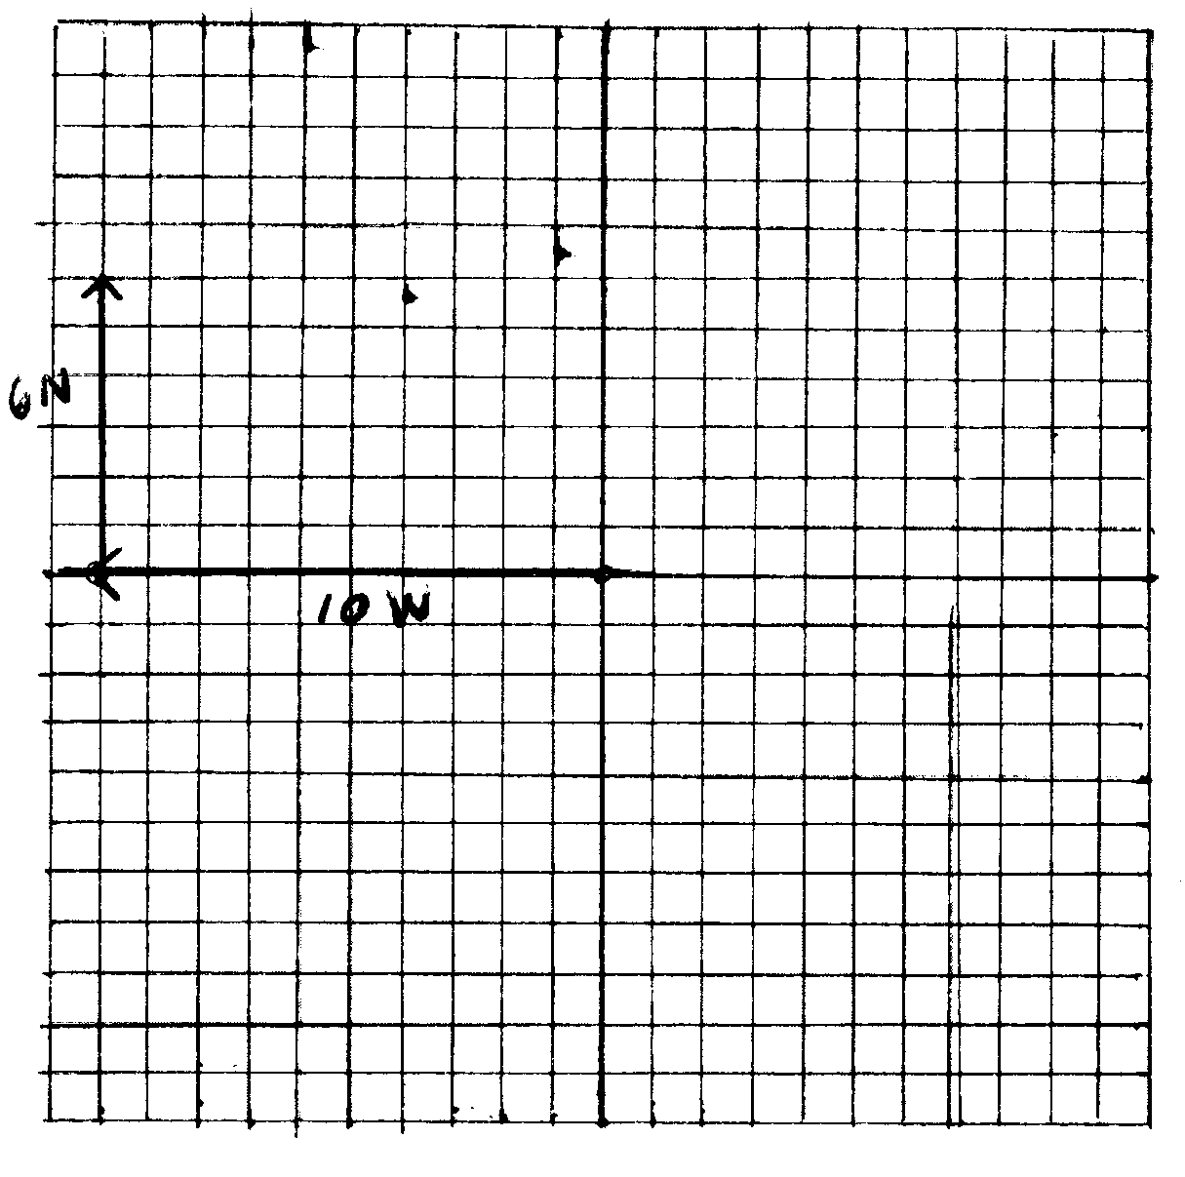

Draw the resultant.
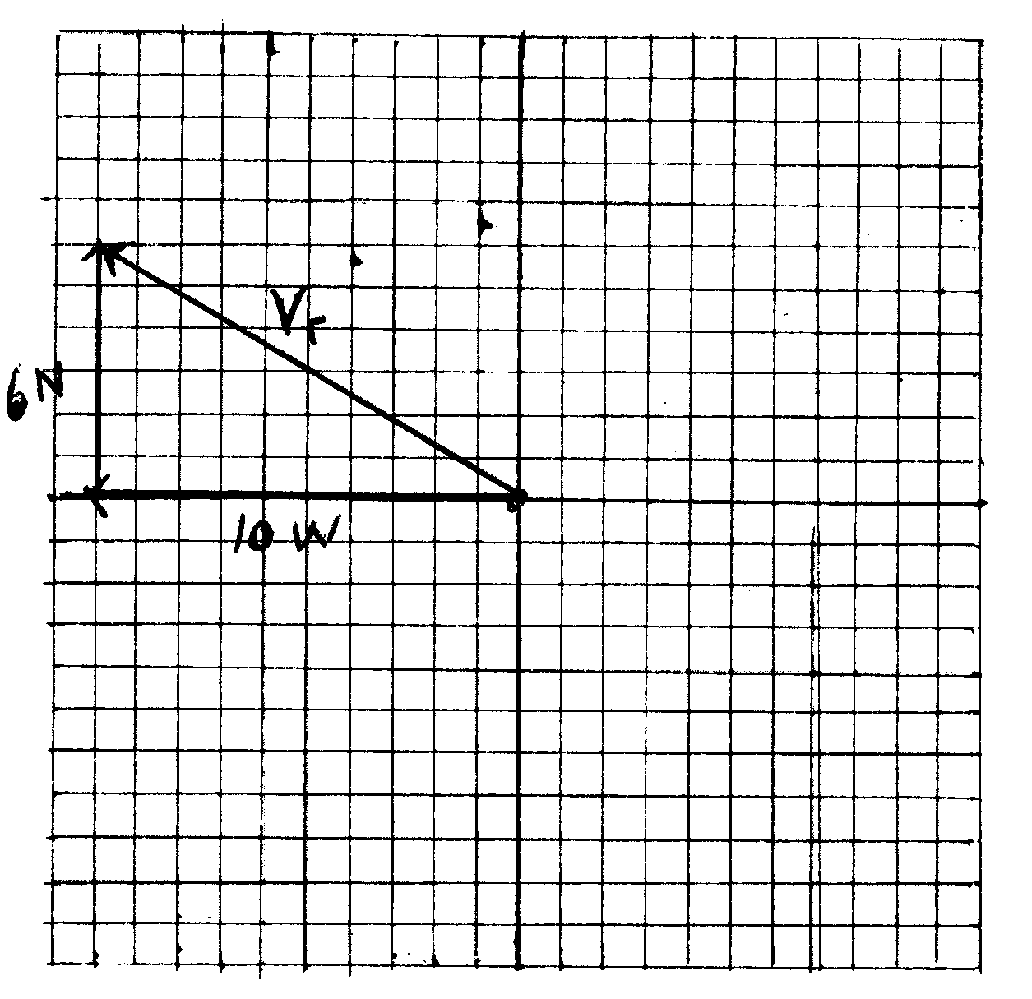

Find the magnitude and direction graphically (using ruler and protractor)

Magnitude _____________ θ _____________

To measure the direction with the protractor, you can just measure the angle from the positive x-axis to the resultant which will give you the proper angle.
Mag ≈ 11.5 – 11.9 units θ ≈ 149°

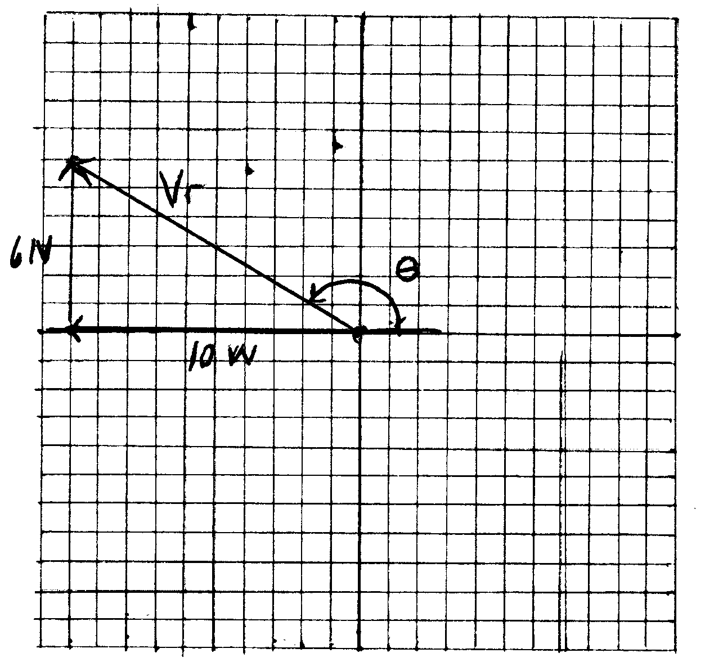

Find the resultant using the Pythagorean Theorem and Trig.
v_{r}² = (v_{x}² + v_{y}²)^{1/2} so v_{r} = $\sqrt{36+100}$ = 11.7 units
The angle here can be tricky, because to use trig we must find the angle that is inside our triangle.
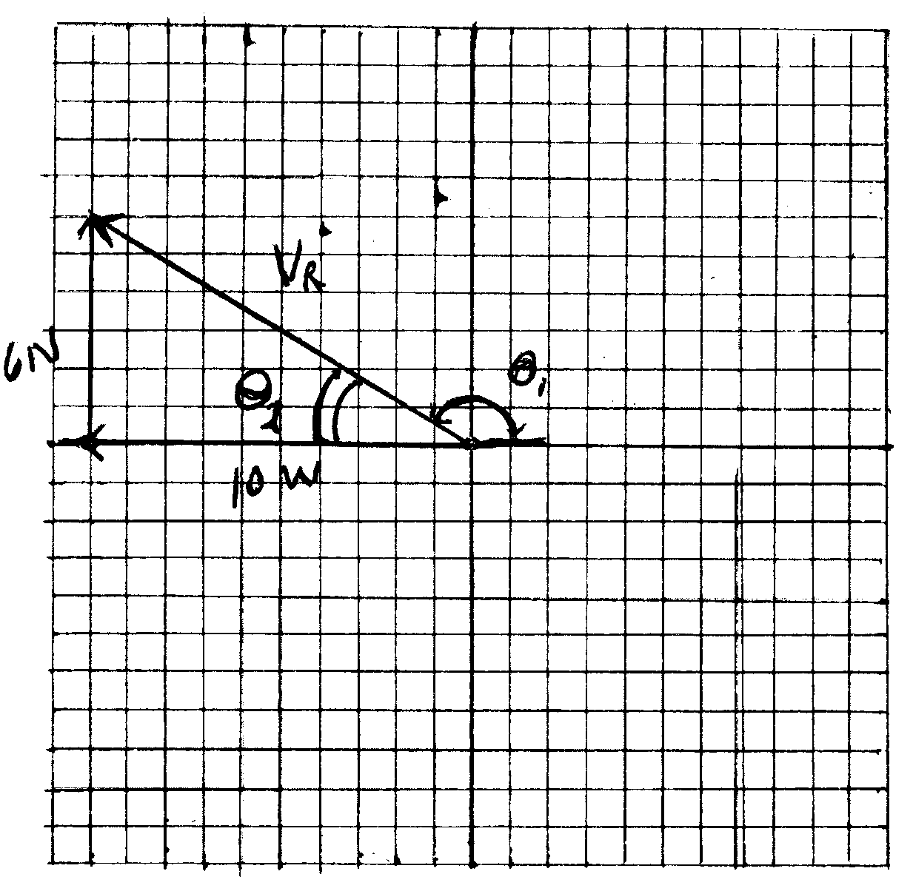
Using Trig, find the measure of θ₂ __________

Tan⁻¹ (6/10) = 31°
The angle we need to use to properly express our direction is indicated by θ₁ above. If we know θ₂ how can we find θ₁?

Θ₁ = 180° – θ₂ = 149°
If you had a set of vectors that put you in quadrant III
(10 W and 6 S for example) The angle of the resultant should fall between ________° and ________°
180° and 270°

Find the resultant of 10 W and 6 S
(solution to the above should be 11.7 units at (180 +31) or 211°
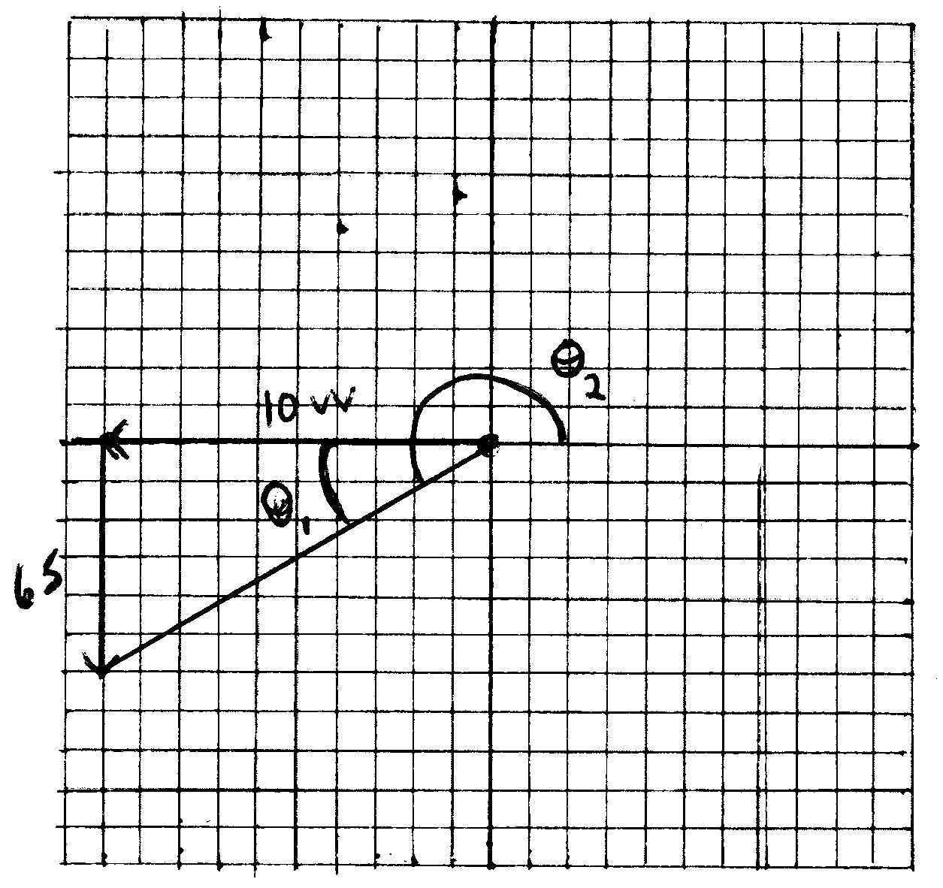
In quadrant IV, the angle is usually expressed as – 1 to – 90, but this only happens in quadrant IV.
(10 E and 6 S for example)
Draw this one on the board for them
11.7 units @ – 31°

