Torque and Newton’s laws
Take a solid frictionless pulley with mass M and radius R and have a mass m hanging from a string wrapped around the pulley suspended in the air as shown below. I = ½ MR²
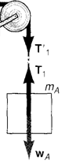

ΣF_{block} = ma = mg – T
Στ_{pulley} = Iα = T R = ½ MR²(a_{tan}/R) = TR
½ M (a) = T
ma = mg – T
( ½ M + m) a = mg
a = mg/[ ½ M + m]
Say M = 4 kg R = 0.1 m and m = 1 kg
a = 9.8/(2 +1) = 3.27 m/s/s α = a/R = 32.7 rad/s/s
if R = 0.2 m a still = 3.27 m/s/s α = 3.27/ 0.2 = 16.33 rad/s/s
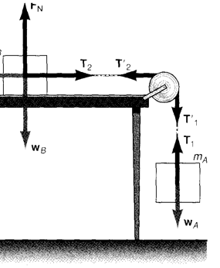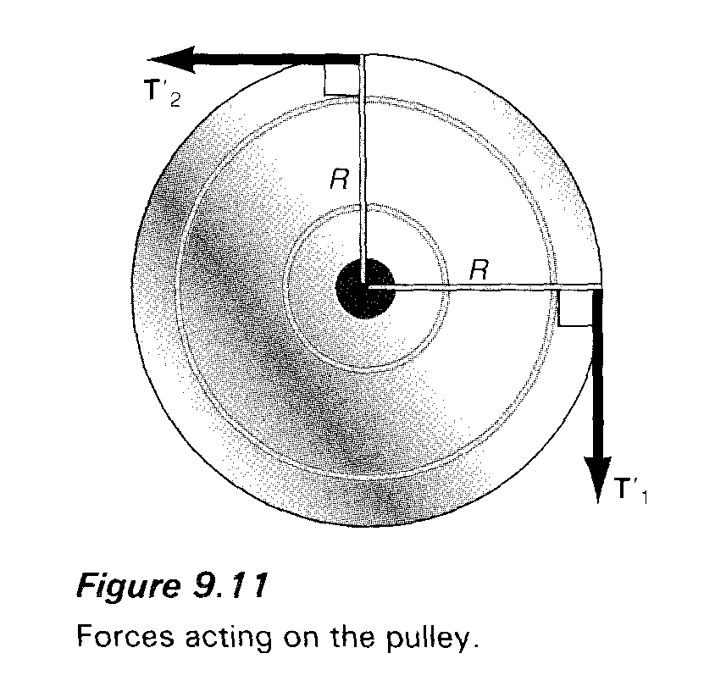

ΣF₁ = m₁a = m₁g – T₁
ΣF₂ = m₂a = T₂
Στ = I α = T₁R – T₂R = (T₁ – T₂)R; ½ MR² (a/R) = (T₁ – T₂)R

m₁a = m₁g – T₁
m₂a = T₂
½ M a = (T₁ – T₂)
( ½ M + m₂ + m₁) a = m₁g a = m₁g/( ½ M + m₂ + m₁)

