Static forces
When objects experience zero net force, there are two options for what is happening because the acceleration is zero. 1) The object moves at constant velocity until acted upon by an outside force, (Already dealt with in Dynamics Unit) or 2) The object will be motionless in a state of equilibrium. This second situation is the focus of our next studies.
- Resolving forces into components along any two perpendicular planes, we get:
- ΣF_{x} = 0 and ΣF_{y} = 0

- A load supported by two lengths of rope. Since the system is at equilibrium, 2(F_{T}) = F_{w}. Here the ropes distribute the load the way the legs of a table do. The force on each ceiling hook is 150 N.  - There are no forces in the x-direction | 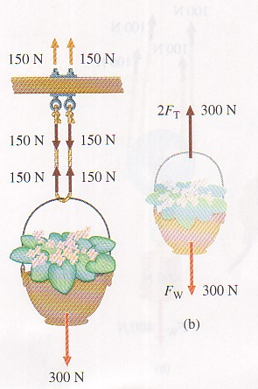

- Again the two ropes each supply half of the upward force. The hand applies  150 N and the ceiling hook supplies the other.  Σ F_{x} = 0 and  Σ F_{y} = 0 = 2T – W = 2T – 300 | 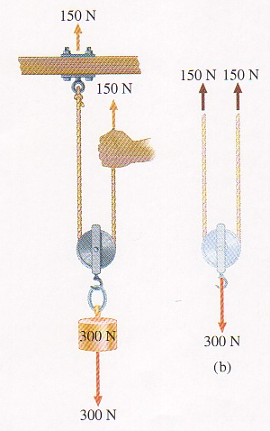
Combinations of pulleys allow for smaller loads on each rope. Here there are 4 ropes supporting the load, each with tension 100 N. The far left rope is bent over the top pulley, remaining at 100 N, which is supplied by the hand. | 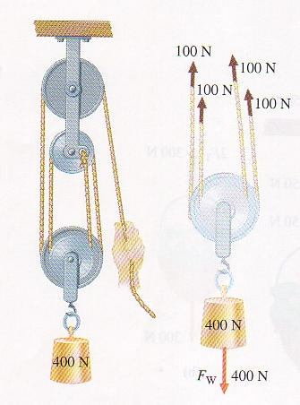

We also frequently encounter situations that involve three or more forces that are not parallel or perpendicular but act at the same point in space, or concurrently. These must be resolved into both x and y components in order to solve for the forces.
An engine, 800 N, hangs from a rope that is suspended from another rope attached to two hooks in the wall. If Θ = 20 ° find the tension in each rope and the force pulling the hooks out of the wall.
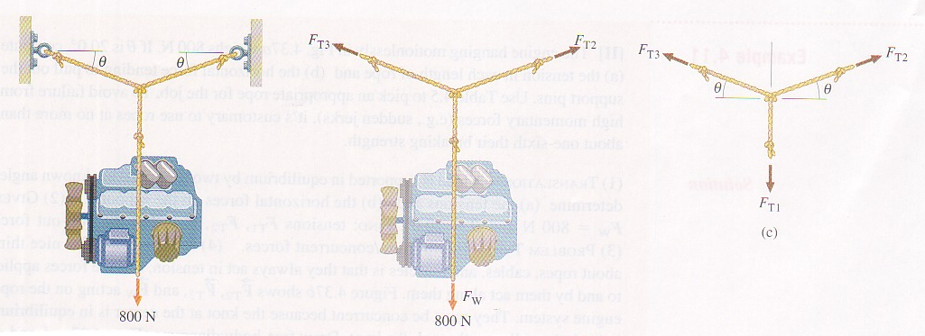
- T₁ = 800 N because W = 800 N
- At knot, because of symmetry, T₂ and T₃ must be equal to each other.
- Σ F_{x} = F_{T2} cos Θ – F_{T3} cos Θ = 0
- Σ F_{y} = F_{T2} sin Θ + F_{T3} sin Θ – F_{w} = 0
2 F_{T2} sin 20° = 800 N ; F_{T2} = 1170 N
At each wall pin, F_{rp} = F_{T2}cos 20 = 1100 N

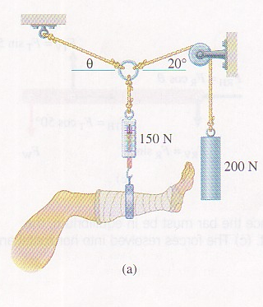 | 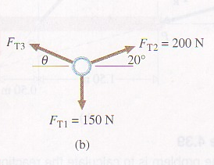
Find the F_{T3} and the angle Θ.
ΣF_{x} = F_{T2} cos 20 – F_{T3}cos Θ = 0; F_{T3}cos Θ = 188 N
ΣF_{y} = F_{T2} sin 20 + F_{T3} sin Θ – 150 N = 0
= F_{T3} sin Θ = 150 N – 68 N = 82 N
F_{T3} sin Θ = 82 N = Tan Θ = 0.434
F_{T3}cos Θ = 188 N Θ = 23 ° and F_{T3} = 205 N

- A 400 N object is suspended from a 2.0 m horizontal bar of negligible mass which is attached to the wall via a pivot. The bar is held up by a rope making an angle of 50 ° with the bar.  T= 0.7 kN the rope is attached 0.5m from the end of the bar. |  | 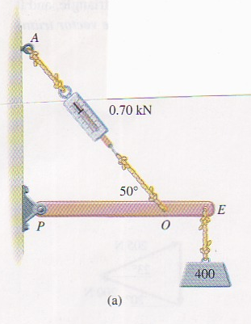

There must be a force that the wall puts back on the bar and it should have a horizontal and vertical part or component.
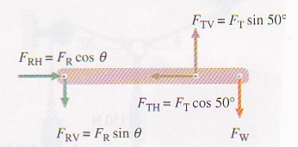
ΣF_{y} = F_{T} sin 50 – F_{w} – F_{RV} =0
ΣF_{x} = F_{T} cos 50 –F_{RH} =0
Knowing F_{T} = 700 N, F_{RH} = 450 N and F_{RV} = 136 N

