Static Equilibrium problems

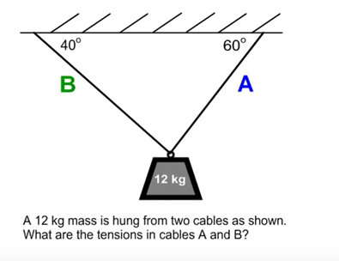

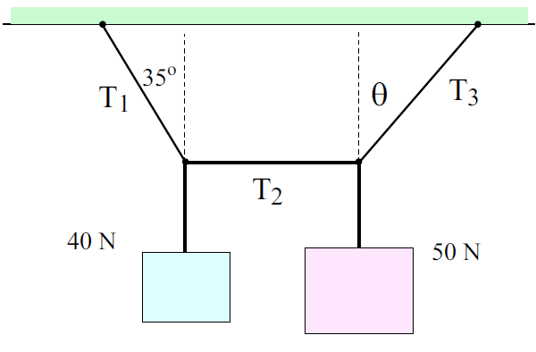
Find T₁, T₂, T₃ and Θ

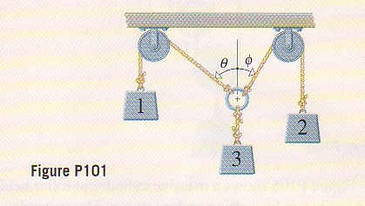
- In figure P101, the pulleys and ropes are weightless. If weight 1 is 15.0 N, weight 2 is 31.0 N, and the two angles are measured to be Θ = 45.0° and φ = 20.0, determine the value of weight 3. Check that the system is in equilibrium.

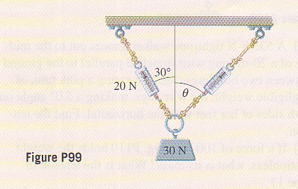
- Determine the reading on the spring scale to the right as well as the angle Θ for the situation shown in figure 99 above.

