Solution Stoichiometry Precipitation probs
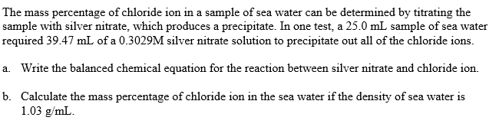
- All the silver in a 45.0 mL portion of silver nitrate solution is precipitated as silver iodide by 26.0 mL of 0.250 M CaI₂ according to the reaction below.
- AgNO₃ (aq) + CaI₂ (aq) 2 AgI (s) + Ca(NO₃)₂ (aq)
What is the concentration of the silver nitrate solution?
What is the mass of silver iodide precipitated?
- What volume of 0.750 M Pb(NO₃)₂, in mL is required to react completely with 1.25 L of 2.25 M NaCl solution?

- What volume of 0.100 M lead(II) nitrate is required to precipitate completely
- 25.0 ml of 0.0832 M nickel(II)sulfate
- 55.8 mL of 0.222 M hydrochloric acid
- 18.7 mL of 0.389 M potassium chromate
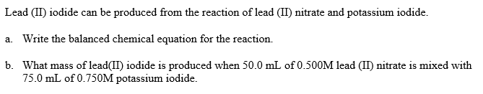
- A mixture contains only NaCl and Fe(NO₃)₃. A 0.456 g sample of the mixture is dissolved in water, and an excess of NaOH is added, producing a precipitate, Fe(OH)₃. The precipitate is filtered, dried and weighed. Its mass is 0.107 g. Calculate the following:
  - The mass of iron in the sample
  - The mass of Fe(NO₃)₃ in the sample
  - The mass percent of iron III nitrate in the sample

2 AgNO₃(aq) + K₂CrO₄(aq) Ag₂CrO₄(s) + 2 KNO₃(aq)
- How many milliliters of 0.10 M K₂CrO₄ must be added to excess AgNO₃ solution to produce 2.0 x 10⁻⁴ mol of Ag₂CrO₄ precipitate?
  - How many mL of 0.60 M silver nitrate must be added to excess potassium chromate solution to produce 3.0 g of silver chromate?
  - How many mL of 0.60 M silver nitrate will react with 50.0 mL of 0.10 M potassium chromate?

