Rigid body Equilibrium under coplanar forces
- Consider the situation shown in figure 3-8 below. A uniform 600 N beam is hinged at P. Find the tension in the tie rope and components of the force exerted by the hinge on the beam.
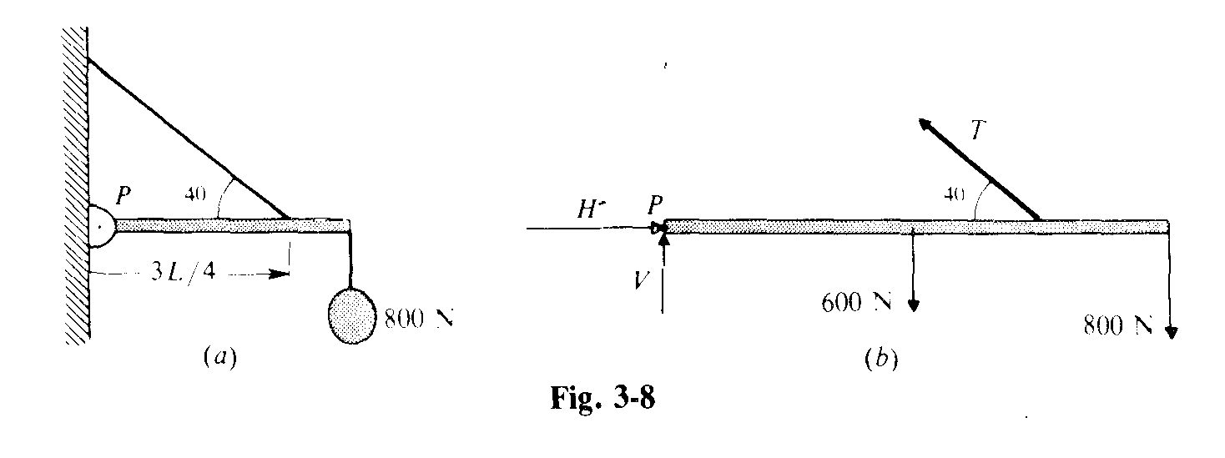
- A uniform 400 N boom is supported as shown in figure 3-9 (a) below. Find the tension in the tie rope and force exerted on the boom by the pin at point P.
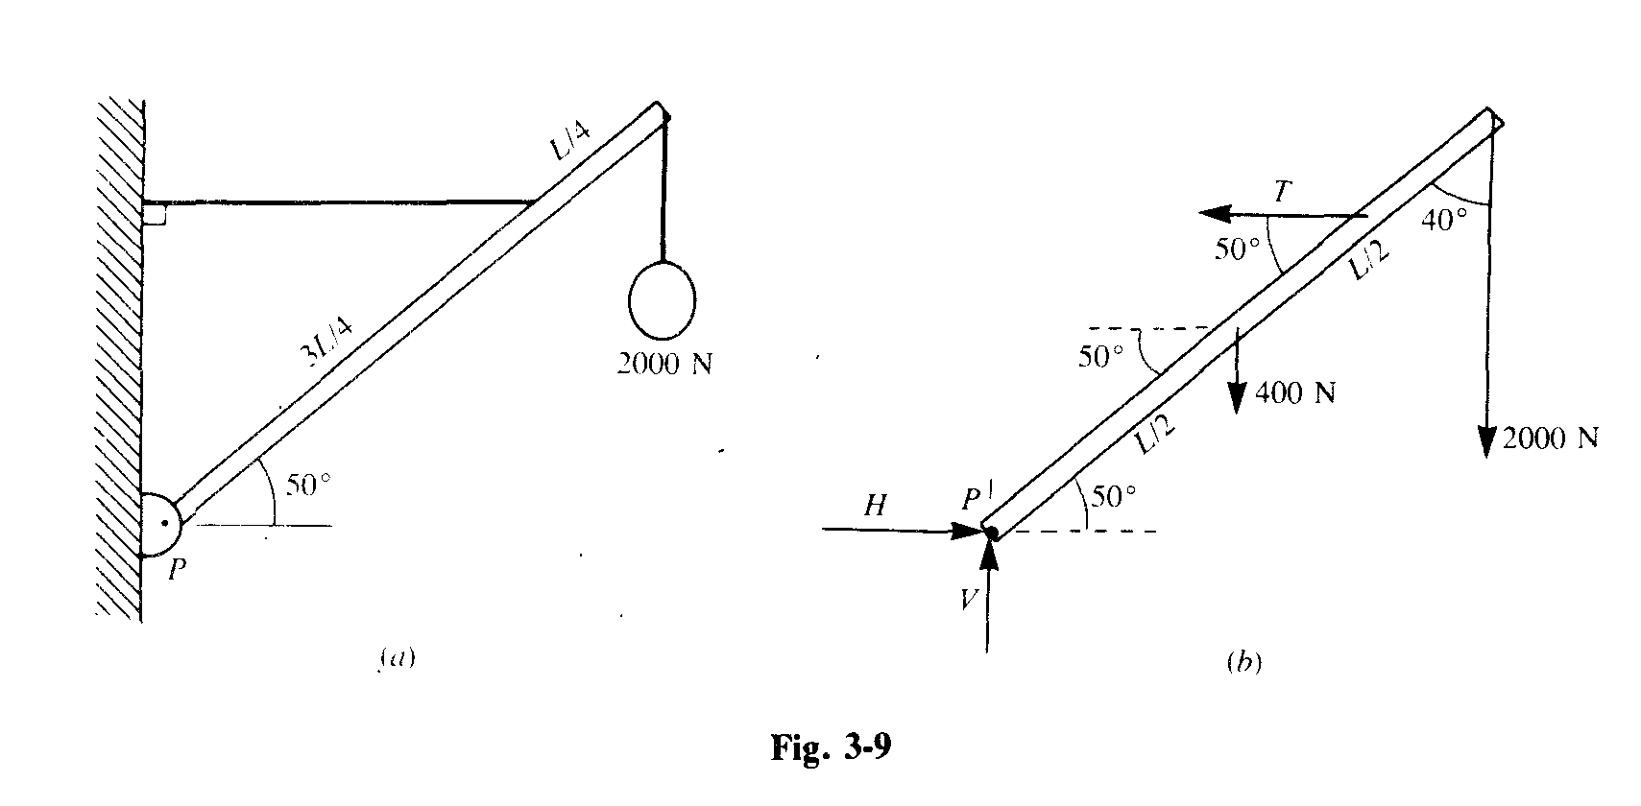

- A ladder leans against a smooth wall, as shown in figure 3-11. (the wall exerts only a normal force on the ladder) The ladder weighs 200 N and its center of gravity is 0.40 L from the base, where L is the ladders length. How large a friction force must exist at the base of the ladder if it is not to slip? What is the necessary coefficient of friction?
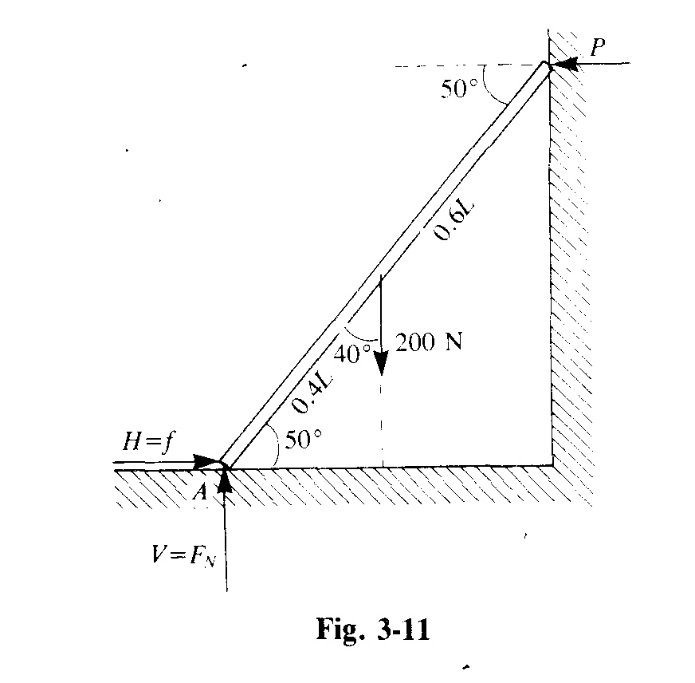
- As shown in figure 3-14, the uniform 1600 N beam is hinged at one end and held by a tie rope at the other. Determine the tension in the rope and the force components at the hinge.
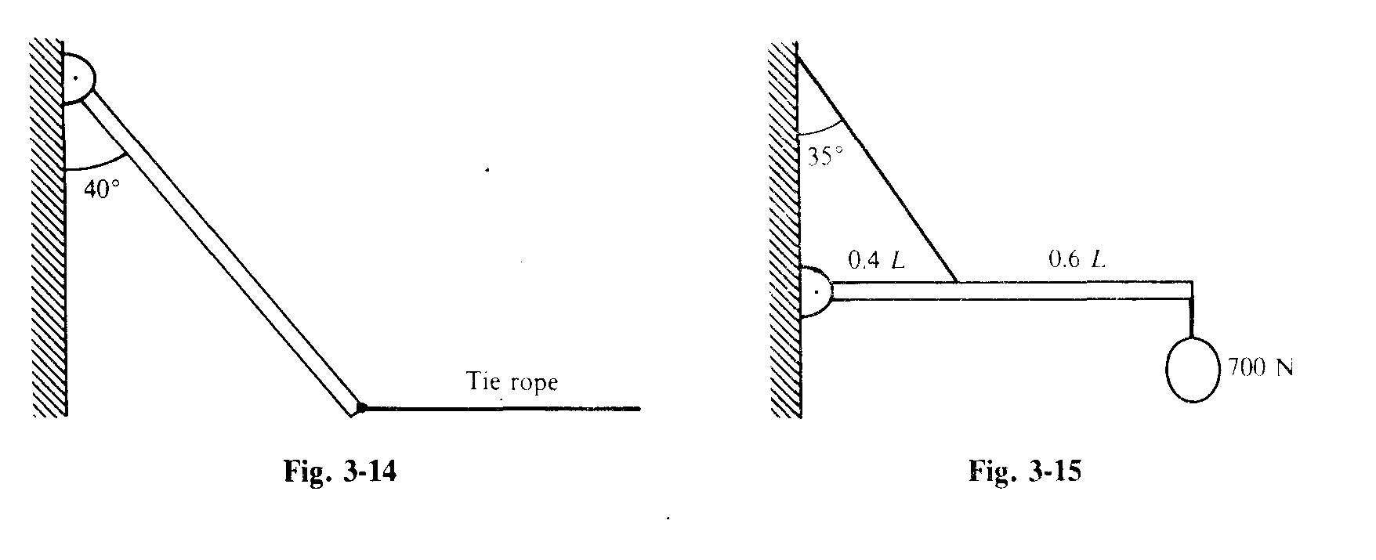
- The uniform beam shown in figure 3-15 above weighs 500 N and supports a 700 N load. Find the tension in the rope and the force of the hinge on the beam.

- A ladder rests against a wall and its top is held by a rope as shown in figure 3-19. The ladder weighs 100 N and its center of gravity is 0.40 of its length from the foot. A 150 N child hangs from a rung that is 0.20 m of the length from the top. Determine the tension in the rope and the components of the force on the foot of the ladder.

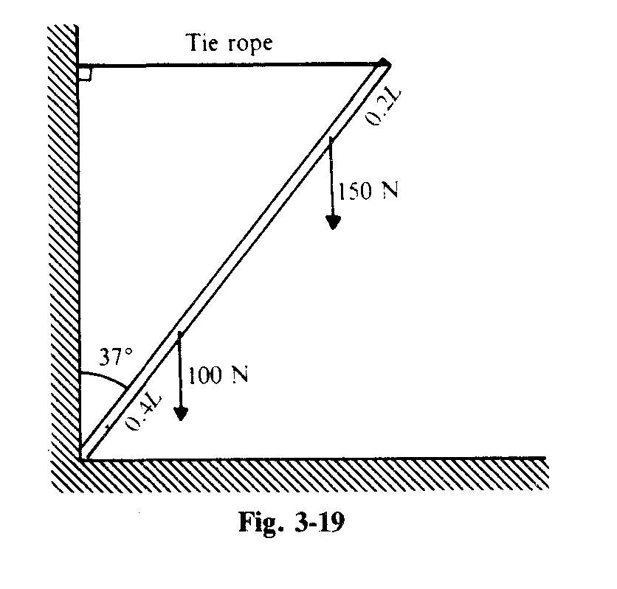

- In figure 3-22, the uniform beam weighs 500 N. If the tie rope can support 1800 N, what is the maximum value the load w can have?
