Rigid body Equilibrium solutions
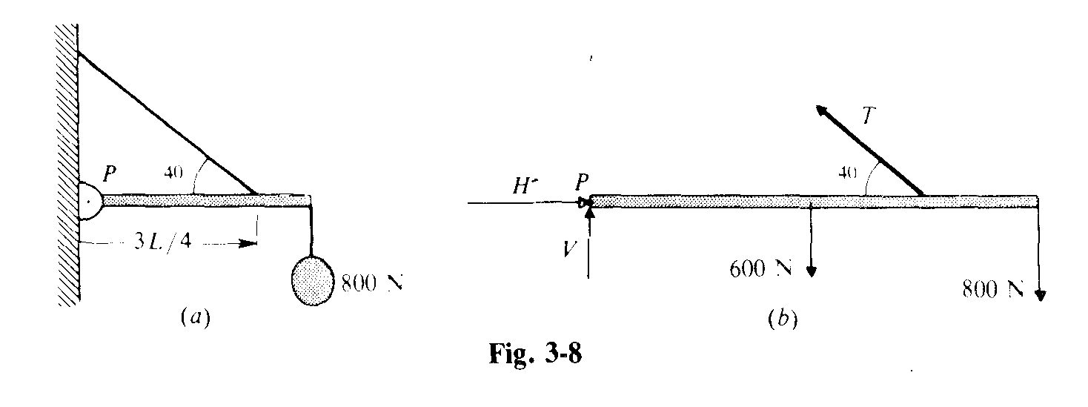
- ΣF_{x} = 0 = Tcos40 – H ΣF_{y} = 0 = 1400 – T sin 40 – V
Στ = 0 = 600 sin 90 (L/2) + 800 sin 90 (L) – T sin 40 (3L/4) = 0
(1100)(4)/[3 sin 40] = T = 2282 N
H = Tcos 40 = 2282 (cos 40) = 1748 N
V = 1400 – T sin 40 = – 67 N Meaning it points down
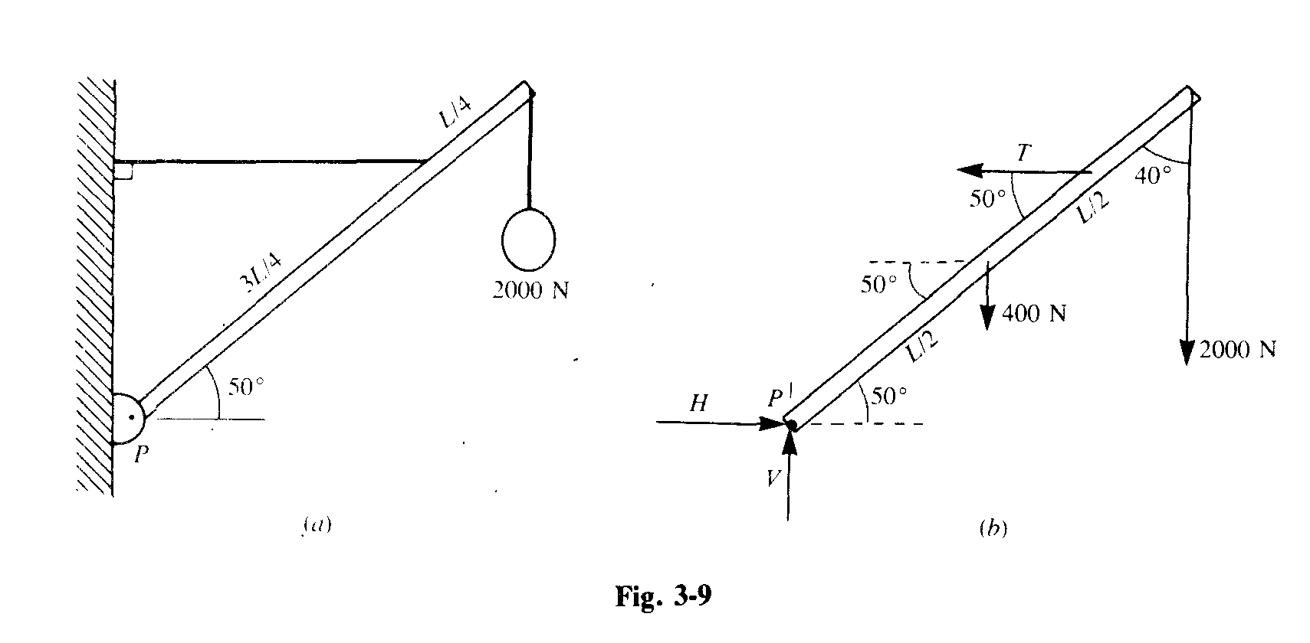
- ΣF_{x} = 0 = T – H ; H = T ΣF_{y} = 0 = 200 + 400 – V V = 2400 up
Στ = 0 = T sin 50 (3L/4) – 400 sin 40 (L/2) – 2000 sin 40 (L)
T = (4)(1415)/[3 sin 50] = 2463 N
H = 2463 N

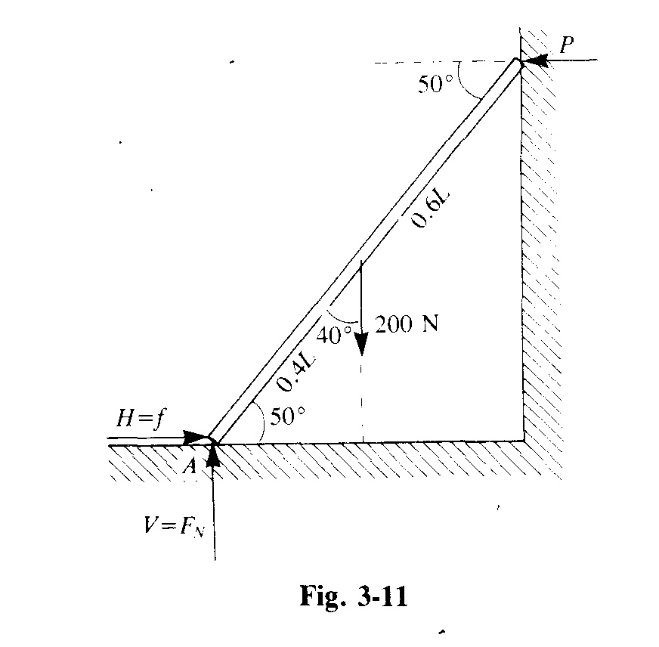
- ΣF_{x} = 0 = N_{wall} – f ; ΣF_{y} = 0 = 200 – N_{ground}
Στ = 0 = N_{wall}(sin50)(L) = 200 (sin 40)(L/2); 200 sin 40(.4)/ sin 50 = N_{wall}
N_{wall} = 67.1 N
N_{ground} = 200 N μ = f/N = 67.1/200 = 0.33
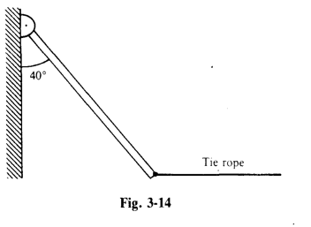
- ΣF_{x} = 0 = T – H; ΣF_{y} = 0 = 1600 – V
Στ = 0 = T sin 50 (L) – 1600 sin 40 (L/2); 800 sin 40/ sin 50 = T = 671 N
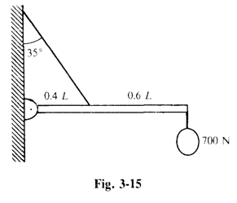
- ΣF_{x} = 0 = T cos 55 – H ; ΣF_{y} = 0 = T sin55 – 500 – 700 – V
Στ = 0 = 700 L + 500 (L/2) – T sin55 (0.4L)
950/[(0.4)( sin55)] = 2899 = T
2899(sin55) – 1200 = V = 1174 down
Tcos55 = H = 1663 right

