Q test and Reaction Shift
- K_{c} = 5.6 x 10⁻¹² at 500 K for the reaction I₂ (g) 2 I (g). A mixture contains [I₂ (g)] = 0.020 and [I] = 2.0 x 10⁻⁸. Is the reaction at equilibrium? If not which way will it shift
- A mixture of SO_{2,} O_{2,} and SO₃ at 100 K contains the gases at the following concentrations: [SO₂] = 5.0 x 10⁻³ M, [O₂] = 1.9 x 10⁻³ M, and [SO₃] = 6.9 x 10⁻³ M. If K_{c} for the reaction is 279, determine if the reaction is at equilibrium or not. If not, determine the direction of the shift 2 SO₂ + O₂ 2 SO₃
- The reaction 2 NO (g) N₂O₄ (g) has an equilibrium constant, K_{c}, of 170 at 25 °C. if 2.0 x 10⁻³ mol of NO₂ is present in a 10.0 L flask along with 1.5 x 10⁻³ mol of N₂O₄, is the system at equilibrium? If not, determine the shift direction
- K_{c} for the reaction 2 NOCl (g) 2 NO (g) + Cl₂(g) is 3.9 x 10⁻³ at 300 °C. A mixture contains the gases at the following concentrations: [NOCl] = 5.0 x 10⁻³, [NO] = 2.5 x 10⁻³, [Cl₂] = 2.0 x 10⁻³. Is the reaction at equilibrium? Determine the direction of shift.
- 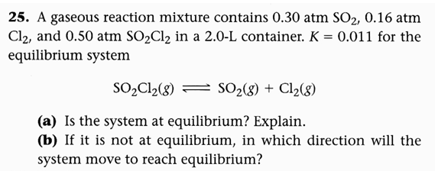
- 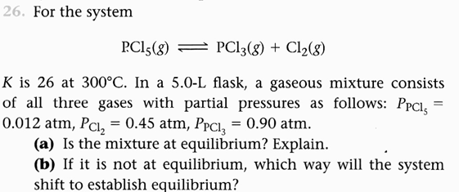
- 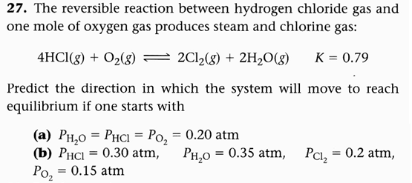
- The equilibrium constant, K, is 2.4 x 10³ for the reaction
2NO (g) <----> N₂ (g) + O₂ (g. for which of the following sets of conditions is the system at equilibrium? for those that are not at equilibrium, in which direction will the system shift?
- a 1.0 L flask contains 0.024 mol NO, 2.0 mol N₂, and 2.6 mol O₂.
- a 2.0 L flask contains 0.032 mol NO, 0.62 mol N₂, and 4.0 mol O₂.
- a 3.0 L flask contains 0.060 mol NO, 2.4 mol N₂, and 1.7 mol O₂.
- The equilibrium constant, K_{p} , is 2.4 x 10³ for the reaction
2NO (g) <----> N₂ (g) + O₂ (g). For which of the following sets of conditions is the system at equilibrium? for those that are not at equilibrium, in which direction will the system shift?
- P_{no} = 0.010 atm, P_{N2} = 0.11 atm, P_{O2} = 2.0 atm
- P_{no} = 0.0078 atm, P_{N2} = 0.36 atm, P_{O2} = 0.67 atm
- P_{no} = 0.0062 atm, P_{N2} = 0.51 atm, P_{O2} = 0.18 atm

