Projectile Problems
Set 2 horizontal and off the ground
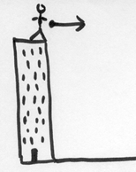 | A projectile is launched horizontally off a building 4.5 m high and lands a distance of 25 m from the building on the flat ground below. Determine initial velocity of the ball.  How will the velocity of the ball when it hits the ground compare to the initial velocity of the ball?  The same  Greater than because it has a vertical component  Less than because of friction with the air  Justify your answer with some math?
 | A projectile is launched horizontally off a tower with a velocity of 10.5 m/s. If the projectile lands a distance of 31.5 m from the base of the tower, from what height was it launched?
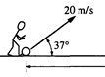 | A ball is kicked at 37° above the horizontal on level ground with a velocity of 20 m/s.  Is the ball moving in both the x and y direction equally?  Show some math to justify your answer above.  Find the max height of the ball above the ground.  How long will the ball be in the air before it lands?  How far will the ball go before it lands?  Is there another angle that the ball can be kicked at with a velocity of 20 m/s and still hit the same spot on the ground? Justify your answer with some math?
 | Now place the ball on a building that is 10.0 m above the ground. If the ball is kicked at 20 m/s at 37° above the horizon, how far above or below the 10 m mark will the ball hit the next building over which is 25 m away?

