Kinematics One Dimension
Summary assignment
Physics I
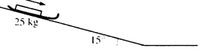
- An empty sled of mass 25 kg slides down a slippery hill that is inclined at an angle of 15° with the horizontal as shown in the figure above.
  - Describe the change in the velocity of the sled as it moves down the incline. Increasing velocity at a constant rate.

When the sled has travelled a distance of 8.1 m down the incline, it has a velocity of 6.4 m/s.
Write the kinematics formula that can be used to determine the acceleration of the sled down the incline.
v_{f}² = v_{o}² + 2 a Δx

  - Determine the acceleration of the sled down the incline.
(6.4m/s)²/(2)(8.1m) = 2.53 m/s/s

  - Using a different equation, determine the time it will take the sled to travel the 8.1 m down the incline.
v_{f} = v_{o} + at; 6.4 m/s /2.53 m/s/s = t = 2.53 s

- A 70.0 kg package is suspended by a 5.0 m rope from a helicopter that accelerates upward at 5.0 m/s². The package starts on the ground with the rope tight as the helicopter starts accelerating. When the helicopter is 100 m above the ground, the rope is cut.
  - After the rope is cut, what is the acceleration experienced by the package?
– 9.8 m/s/s (Gravity)

  - Describe the motion of the package after the rope is cut.

Continues to rise until it stops and begins falling back toward Earth.

  - How will the time that the package takes to hit the ground compare to the time that it took to reach the point when the rope was cut?
Time to return to the ground will be longer than time it takes to get to 95 m (cut) because the crate has a final velocity when the rope is cut of 30.8 m/s

Time to get 95 m: x = ½ at² [95)(2)/5]^{1/2} = 6.16 s
(v_{f} when cut = v_{o} + a)(t) v_{f} = 0 + 5.0m/s/s)(6.16 s) = 30.8 m/s
UP AFTER CUTTING OF ROPE TO STOP
(v_{f} = v_{o} + at) 30.8/9.8 = 3.14 s and it flies up a total of 48.4 m during that time.
Now it must fall from a height of 143.4 m (95 + 48.4)
To find that time: h = ½ a t²; [[(2)(143.4)]/9.8]^{1/2} = 5.41 s

Total time to reach ground after cut 5.41 + 3.14 = 8.55 s
Total time before cut = 6.16 s

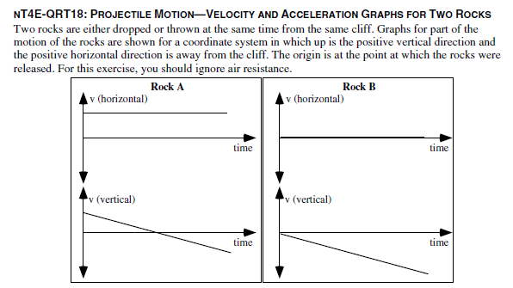
- Is rock A dropped, thrown, or is it not possible to determine whether it was dropped or thrown? Explain
Thrown because it has an initial positive velocity vertically and horizontally. It is thrown up and away from the cliff

- Is rock B dropped, thrown, or is it not possible to determine whether it was dropped or thrown? Explain.
Dropped. Has not initial horizontal velocity and has initial vertical velocity at zero

- Does Rock A hit the ground first, at the same time, or after Rock B? Explain.
A hits after, it is thrown up and out while B is just dropped. A must go up and stop and then fall, while B is falling from the instant it is let go at the same height.

- Does Rock A hit the ground closer to, at the same distance from, or farther from the base of the cliff compared to Rock B? Explain.
Farther from the base. B fall straight down, A is thrown up and away from the cliff, so it will move away from the cliff as it falls.

