Kinematics One Dimension
Summary assignment
Physics I
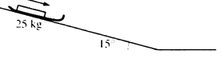
- An empty sled of mass 25 kg slides down a slippery hill that is inclined at an angle of 15° with the horizontal as shown in the figure above.
  - Describe the change in the velocity of the sled as it moves down the incline.

When the sled has travelled a distance of 8.1 m down the incline, it has a velocity of 6.4 m/s.
Write the kinematics formula that can be used to determine the acceleration of the sled down the incline.

  - Determine the acceleration of the sled down the incline.

  - Using a different equation, determine the time it will take the sled to travel the 8.1 m down the incline.

- A 70.0 kg package is suspended by a 5.0 m rope from a helicopter that accelerates upward at 5.0 m/s². The package starts on the ground with the rope tight as the helicopter starts accelerating. When the helicopter is 100 m above the ground, the rope is cut.
  - After the rope is cut, what is the acceleration experienced by the package?

  - Describe the motion of the package after the rope is cut.

  - How will the time that the package takes to hit the ground compare to the time that it took to reach the point when the rope was cut?

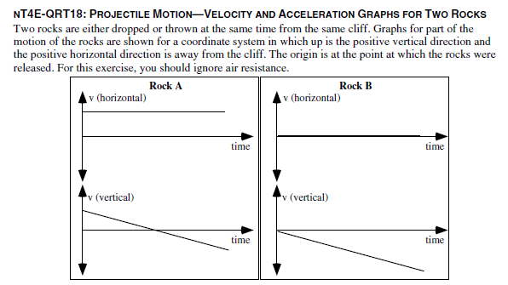
- Is rock A dropped, thrown, or is it not possible to determine whether it was dropped or thrown? Explain

- Is rock B dropped, thrown, or is it not possible to determine whether it was dropped or thrown? Explain.

- Does Rock A hit the ground first, at the same time, or after Rock B? Explain

- Does Rock A hit the ground closer to, at the same distance from, or farther from the base of the cliff compared to Rock B? Explain.

