Velocity Graph Physics C
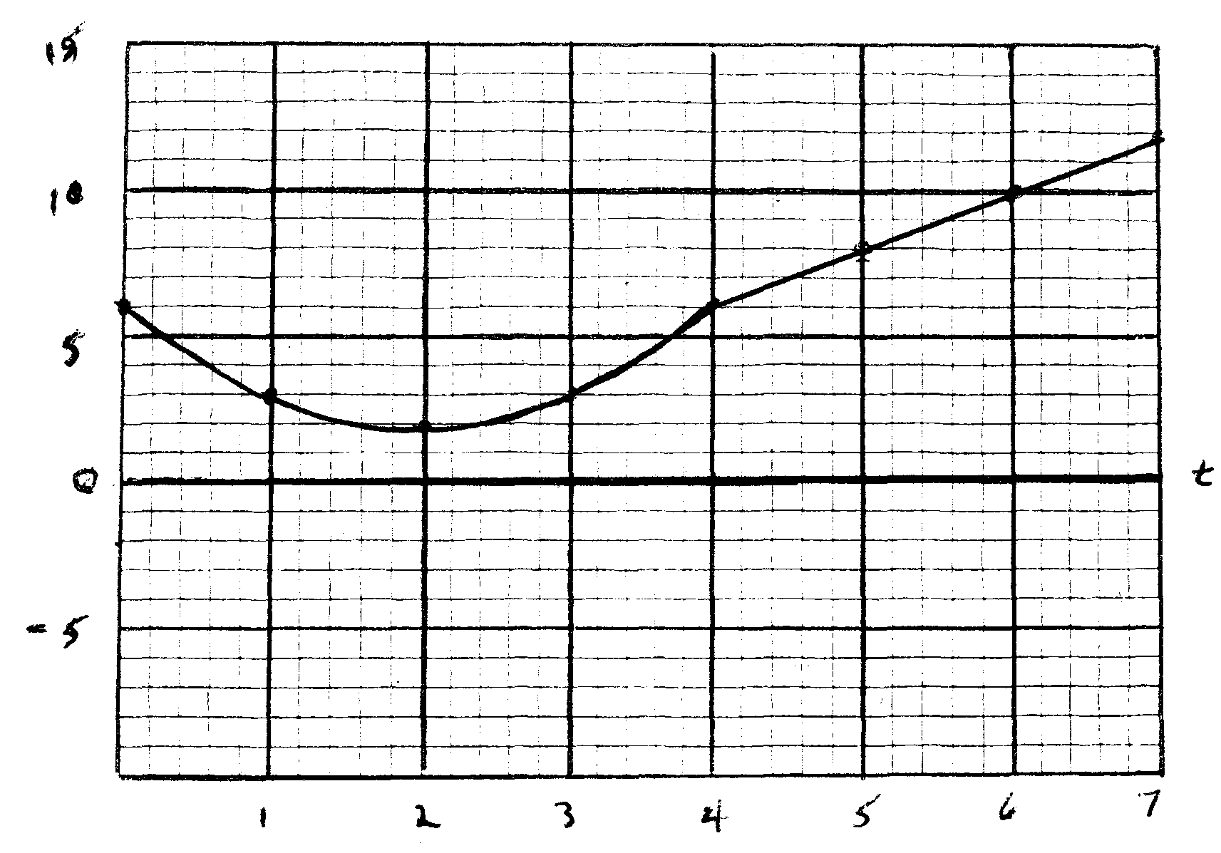
An object moves along a one dimensional track as shown in the graph above.
For the first 4 seconds (t = 0 – 4) the velocity is given by the function y = x² – 4x + 6.
From t = 4 – t = 7, the velocity function is given by the equation y = 2x – 1.
Determine the displacement of the object during each of the listed intervals as well as for the 7 seconds depicted on the graph.
t = 0 – 4 $\int_{0}^{4}{x^2 -4x +6}$ dx x³/3 – 2x² + 6x │ $\begin{matrix}4 \\ 0\end{matrix}$ = 13.3 m
t = 4 – 7 $\int_{7}^{4}{2x-1 }$dx x² – x │$\begin{matrix}7 \\ 4\end{matrix}$ = 30 m
Net Displacement = 43.3 m

