Velocity Graph Physics C
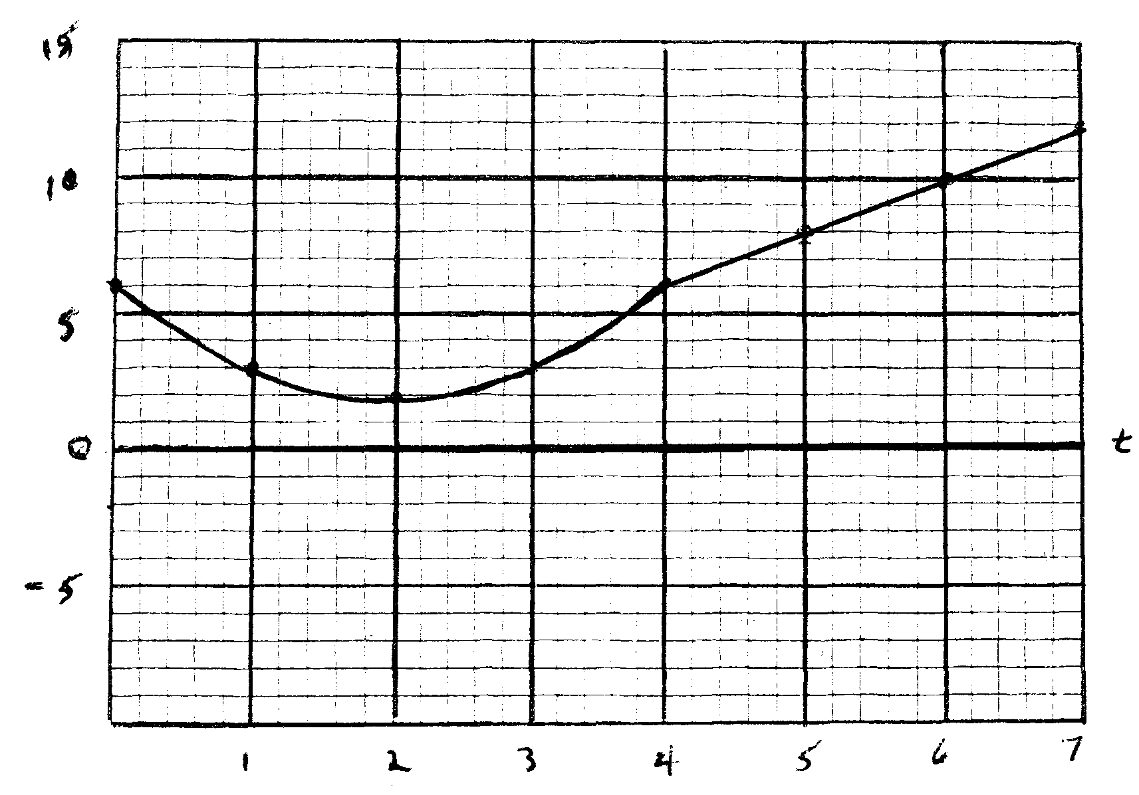
An object moves along a one dimensional track as shown in the graph above.
For the first 4 seconds (t = 0 – 4) the velocity is given by the function y = x² – 4x + 6.
From t = 4 to t = 7, the velocity function is given by the equation y = 2x – 1.
Determine the displacement of the object during each of the listed intervals as well as for the 7 seconds depicted on the graph.

