nTIPERS
Projectiles
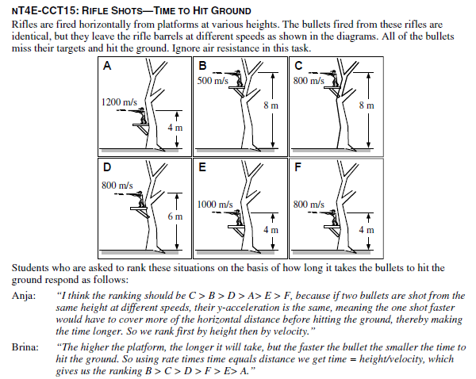
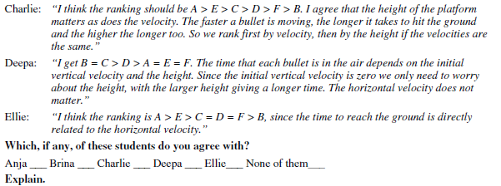

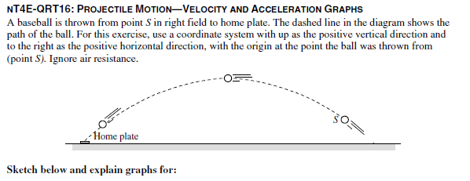
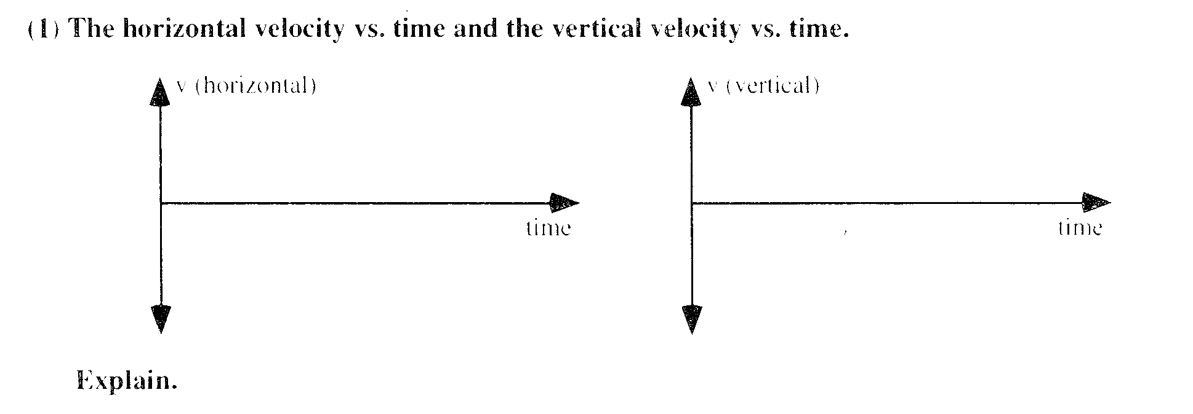
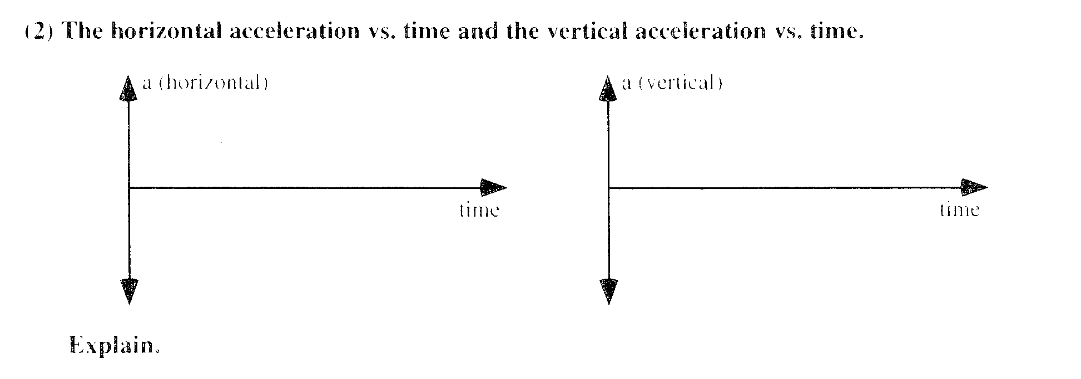

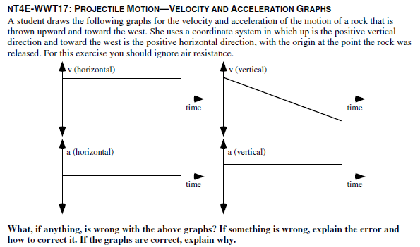

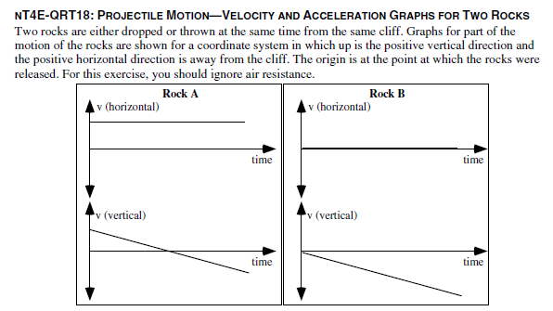
- Is rock A dropped, thrown, or is it not possible to determine whether it was dropped or thrown? Explain

- Is rock A dropped, thrown, or is it not possible to determine whether it was dropped or thrown? Explain.

- Does Rock A hit the ground first, at the same time, or after Rock B? Explain

- Does Rock A hit the ground closer to, at the same distance from, or farther from the base of the cliff compared to Rock B? Explain.

