Representing Motion
There are several ways of representing the motion of an object. Often graphs of position, velocity and acceleration vs time. We’ve looked at these already. Another method of representing or describing the motion of an object is the use of a Motion Map or Motion diagram.
The motion map is like a strobe light picture of the motion where each point represents the object at a certain point in time, usually in 1 second increments. The position of the object at each of those times will be represented by a dot. In order to properly determine the position of the object at t = 0, we must have an axis with an origin as shown below.

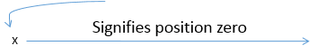

Then the position of the object is shown with a dot, and the velocity of the object is shown as an arrow off the dot. It must point in the direction of the object’s motion and its length will be proportional to its magnitude (how fast its moving)
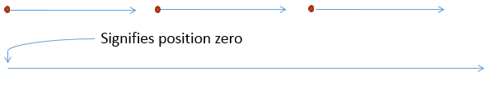
The object above is moving to the right at constant velocity beginning at the origin, and the first three seconds of motion is shown.

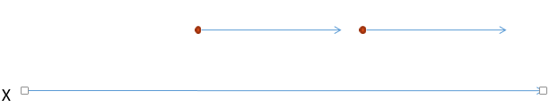
Here the object above the line begins at a position to the right of the origin and moves at a constant velocity to the right. The object below the line begins at the same position but moves to the right at a slower velocity.

If the object stops it can just be represented by a dot at that time. Below, the object moves to the right at one velocity, stops and then moves to the left at a slower velocity.
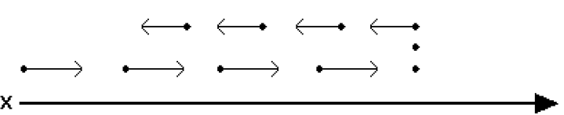

Hints for drawing motion maps
- Draw dots to indicate the position of the object at equal time intervals
- Attach arrows to the dots to indicate the direction of motion. Make the arrows stop well before the next dot to make your map easy to read.
- When an object is stopped, draw a dot with no arrow. If it stays in that position for more than one second, stack the dots up.
- Make sure your map flows logically and that the motion is clearly communicated. If the object changes direction make sure your arrows change direction as well.

Example Problems
Describe the motion of the object given the following motion maps:
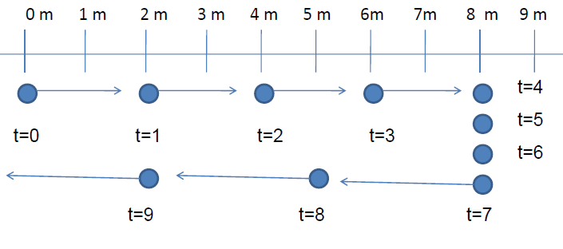
Description:

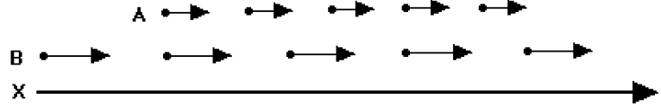
Which cyclist is moving faster? Is there a time when they cyclists are in the same position? If so, when is it? Sketch position vs t graphs for each biker below
Accelerated Motion Maps
What would be different about the motion graph for an object accelerating during the motion? How could we represent this change?
Here the object has a different velocity vector attached at each interval, and the distance travelled during each interval increases. If the object is travelling further during this interval than it did in the last interval, it must be moving faster.
Sometimes it can also be understood by thinking about a car that moves and drips a drop of oil every second. The spacing of the dots will then tell us if the speed is changing by showing the distance the car moves every second.
Is the car covering the same distance each second? More distance or less distance? Is it constant speed, increasing or decreasing?

Describe the motion of the object above. When is it increasing velocity? When is it decreasing velocity?

