Momentum Conservation Problems
- A 730 N man is stranded in the center of a frozen pond because of a lack of friction between his shoes and the ice. The pond is 5.0 m in radius. He decides to throw his 1.2 kg physics book horizontally at 5.0 m/s due north. How long will it take him to get to the south shore of the pond?
- A rifle of weight 30 N fires a 5.00 g bullet with a speed of 300 m/s. Find the recoil velocity of the rifle. If a 700 N man holds the rifle firmly against his shoulder, determine the recoil velocity of the man and rifle.
- A 1200 kg car is initially traveling at 25.0 m/s east and collides with a 9000 kg truck traveling at 20 m/s east. After the collision, the car is traveling 18.0 m/s east. What is the speed of the truck right after the collision? How much energy is lost in the collision?

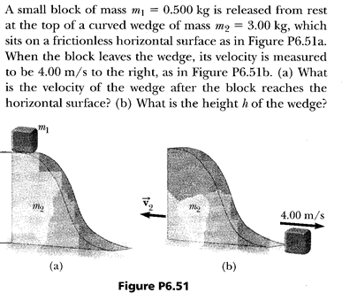

- Velocity of block 2 after collision is + 6.6 m/s.
