Momentum and Energy Review 90 92 94
Momentum Review problems
90 #1, 92 #2, 94 #2, 08 #1, 08b#1, 84 #2
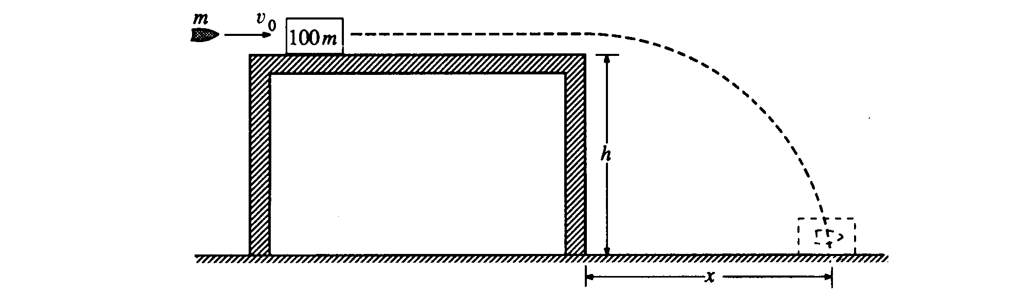
1990B1. A bullet of mass m is moving horizontally with speed v_{o} when it hits a block of mass 100m that is at rest on a horizontal frictionless table, as shown above. The surface of the table is a height h above the floor. After the impact the bullet and the block slide off the table and hit the floor a distance x from the edge of the table. Derive expressions for the following quantities in terms of m, h, v_{o}, and appropriate constants:
a. the speed of the block as it leaves the table
b. the change in kinetic energy of the bullet-block system during impact
c. the distance x

Suppose that the bullet passes through the block instead of remaining in it.
d. State whether the time required for the block to reach the floor from the edge of the table would now be greater, less, or the same. Justify your answer.
e. State whether the distance x for the block would now be greater, less, or the same. Justify your answer.

1992B2. A 30-kilogram child moving at 4.0 meters per second jumps onto a 50-kilogram sled that is initially at rest on a long, frictionless, horizontal sheet of ice.
a. Determine the speed of the child-sled system after the child jumps onto the sled.
b. Determine the kinetic energy of the child-sled system after the child jumps onto the sled.
After coasting at constant speed for a short time, the child jumps off the sled in such a way that she is at rest with respect to the ice.
c. Determine the speed of the sled after the child jumps off it.
d. Determine the kinetic energy of the child-sled system when the child is at rest on the ice.
e. Compare the kinetic energies that were determined in parts (b) and (d). If the energy is greater in (d) than it is in (b), where did the increase come from? If the energy is less in (d) than it is in (b), where did the energy go?

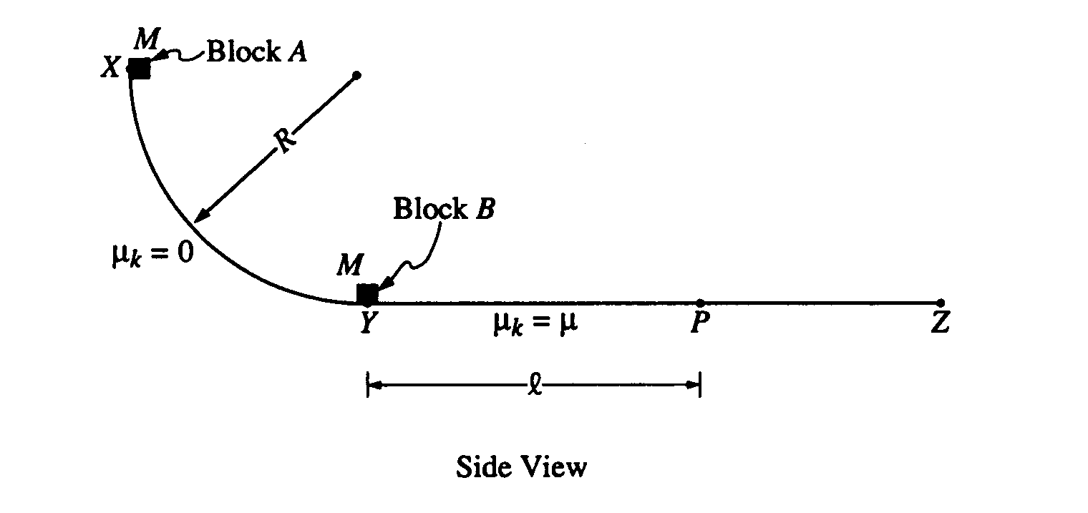

1994B2. A track consists of a frictionless arc XY, which is a quarter-circle of radius R, and a rough horizontal section YZ. Block A of mass M is released from rest at point X, slides down the curved section of the track, and collides instantaneously and inelastically with identical block B at point Y. The two blocks move together to the right, sliding past point P, which is a distance l from point Y. The coefficient of kinetic friction between the blocks and the horizontal part of the track is μ Express your answers in terms of M, l, μ, R, and g.
a. Determine the speed of block A just before it hits block B.
b. Determine the speed of the combined blocks immediately after the collision.
c. Determine the amount of kinetic energy lost due to the collision.
d. Determine the amount of energy lost due to friction as the block slides from point Y to P

