Newtons Laws relating to rotational motion
Objectives: At the end of this screen cast you should be able to:
Define moment of inertia
Understand that mass distribution affects rotation
Describe the distribution of mass that will lead to the highest angular acceleration of an object
Rank the angular acceleration of three objects of equal mass when they experience the same force based upon moment of inertia.
State Newton’s 2nd law for rotation
Calculate the angular acceleration of an object given the torque and knowing its moment of inertia.

Newton’s Law apply to any object that experiences forces, including those forces that result in rotation. Torques are the rotational counterpart (analog) of linear forces, and net torque will rotate an entire object. Since the torque acts at a distance r from the axis of rotation of an object,

τ = F_{T} r = and F_{T} = m a_{T} (a _{tangential}) where radius is equal to the length of the lever arm,

So we end up with τ = F_{T} r = (m a_{T})r

Recall that a_{T} = rα from rotational kinematics.
Substituting, we get τ = (m)(a_{T}) r = m(rα)r = mr²(α)
mr² = I, the Moment of Inertia. Moment of inertia is a measure of how the distribution of mass in an object influences how the object rotates. It is sometimes referred to as Rotational Mass. Each type of mass distribution will rotate differently.
The simplest rotating mass is a mass on a string or at the end of an ideal rod (massless). In this case, the moment of inertia I = mr².
If I put another mass next to that first one, I remains unchanged, mr², but mass would increase. In fact for an entire circle of such masses, a hoop, I = mr². Academy students watch this video for derivation of I for a solid disc.
Thin rod video for the derivation of the Moment of inertia for a thin rod rotating about its center.
Other common objects have different moments of inertia and are listed below. These moments involve calculus for their derivation which is not required in Physics I. Most of the time, in both AP Physics I and Physics C mechanics, the moment of inertia for an object will be given.

Reference chart for Moments of Inertia:

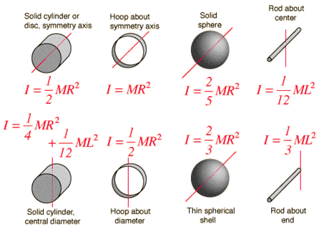
Στ = Iα. (Newton’s 2nd Law for rotation) Here, as in all rotational dynamics, substitute the moment of inertia for mass and we can solve for acceleration in either the angular or tangential sense.
A thin Hoop with a mass of 250 g and a radius of 0.10 m rotates as it rolls down an incline, with a net torque of .10 N·m causing the rotation. Find the angular acceleration of the hoop and the tangential acceleration of a point on the edge of the hoop.

τ = Iα = mr²(α); 0.1 N·m = (.50)(.1)²α = 20.0 Rad/s²

