Mech C kinematics 2

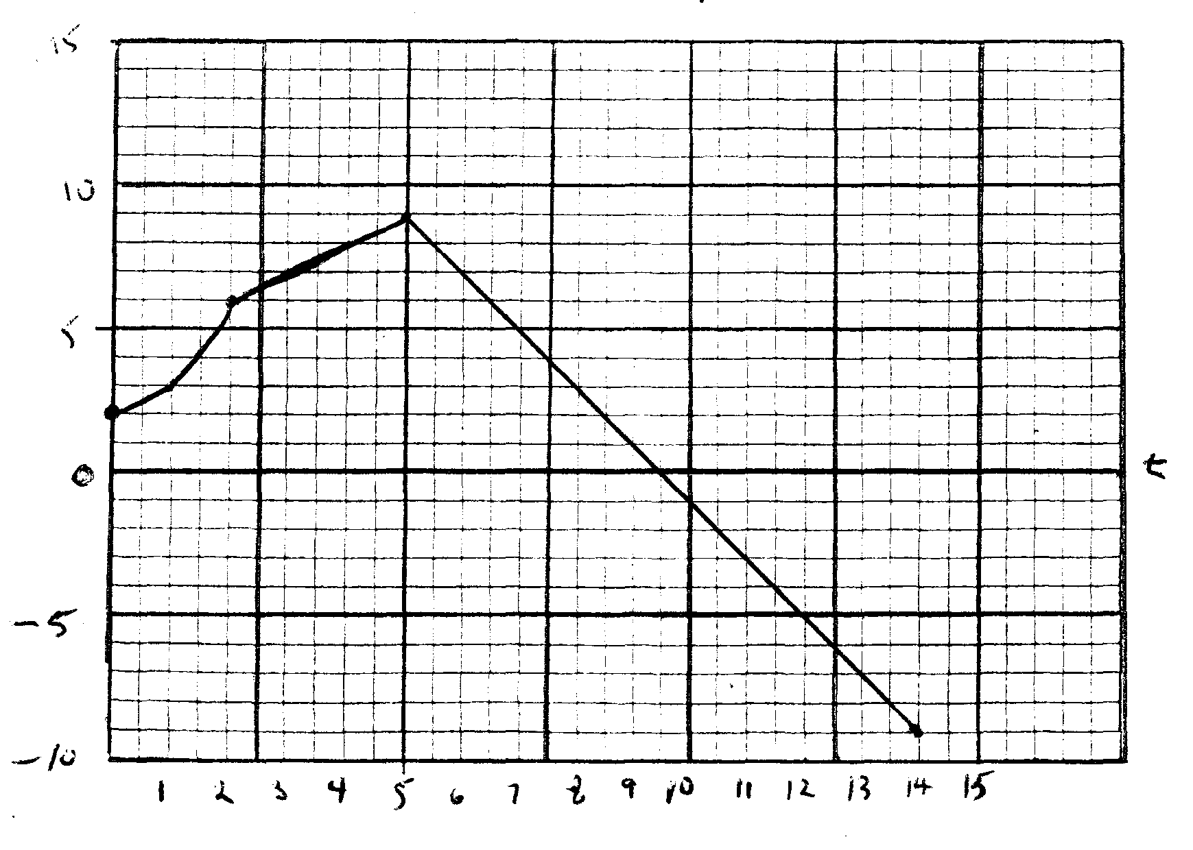
A cart travels along a one dimensional track and its velocity is pictured on the graph above. During the time intervals below, the velocity is given by the function listed.
t = 0 – 2 y = x² + 2
t = 2 – 5 y = x + 4
t = 5 – 14 y = –2x + 19
Determine the displacement of the cart for each of the listed intervals and for the entire 14 seconds.
t = 0 – 2 $\int_{0}^{2}{x^{2}+2 dx}$ = x³/3 + 2x │$\begin{matrix}2 \\ 0\end{matrix}$ 8/3 + 4 = 6.67 m
t = 2 – 5 $\int_{2}^{5}{x+4 dx}$ = ½ x² + 4x │$\begin{matrix}5 \\ 2\end{matrix}$ 25/2 + 20 = 32.5 m
t = 5 – 14 $\int_{5}^{14}{-2x+19 dx }$ = – x² + 19x │$\begin{matrix}14 \\ 5\end{matrix}$ (-196 + 266) – (– 25 + 95) = -70 = 70 = 0
Net = 39.2 m

