Mech C kinematics 2

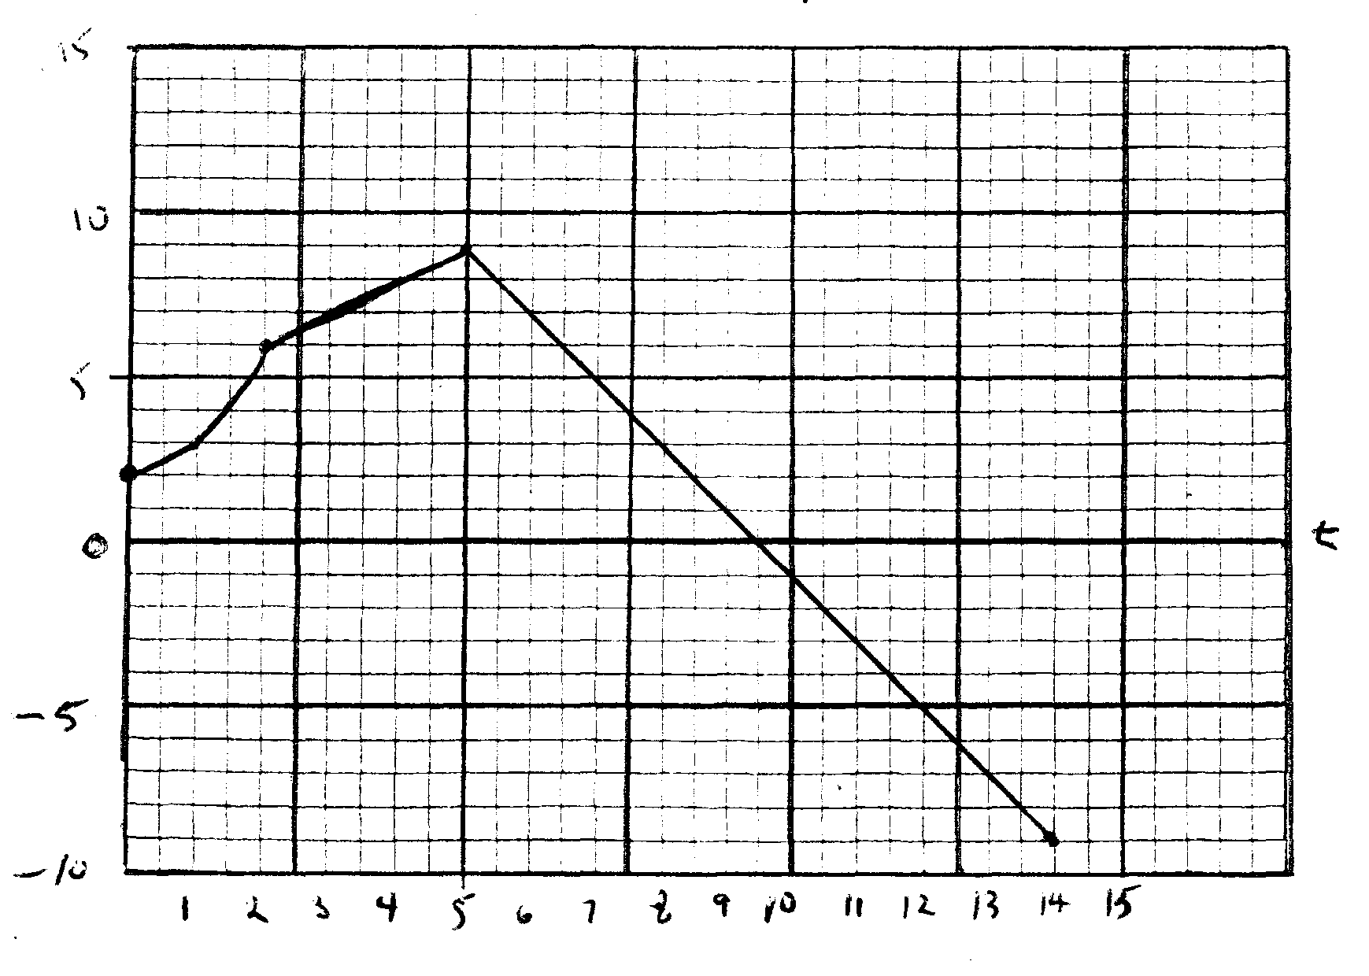
A cart travels along a one dimensional track and its velocity is pictured on the graph above. During the time intervals below, the velocity is given by the function listed.
t = 0 – 2 y = x² + 2
t = 2 – 5 y = x + 4
t = 5 – 14 y = –2x + 19
Determine the displacement of the cart for each of the listed intervals and for the entire 14 seconds.

