Manipulating Reactions and changes in K
- The reaction NO₂ (g) + NO (g) N₂O (g) + O₂ (g) has K_{c} = 0.914 at a certain temperature. At this same temperature determine K_{c} for the following reaction 2 N₂O (g) + 2 O₂ (g) 2 NO₂ (g) + 2 NO (g)
- How does the equilibrium constant, K_{c}, of the second reaction compare with that of the first reaction below;
H₂ (g) + Cl₂(g) 2 HCl and ½ H₂ (g) + ½ Cl₂ HCl (g). How does K_{c} for this reaction compare to the first above. 2HCl (g) H₂ (g) + Cl₂ (g)?
- Use the following equilibria to calculate K_{c} for the reaction below:
2CH₄ (g) C₂H₆ (g) + H₂ (g) K_{c} = 9.5 x 10⁻¹³
CH₄ (g) + H₂O (g) CH₃OH (g) + H₂ (g) K_{c} = 2.8 x 10⁻²¹
2 CH₃OH (g) + H₂ (g) C₂H₆ (g) + 2H₂O (g) K_{c} = ?
- K_{c} for the reaction N₂ (g)+ O₂ (g) 2 NO (g) is 1.7 x 10⁻³ at 2300 K. What is K_{p} for the reaction, what is K_{c} for the reaction:
½ N₂ (g)+ ½ O₂ (g) NO (g), what is K_{c} for the reaction when written as
2 NO (g) O₂ (g) + N₂ (g)
- The equilibrium constant for the reaction 2 HI (g)( H₂ (g) + I₂ (g) at 425°C is 1.84. What is the value of the equilibrium constant for the following reaction at 425 °C? H₂(g) + I₂ (g) 2HI (g)?
- K_{c} for the reaction CS₂(g) + 4 H₂ (g) CH₄(g) + 2 H₂S (g) at 900°C is 27.8. What is the value of K_{c} for the following reaction at 900 °C?
½ CS₂(g) + 2 H₂ (g) ½ CH₄(g) + H₂S (g)
- The value of K_{c} for the following reaction at 900 °C is 0.28.
CS₂ (g) + 4H₂ (g) CH₄ (g) + 2 H₂S (g). What is K_{p} at this temperature?
- The reaction SO₂ (g) + ½ O₂ (g) SO₃ (g) has K_{p} = 6.55 at 627°C. What is K_{c} at this temperature?
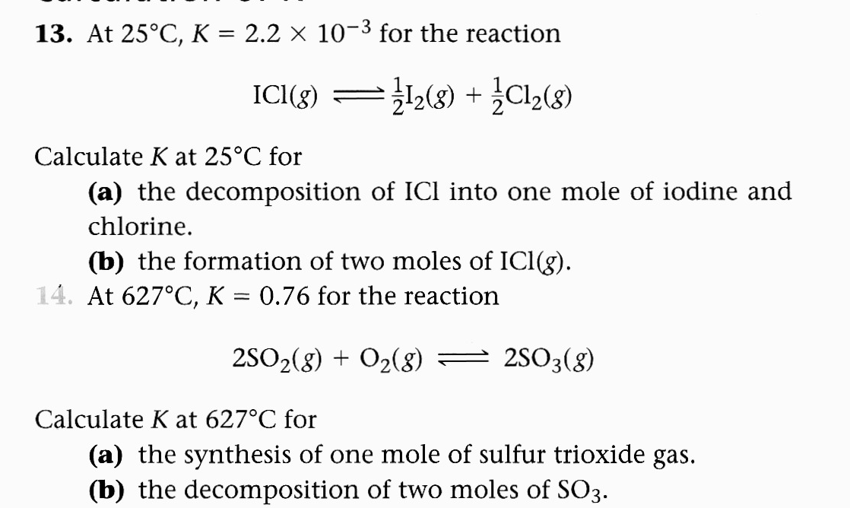
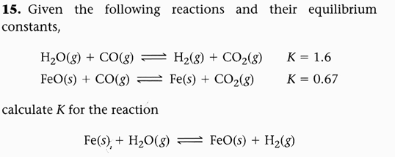
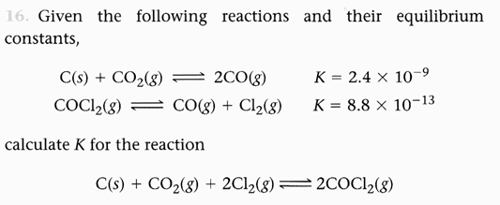
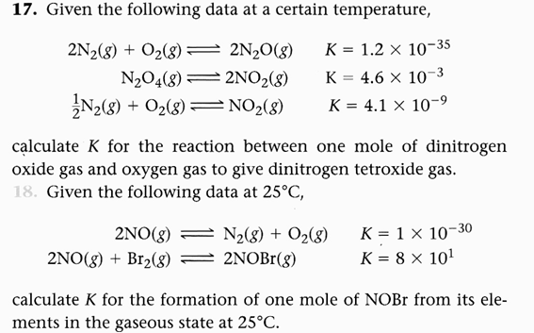
- At 1100 Kp = 0.25 for the reaction 2SO₂ (g) + O₂ (g) <----> 2SO₃ (g). What is the value of K_{c} at this temperature?

