Lattice energy problems
Which of the following statements is false
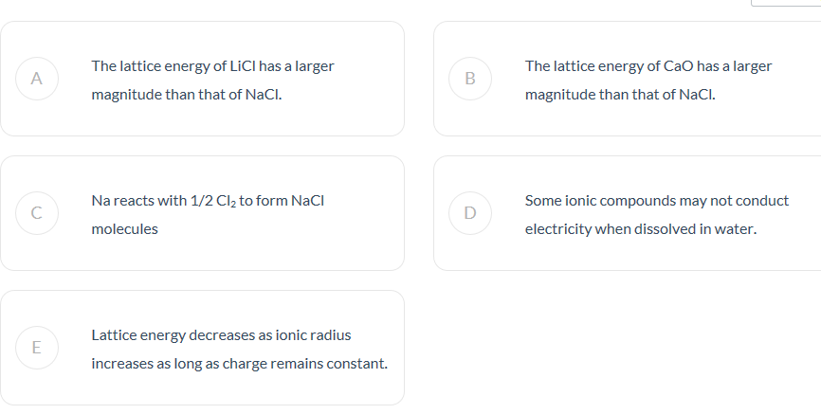
Rank the following compounds from lowest to highest lattice energy, and explain your reasoning
SrO, CsI, NaBr, MgO, BaS

Rank the following from highest to lowest lattice energy and explain your reasoning
NaCl, MgO, CaO, Al₂O₃
Rank the following from lowest to highest in terms of bond strength and explain your reasoning
BeCl₂, MgCl₂, SrCl₂, BaCl₂
Rank the following from highest to lowest melting point and explain yoru reasoning
KF, KBr, KCl, LiF, LiCl

