Kinematics Problems
- A person paces back and forth, producing the position vs time graph below. Is the velocity in each segment of the graph positive, negative, or zero? Verify your answers by calculating the velocity in each segment A, B, C, D.
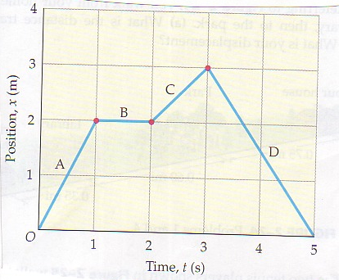
- Indicate the speed of the object in each segment of the position vs time graph below.
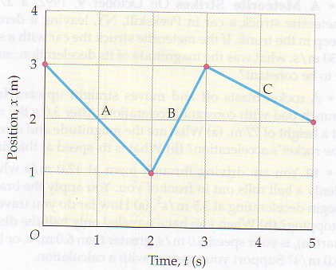

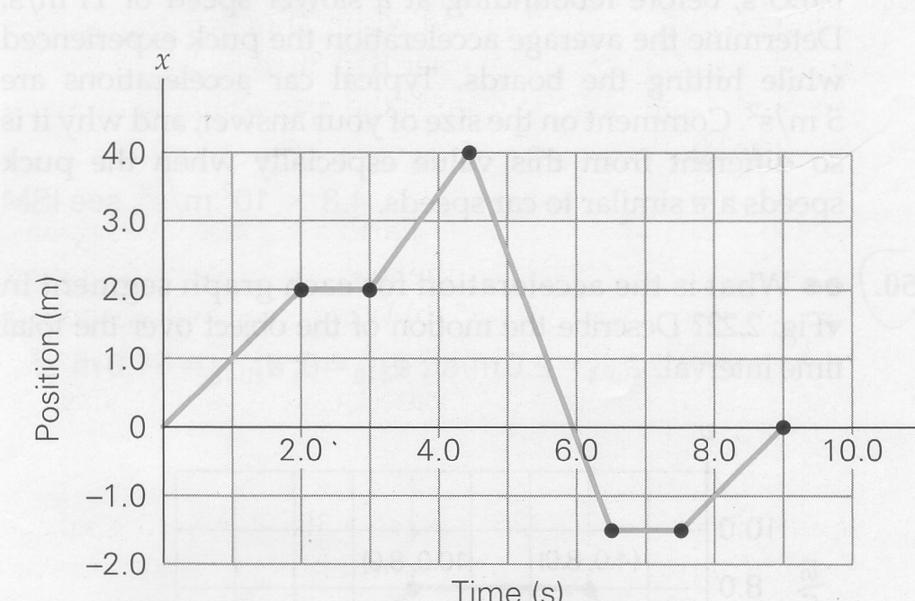
- In demonstrating a dance step, a person moves in one dimension, as shown in the figure above. What are the (a) average speed and (b) average velocity for each phase of motion? What is the average velocity for the interval between t = 4.5 and 9.0 s. What is the displacement of the person in the entire 9.0 s?
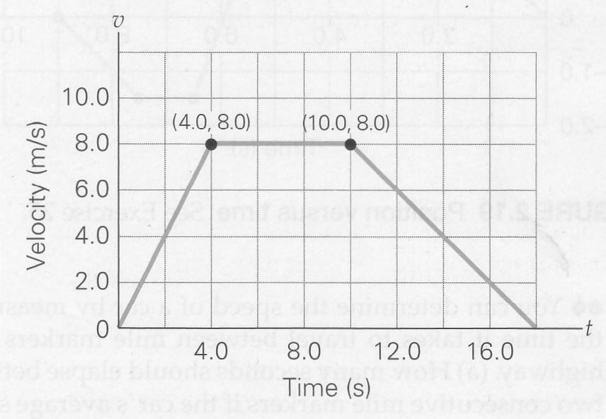
- What is the acceleration for each graph segment in the figure above? Describe the motion of the object over the total time interval. What is the total displacement of the object?
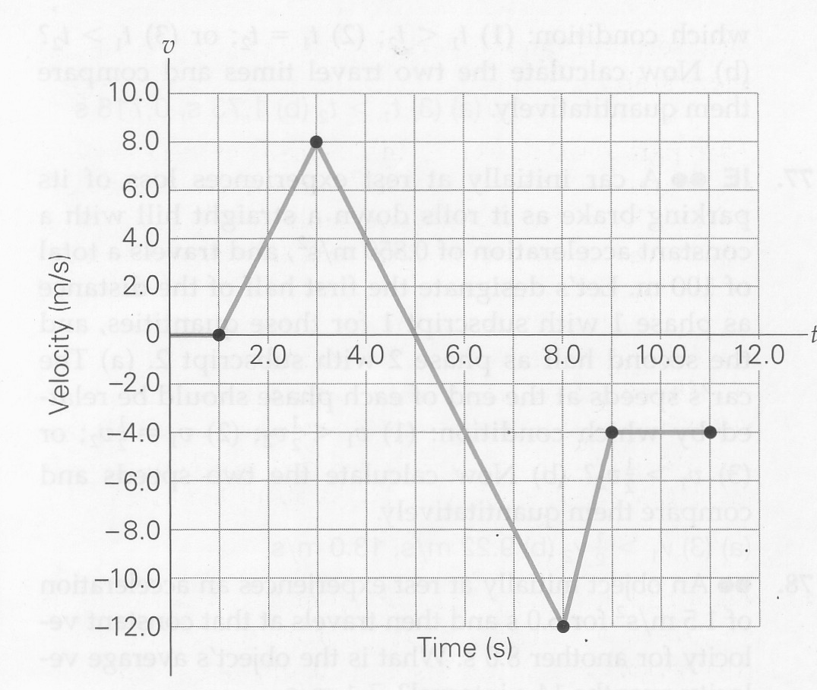
- The figure above shows a plot of velocity versus time for an object in linear motion. (a) Compute the acceleration for each phase of motion. Describe how the object moves during the last segment.
What is the displacement of the object over the entire 11 s interval? What is the average velocity over the interval?
What is happening at t = 3 and t = 8?

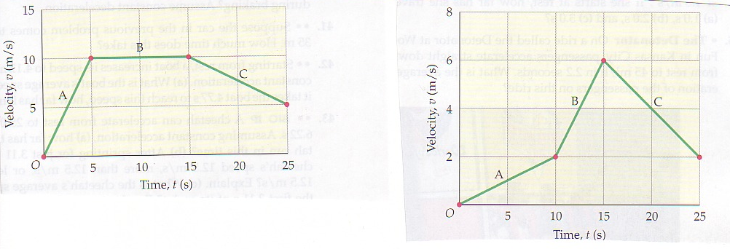
figure 1 Figure 2
- Figure 1 above shows a velocity vs time graph for a motorcycle. Find the average acceleration of the motorcycle during phase A, B, and C.
- Figure 2 shows the velocity vs time graph of a person moving on horseback. Find the displacement of the person during each segment A, B, and C.

