In class Static forces

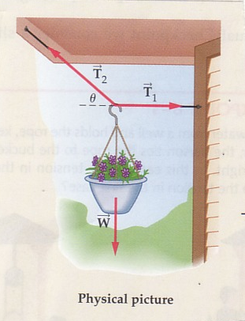 | A 6.20 kg pot of flowers is to be hung using two wires, one horizontally to a wall with tension T₁ and the other with tension T₂ sloping up at an angle Θ = 40.0 ° tied to an overhang. Find the tension in each wire.

FBD: Components:

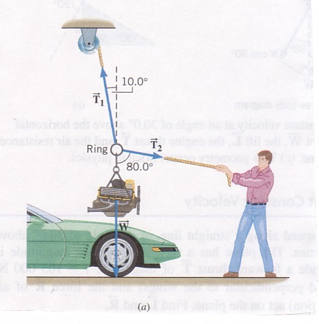 | An automobile engine with a mass of 320 kg is suspended from a ring by a cable. It is held in position by two ropes; one suspended from a pulley on the ceiling and one pulled by a mechanic as shown in the diagram. Determine the tension in each cable.

FBD: Component diagram:

