In class Static forces

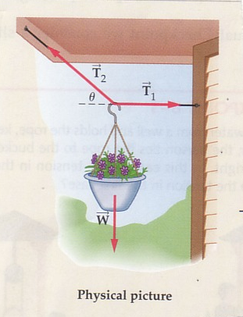 | A 6.20 kg pot of flowers is to be hung using two wires, one horizontally to a wall with tension T₁ and the other with tension T₂ sloping up at an angle Θ = 40.0 ° tied to an overhang. Find the tension in each wire.

FBD: Components:

∑ F_{x} = 0 = T₁ – T₂ cosΘ ∑ F_{y} = 0 = T₂ sin Θ – F_{w}
T₂ cos 40 = T₁ F_{w} = T₂ sin 40
0.766 T₂ = T₁ (6.2 )(9.8)/0.642 = T₂
0.766)(94.6) = T₁ = 72.5 N 94.6 = T₂

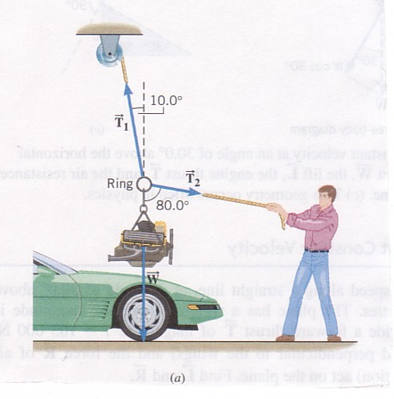 | An automobile engine with a mass of 320 kg is suspended from a ring by a cable. It is held in position by two ropes; one suspended from a pulley on the ceiling and one pulled by a mechanic as shown in the diagram. Determine the tension in each cable.

FBD: Component diagram:

∑ F_{x} = T₁ sin 10 – T₂ sin 80 = 0
T₁ sin 10/sin 80 = T₂
0.177 T₁ = T₂
∑ F_{y} = 0 = T₁ cos 10 – T₂ cos 80 – mg
(320 )(9.8) = 0.985 T₁ – (0.177T₁)(cos 80)
(320 )(9.8) = 0.985 T₁ – (0.177T₁)(cos 80)
3136 N = (0.985 – 0.031) T₁
3290 N = T₁ (0.177)(T₁) = T₂ = 582

