Harmonic Motion with graphs
- A butcher throws a cut of beef on spring scales which oscillates about the equilibrium with a period of T = 0.250 s. The amplitude of the vibration is A = 4.00 cm. Find:
a. frequency
b. the maximum acceleration
c. the maximum velocity
d. make graphs of position vs t, vel vs t and a vs t on the axes below. Label each axes appropriately as well as any minimum or maximum values.
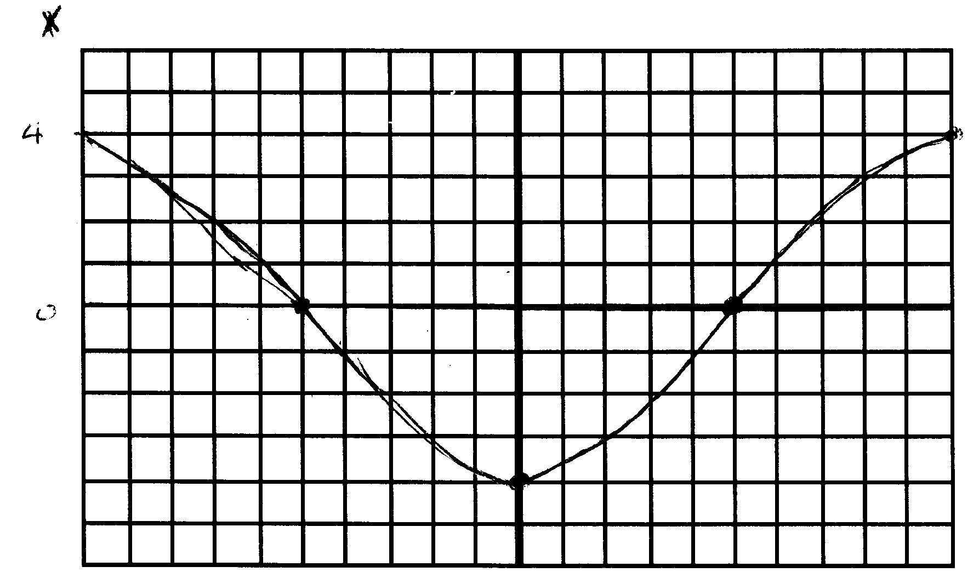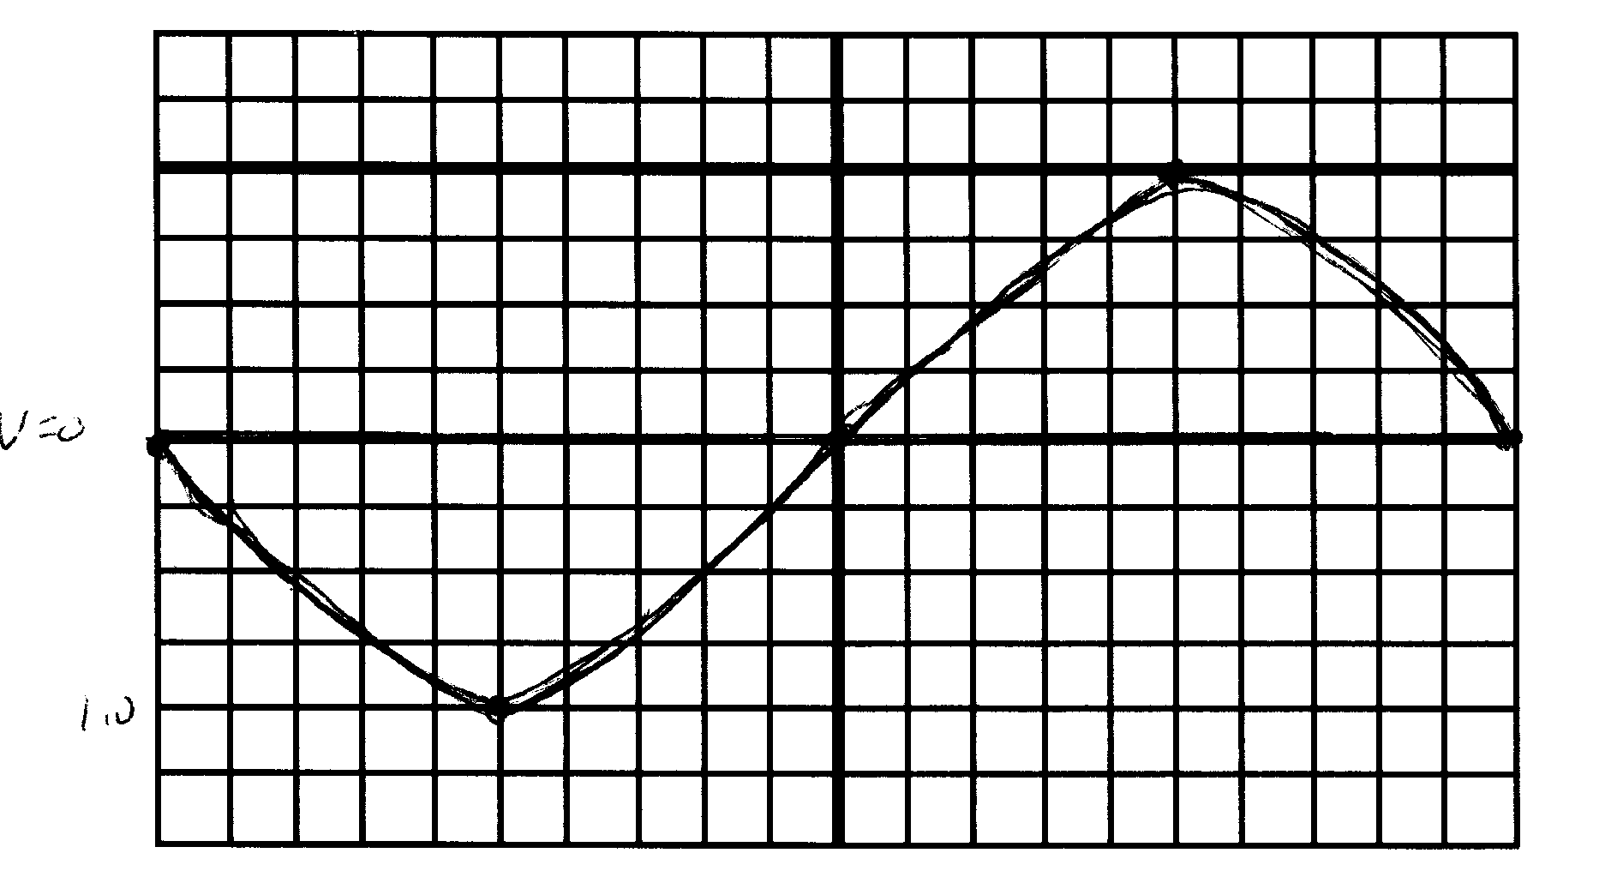
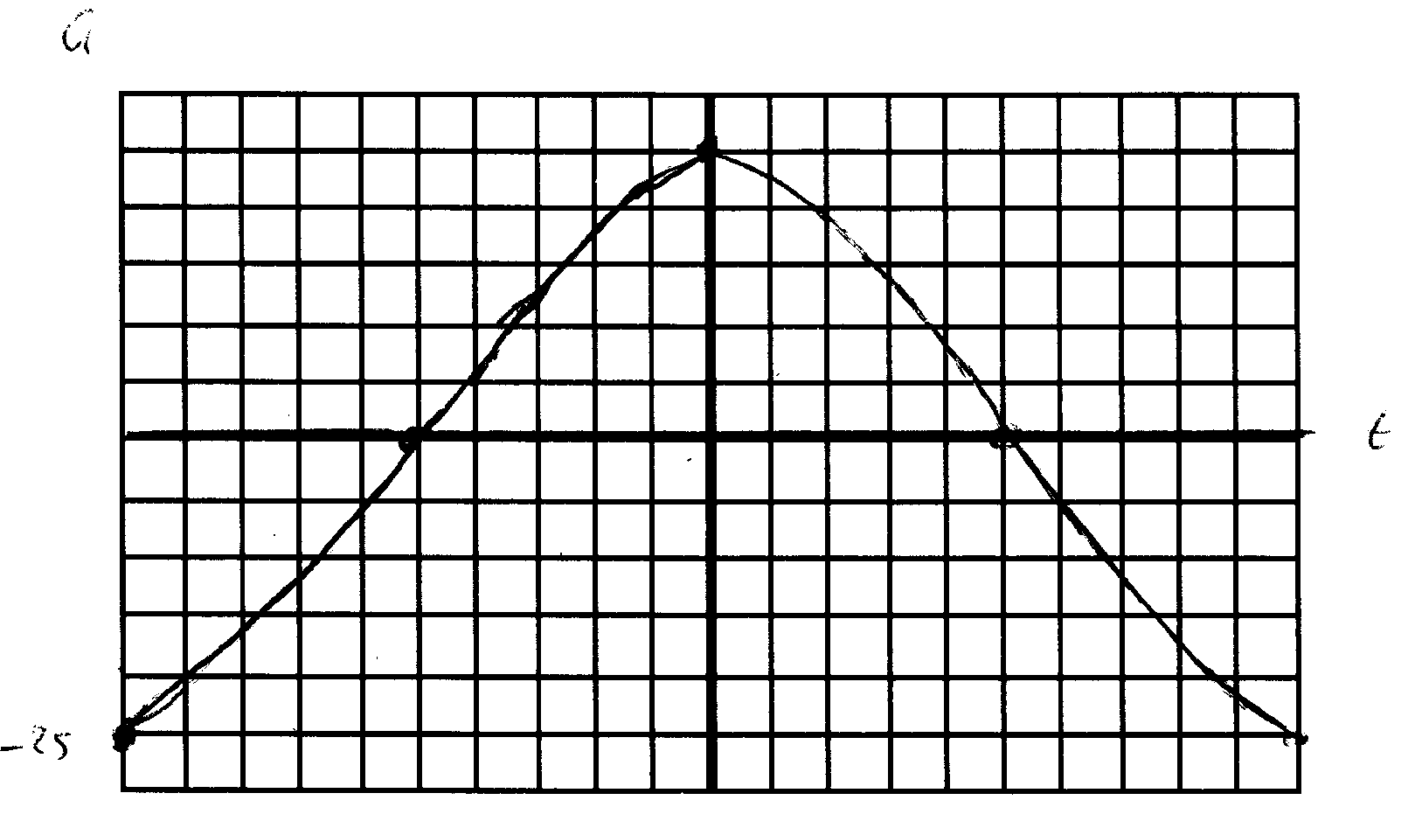

T = 0.250 so f = 4 Hz (1/0.25) ω = 2Πf = 25.1 rad/s
v_{max} = – ωA = – 25.1rad/s)(0.04 m) = – 1.00m/s
a_{max} = – ω²A = – 25.2 m/s²

- In a system undergoing simple harmonic motion, the maximum acceleration is -30.0 cm/s² for a displacement of 15.00 cm. What is the frequency and period of motion? What is the maximum velocity obtained by the mass?
Make graphs of position vs t, vel vs t and a vs t on the axes below. Label each axes appropriately as well as any minimum or maximum values.
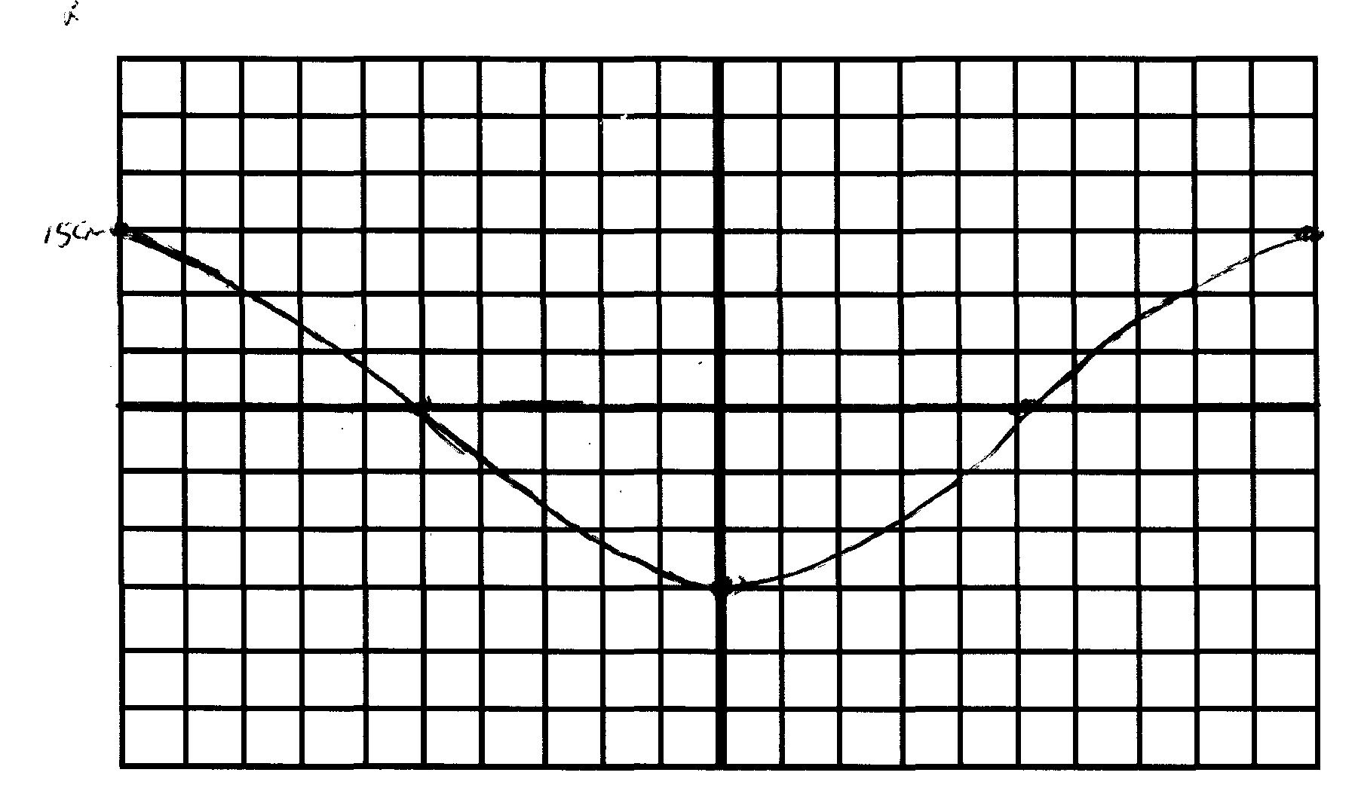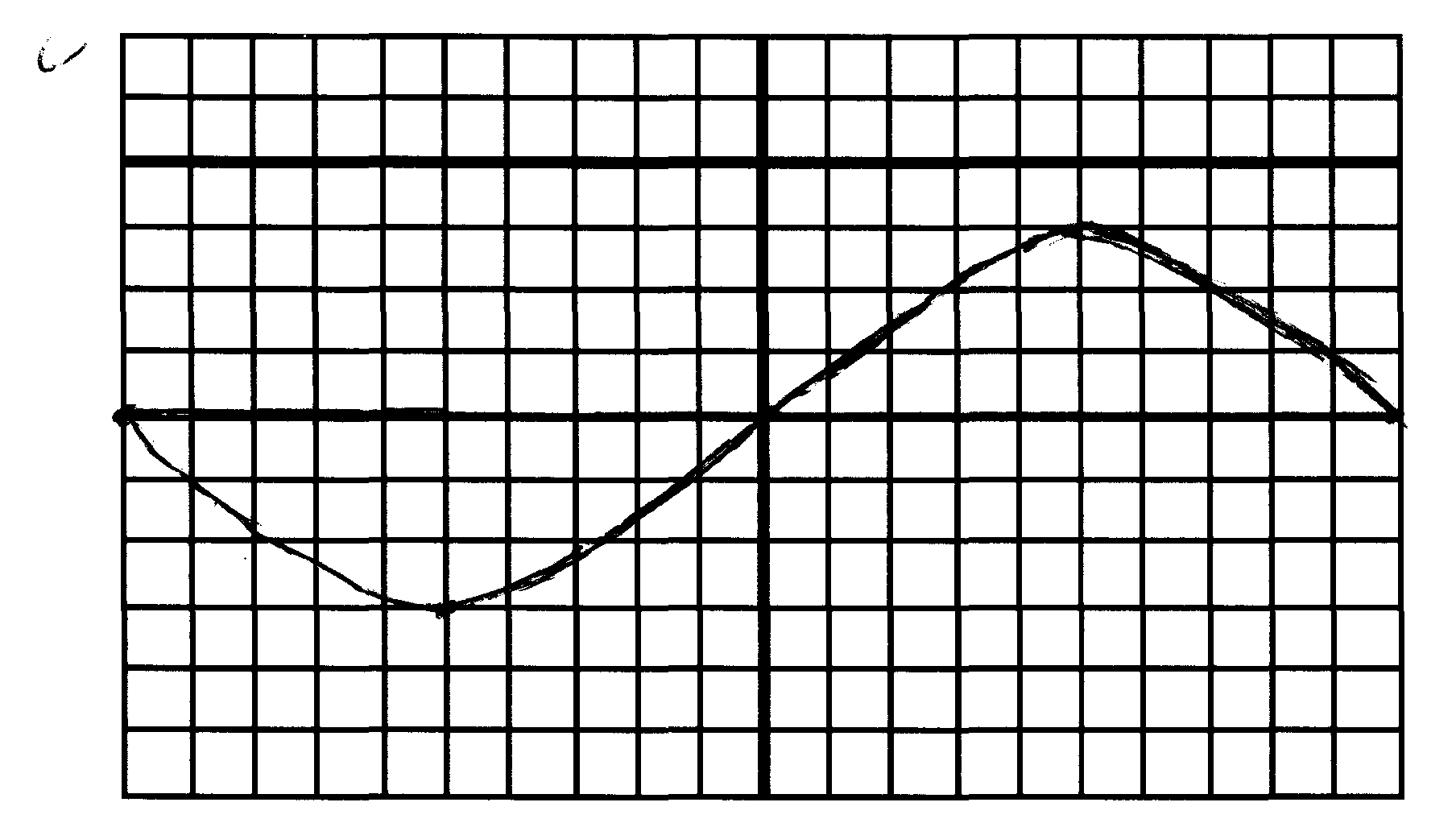

a_{max} = – ω²A ; – 30 cm/s² = ω² (15 cm) ω = 1.41rad/s
ω = 2Πf ; 1.41 = 2Πf = 1.41/Π = 0.0.224/s ; T = 1/0.224 = 4.46 s
v_{max} = – ωA = – 1.41 (0.15)= 0.21 m/s
a_{max =} 0.30 m/s²

- A classic Children’s toy consists of a wooden animal suspended from a spring. If you lift the toy up by 10 cm and let it go, it will gently bob up and down, completing five oscillations in 12 seconds. What is the frequency of oscillation? What is the maximum velocity? What is the maximum acceleration experienced by the mass?
Make graphs of position vs t, vel vs t and a vs t on the axes below. Label each axes appropriately as well as any minimum or maximum values.

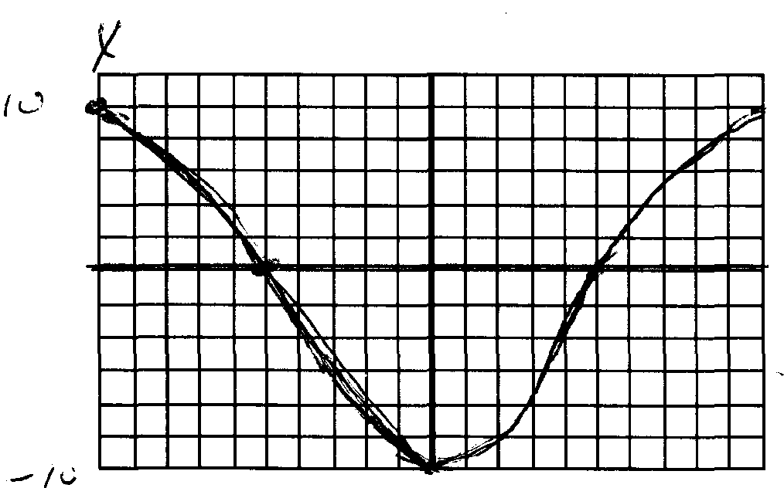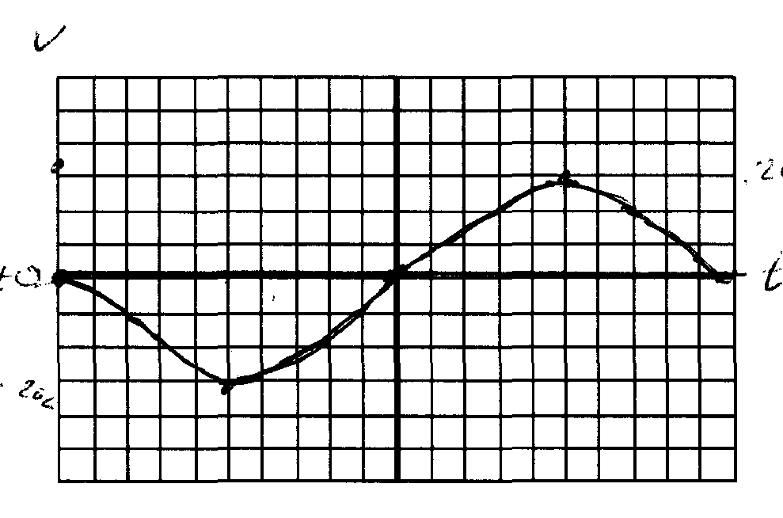

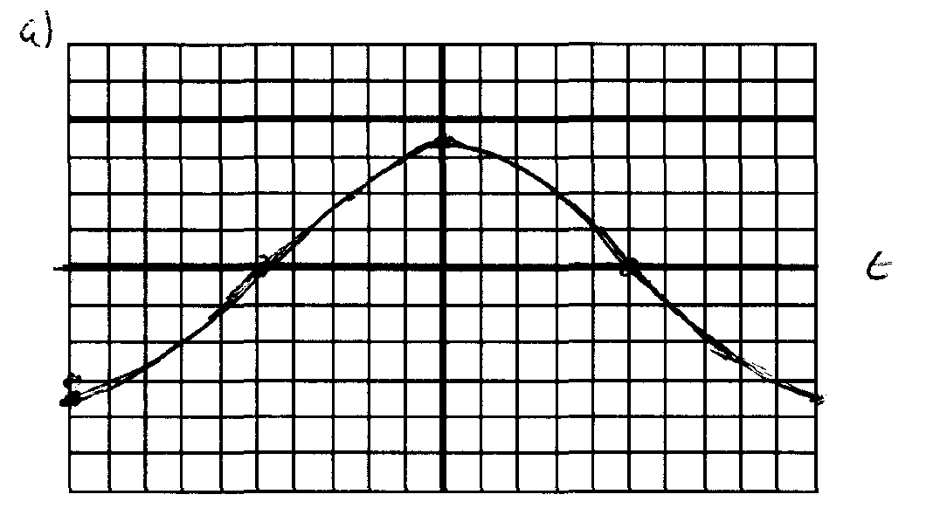
5cycles/12 s = 1 cycle/x s x = 2.4 s = T = 1/f f = 0.417/s
ω = 2Πf = 2Π(0.417) = 2.62 rad/s
v_{max} = – ωA = – 2.62((0.10m) = – 0.262 m/s
a_{max} = – ω²A = – 0.686 m/s²

