Harmonic motion graph problems
- A 0.075 kg mass is oscillating on a spring with a frequency of 10.0 Hz.
Determine the value for the spring constant k for this spring.
Given the graph of the position of the mass as a function of time shown below, determine the maximum velocity and maximum acceleration of the mass as it oscillates.
On the blank grids provided, produce graphs of the velocity and acceleration as functions of time, and on the third grid, produce a graph of both potential and kinetic energy of the mass if it is released from x = 20. cm at t = 0.
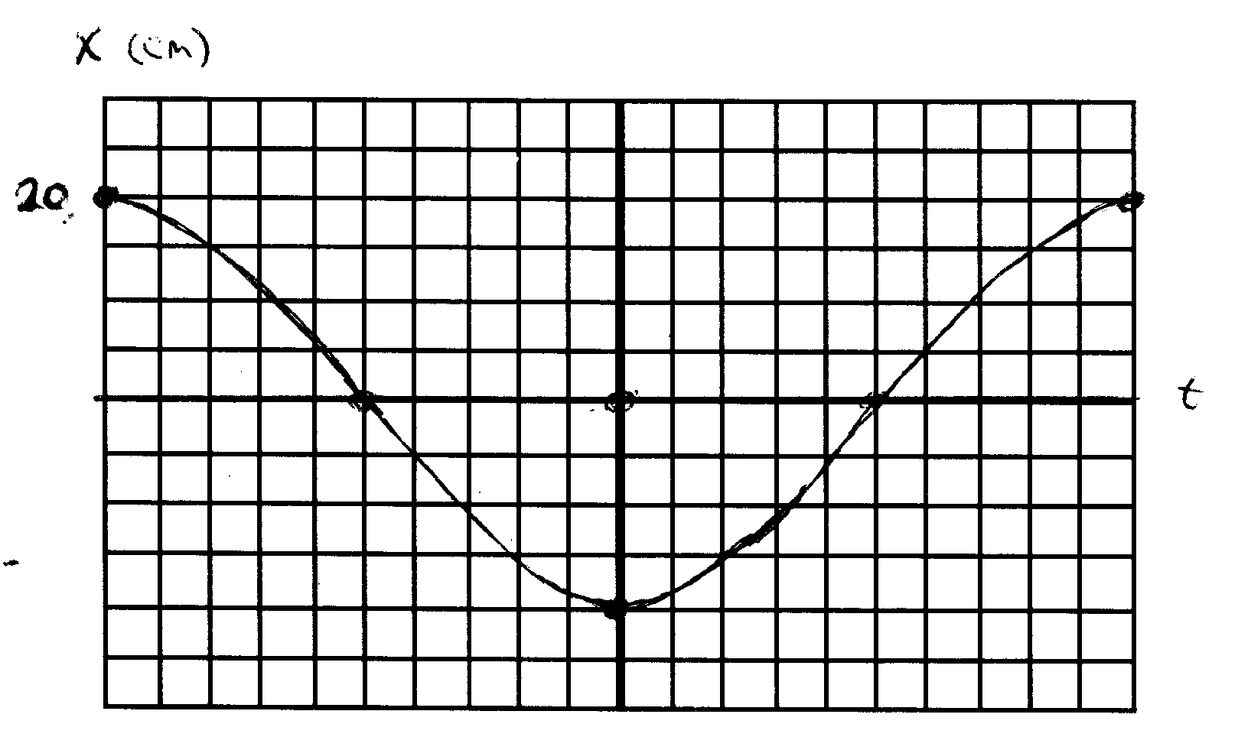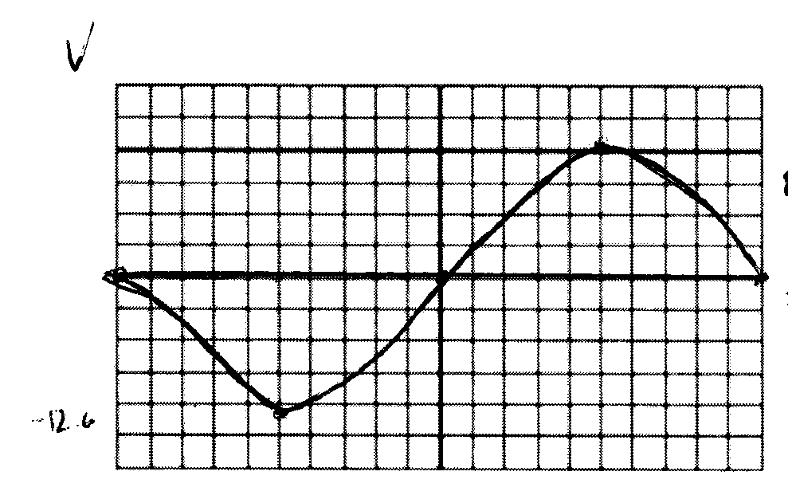

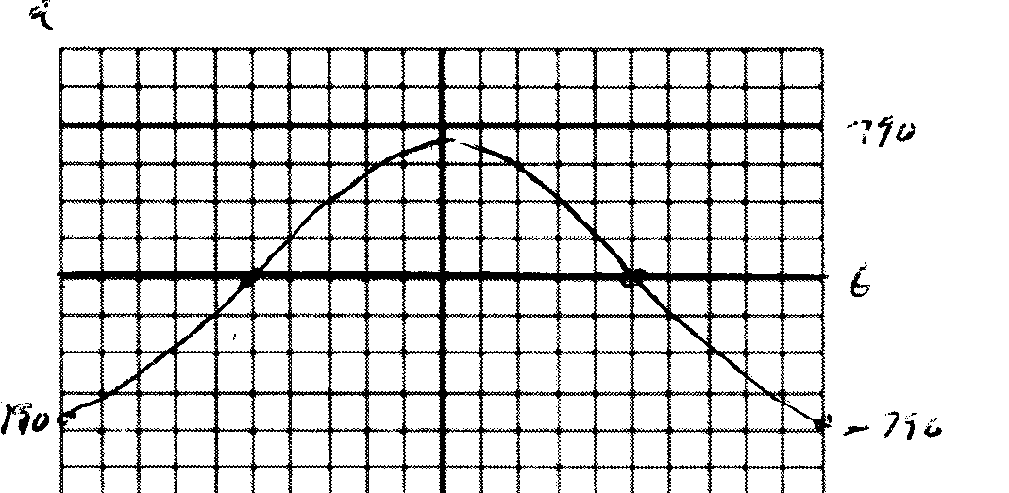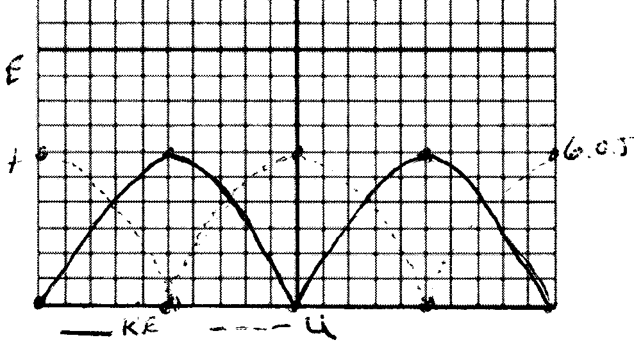

T = 1/f = 1/10 = 0.1 s = 2Π(m/k)^{1/2} k = 47.1 N/m
ω = 2Πf = 62.8 rad/s v_{max} = – ωA = – (62.8)(0.2) = – 12.6 m/s
a_{max} = – ω²A = – 790 m/s²

- Given the following graphs of the position and velocity of an oscillating mass as a function of time, determine the frequency of the oscillation. On the blank grids provided, produce a graph of the acceleration of the mass as a function of time, making sure to label any maximums or minimums correctly. On the second grid, produce a graph of the potential energy as a function of time given that the mass has a position
x = 0.15 m at t = 0 s.
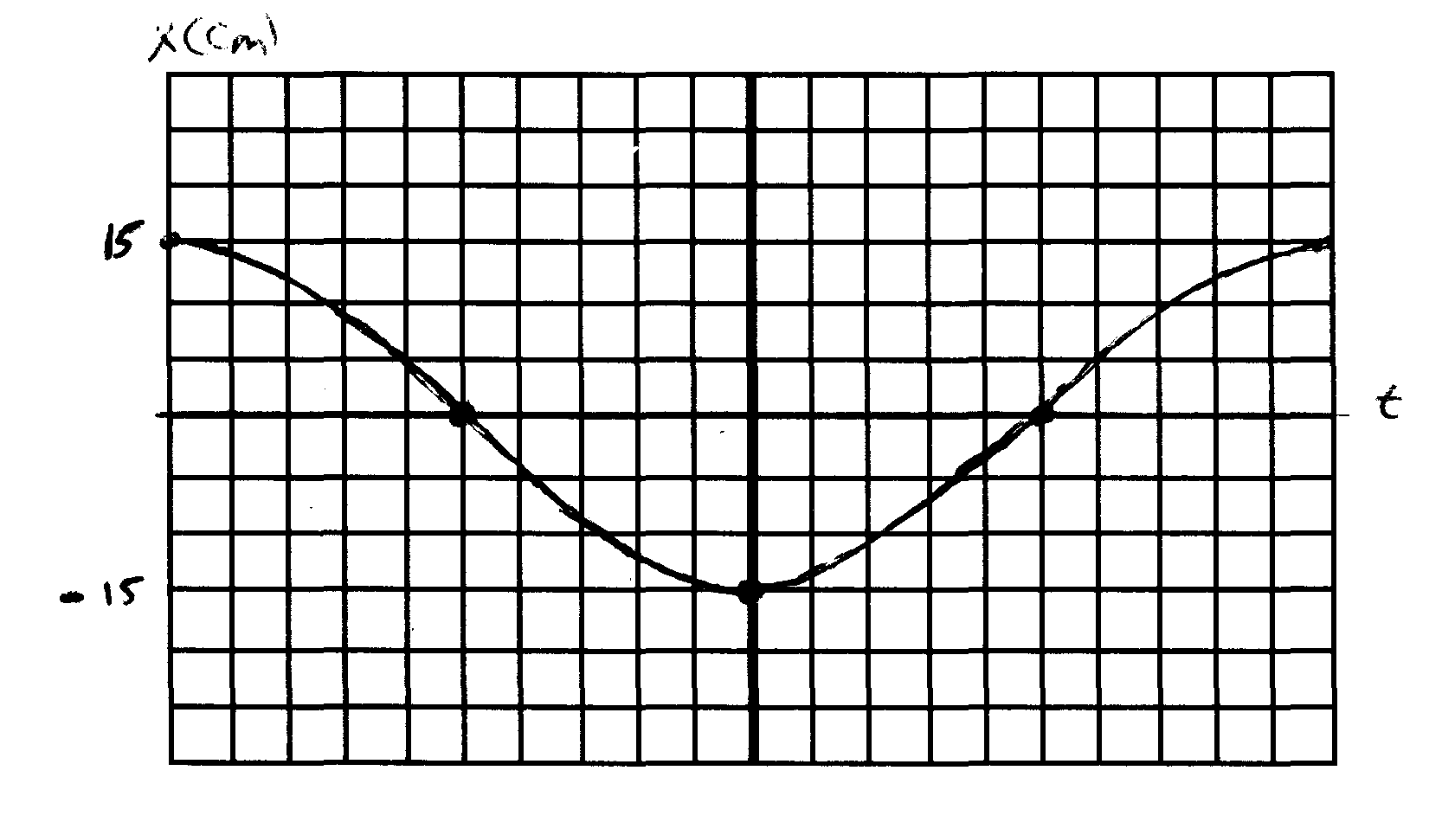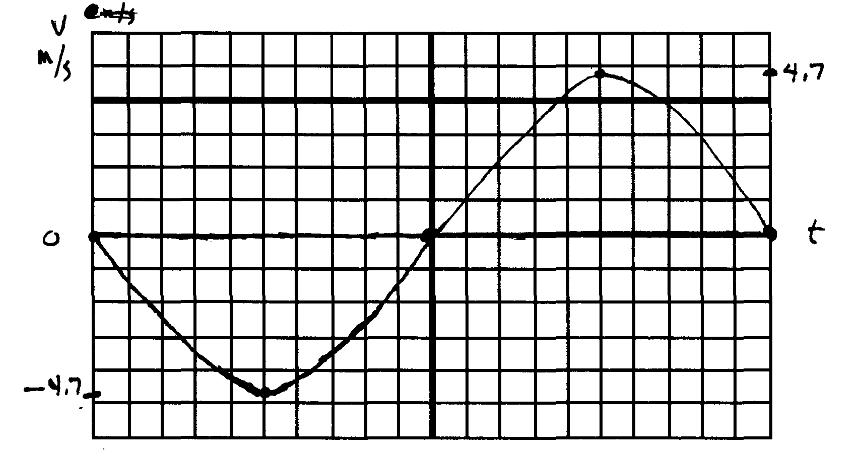
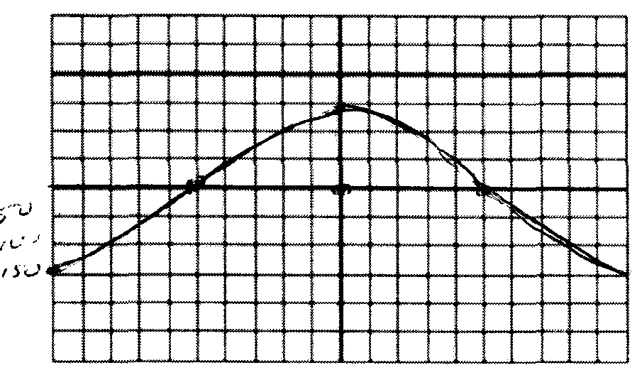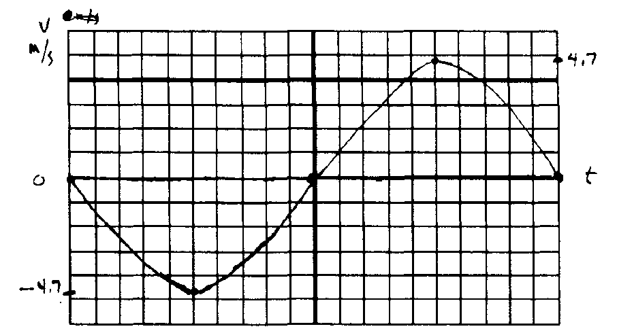

v_{max} = – ω A; – 4.7 m/s = ω(0.15) ω = 31.1 rad/s = 2Πf; f = 4.98 Hz
a_{max} = – ω²A = – 147 m/s²

