Harmonic Motion
The simplest example of harmonic motion is a rotating disc, like a record. We will use this to develop equations to describe position, velocity and acceleration of an object undergoing simple harmonic motion.
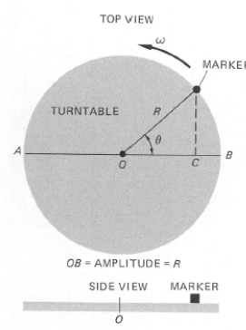 | A marker at the edge of the record and trace its horizontal motion.  Max distance = Amplitude  Will be from R to – R  Horizontal position =

ϴ = ωt so x = A cos θ = A cos ω t or A cos (2πf)
Velocity
The velocity of the marker will be along the tangent line, so the x component of velocity will be the x component of that v_{tan}.
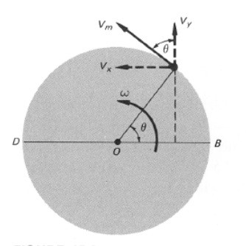 | Here, that x component is the sin of the v_{tan} sin ϴ and it is in the negative direction.  v_{x} =

v_{x} = – v_{tan} sin ϴ = – ω A sin (ω t) = – ω A sin (2π f)
Acceleration
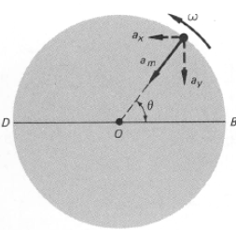 | Acceleration is along radius  a_{c} = (v_{tan})²/R

a_{x} = – ω² A cos (ω t) = – ω² A cos (2π f)
a_{x} = – ω² A cos θ = – ω² x (A cosϴ = x)

Motion Graphs
Think about a mass on a spring oscillating up and down or horizontally.
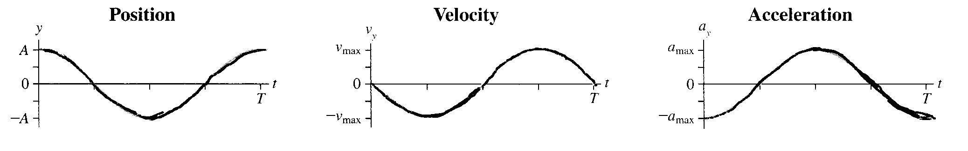
Θ = ω t = 2πnf (t) ω = 2πn n is revolutions
x = A cos ω t v_{x} = – ω A sin ω t a_{x} = – ω² A cos ω t
x = A cos θ v_{x} = – ω A sin θ a_{x} = – ω² A cos θ
x_{max} = A v_{max} = – ω A a_{max} = – ω² A
x_{max} when θ is v_{max} when θ is a_{max} when θ is
0, π or n π (n -1/2)π (odd ½’s) 0, π, or n π

The spring has a restorative force and by Hooke’s Law

Newton’s 2nd law

ma = - kx = m (– ω²x) = – kx ω² = m/k

