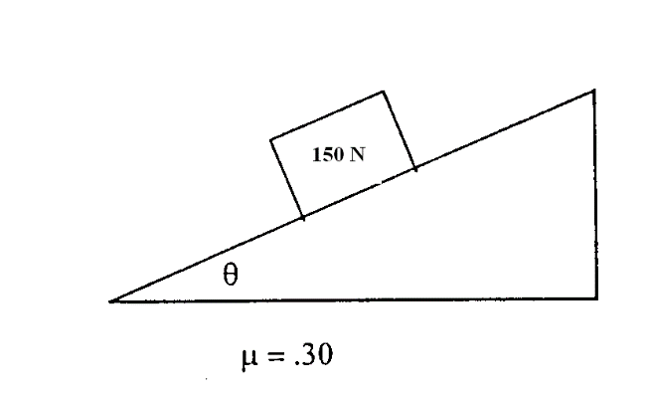

1. A 150 N block sits on an inclined plane, as shown above. The coefficient of static friction between the block and incline is 0.30.
   1. On the dot below that represents the block, draw and label the forces (not components) that act on the block.

 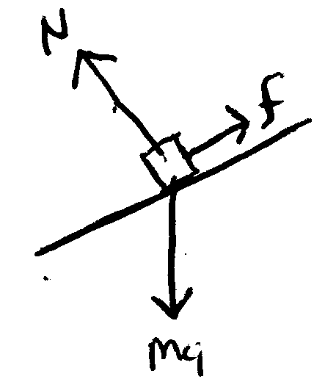

* 1. Is the normal force on the block greater than, less than, or equal to the block’s weight?
     + Greater than
     + Less than Less than the weight. It is the supporting force acting opposite of the component of weight that is acting INTO the plan (perpendicular) and is calculate as

mg cos Θ.is increased. Since cosθ is always between 0 and 1, it must be getting smaller as Θ approaches 90 and the amount of force required to support the block gets amaller as Θ

* + - Equal to

*Justification:*

1. The angle of the plane is increased slowly until the crate begins to slide at constant velocity down the incline. Calculate the angle of the plane from the horizontal, ** If you need to draw anything other than what you have shown in part (a) to assist in your solution, use the space below. Do NOT add anything to the figure in part (a).

ΣF = 0 = N – mg cosθ so that N = mg cos Θ

ΣFx = 0 = mg sinΘ – μMg cosΘ

μ mg cos Θ = mg sin Θ

μ = sin Θ /cos Θ = tan Θ

at constant velocity, μ = tan Θ as shown above. (since mg cancels from both terms)

μ = 0.30, so tan Θ = 0.3 and Θ = arctan 0.3 = 16.7˚

1. Calculate the normal force on the block. If you need to draw anything other than what you have shown in part (a) to assist in your solution, use the space below. Do NOT add anything to the figure in part (a).

ΣF = 0 = N – mg cosθ so that N = mg cos Θ

N = 150 cos 16.7 = 143.6 N = N force

A student of mass *m* stands on a platform scale in an elevator in a tall building. The positive direction for all vector quantities is upward.

1. Draw a free body diagram showing and labeling all the forces acting on the student who is represented by the dot below.

 Normal Force straight up and weight straight down

1. Derive an expression for the reading on the scale in terms of the acceleration, *a,* of the elevator, the mass *m* of the student, and fundamental constants.

Assume acceleration upward so

SF = ma = N – mg so that ma + mg = N

An inspector provides the student with the following graph showing the acceleration, *a,* of the elevator as a function of time *t*.

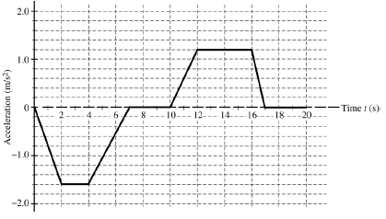

1. During which time interval (s) is the force exerted by the platform scale on the student equal to the actual weight of the student?

If a =0 then N = mg, so at t = 0 or before mg = N; t = 7 – 10 and t = 17- 20

1. During what time interval (s) is the force exerted by the platform on the student at its maximum value?

If a up, then N = ma + mg if a is down the N = mg – ma, so max N force (scale reading) would be at max positive a which is when a = 1.2 m/s/s, so t = 12 – 16