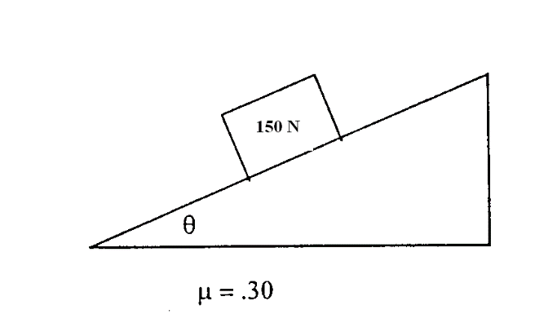

1. A 150 N block sits on an inclined plane, as shown above. The coefficient of static friction between the block and incline is 0.30.
   1. On the dot below that represents the block, draw and label the forces (not components) that act on the block.



* 1. Is the normal force on the block greater than, less than, or equal to the block’s weight?
     + Greater than
     + Less than
     + Equal to

*Justification:*

1. The angle of the plane is increased slowly until the crate begins to slide at constant velocity down the incline. Calculate the angle of the plane from the horizontal, ** If you need to draw anything other than what you have shown in part (a) to assist in your solution, use the space below. Do NOT add anything to the figure in part (a).
2. Calculate the normal force on the block. If you need to draw anything other than what you have shown in part (a) to assist in your solution, use the space below. Do NOT add anything to the figure in part (a).

A student of mass *m* stands on a platform scale in an elevator in a tall building. The positive direction for all vector quantities is upward.

1. Draw a free body diagram showing and labeling all the forces acting on the student who is represented by the dot below.



1. Derive an expression for the reading on the scale in terms of the acceleration, *a,* of the elevator, the mass *m* of the student, and fundamental constants.

An inspector provides the student with the following graph showing the acceleration, *a,* of the elevator as a function of time *t*.

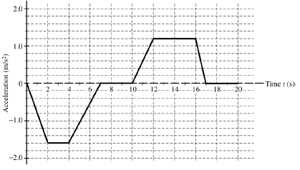

1. During which time interval (s) is the force exerted by the platform scale on the student equal to the actual weight of the student?
2. During what time interval (s) is the force exerted by the platform on the student at its maximum value?