Graphing kinematics discussion notes
- Give a qualitative description of the motion depicted by the position vs time graphs below.

- Give a qualitative description of the motion depicted in the v vs. t graphs below.
- x vs t v vs t a vs t
Slope will give us a method of moving from one graph and the next.
- Produce x vs t; v vs t and a vs t graphs for motion of the following object as it rolls down the incline.
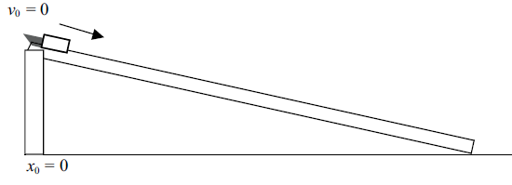
(you need to sketch your own sets of axes)
- Or for this situation
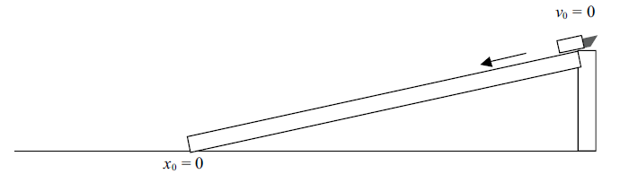
- Or in this case where the cart is pushed up the incline where it stops and comes back down
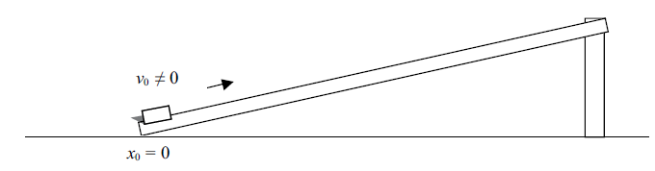
- And finally where the cart rolls down the ramp and continues to roll on the flat ground.
