Free Response UCM

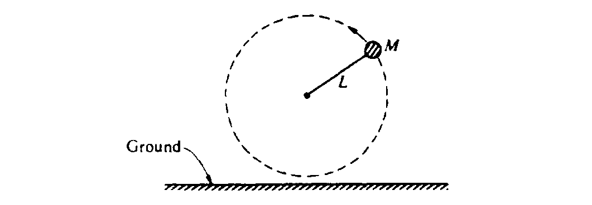
1984B1. A ball of mass M attached to a string of length L moves in a circle in a vertical plane as shown above. At the top of the circular path, the tension in the string is twice the weight of the ball. At the bottom, the ball just clears the ground. Air resistance is negligible. Express all answers in terms of M, L, and g.
a. Determine the magnitude and direction of the net force on the ball when it is at the top.
b. Determine the speed v_{o} of the ball at the top.

The string is then cut when the ball is at the top.
c. Determine the time it takes the ball to reach the ground.
d. Determine the horizontal distance the ball travels before hitting the ground

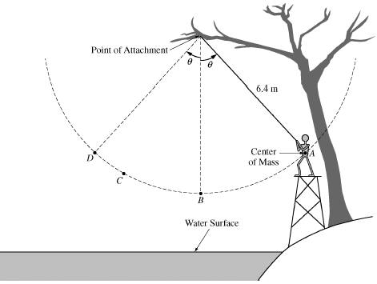
Starting from rest at point A, a 50 kg person swings along a circular arc from a rope attached to a tree branch over a lake, as shown in the figure above. Point D is at the same height as point A. The distance from the point of attachment to the center of mass of the person is 6.4 m. Ignore air resistance and the mass and elasticity of the rope.
- The person swings two times, each time letting go of the rope at a different point.
- On the first swing, the person lets go when first arriving at point C. Draw a solid line to represent the trajectory of the center of mass after the person releases the rope.
ii. On the second swing, the person lets go of the rope at point D. Draw a dashed line to represent the trajectory of the center of mass after the person releases the rope.
- Suppose the person swings a third time from the rope. Find the tension in the rope when the person is located at Point B if they are travelling at 5.77 m/s when they pass through point B
- On their fourth swing, they release the rope when they are at Point B, which is 2.4 m above the water. Determine the horizontal distance below point B that they will land in the water.

