Free body diagrams
Drawing free body diagrams allows us to determine and organize all the forces that are acting on an object at a particular time. To draw free body diagrams (FBD) there is a simple method of steps you can follow.
- Draw a circle around the object. Anywhere the Universe physically touches the object, there must be a force.
- Identify any forces on the object that act at a distance on the object. (Gravitational force is the only one you currently know. It is the force that Earth puts on an object to pull it toward Earth.)
- Draw a vector on the object and label it appropriately for each identified force.
- Draw the Gravitational Force, we call it weight, F_{w} or W.
- These force vectors should be proportional to each other, with larger forces being represented by longer arrows.
Example: A crate sits on the rough ground and is pulled by a worker to the right with a force of 75 N. There is a force due to friction of 40 N acting on the crate as the worker pulls it.
The FBD of this situation is pictured below.
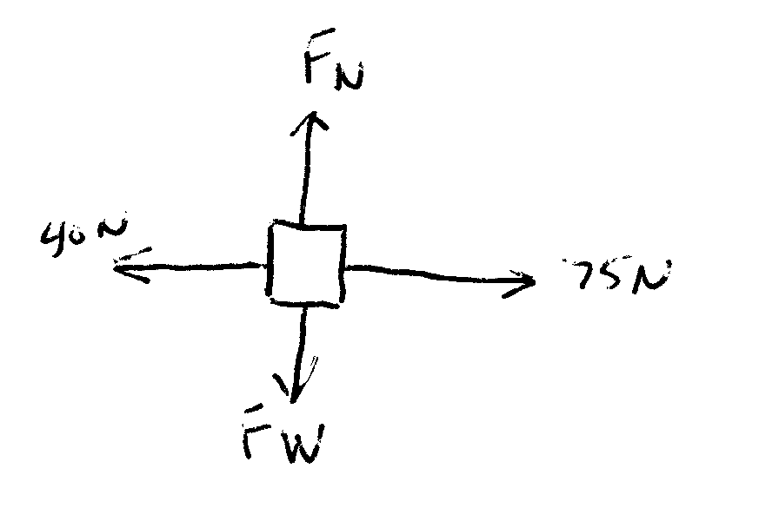
The upward force of the ground onto the crate is a supporting force called the Normal force. NORMAL FORCE IS ALWAYS PERPENDICULAR TO THE SURFACE THE OBJECT SITS ON OR AGAINST. Normal force is only present when an object sits against or on a surface. It is what keeps the crate from burrowing into the ground. The pull of 75 N to the right and the friction of 40 N to the left are shown with proportional vectors.

Forces applied using strings, ropes or cords are called Tension, and are labeled T
