Finding Components of Vectors that are not parallel to either the X or Y axis

We looked at how to resolve perpendicular vectors to obtain one result, the resultant vector, V_{r}. This handout looks at the opposite process, determining which two perpendicular vectors make up any vector that is not along or parallel to one of the axes. Because we search for perpendicular component vectors, we will always have a right triangle and can use trigonometric identities to solve for lengths of the component vectors, V_{x} and V_{y}.
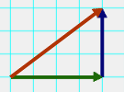
In the example above, the red vector is V, the green vector is its x component, V_{x} and the blue vector is its y component, V_{y.} Let’s say that V = 15 m/s at 37°.
To find the components we will use the cos and sin functions.
For the V_{x} which is the side adjacent to the 37° angle Θ we will use
cos Θ = A/H or here cos Θ = V_{x}/V so that V cos Θ = V_{x} = 12.0 m/s
for the blue vector, V_{y} we would use sin Θ = V_{y}/V so that V sin Θ = 9.0 m/s
Finding components is most useful when adding several vectors together that may or may not run parallel to or along one of the principle axes (x or y). See the example below.

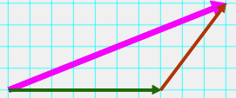
In this example we have a plane flying 700 miles east (The green vector V₁). And then turning and flying at 56.1° (as measured from the x axis) and flying for 500 miles V₂ the red vector. The purple vector represents the Resultant Displacement, V_{r.}
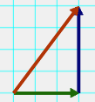
Hopefully in the small diagram above, you can see how the green and blue components of the red vector, V₂, align along the s and y axes. To find these components of vector 2, we must use trig and the method before.
V_{2x} (x component of vector 2) = cos 56.1 (500) = 279 mi
V_{y2} (y component of vector 2) = sin 56.1 (500) = 415 mi
A table often helps us to resolve these type problems
Vector | X component  V (cos Θ) | Y component  V (sin Θ)
700 mi East | 700 mi x | 0.0 mi y
500 @ 56.1 ° | Cos 56.1)(500 mi) =  279 mi | Sin 56.1 )(500) = 415 mi
Resultant V_{r} | 979 mi E | 415 mi N
1063 mi @ 23° From Pythagorean theorem and tan⁻¹
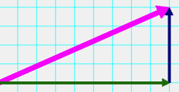
You should see how these two x and y vectors now add up to give us the same overall resultant we had initially. The green x vector above is all of V₁ plus the 279 mile x part of V₂. The blue vector is the entire Northern part of vector V₂

