Find Equilibrium concentrations given K
- At 100°C, K_{c} = 0.135 for the following reaction: 3 H₂ (g) + N₂ (g) 2 NH₃ g). In a reaction mixture at equilibrium [NH₃] = 0.030 M and [N₂] = 0.50 M. Determine the [H₂] in the mixture.
- Assume that the flask in the question above has a volume of 1.0 L. Determine the total pressure in the flask at equilibrium as well as the partial pressure of each gas and K_{p} for the reaction.
- 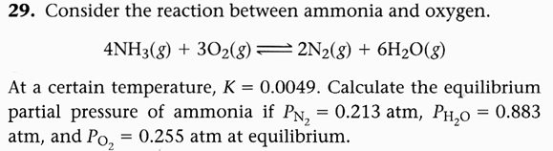
- 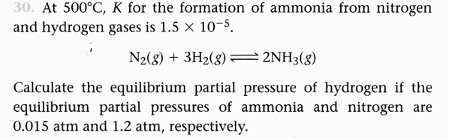
- 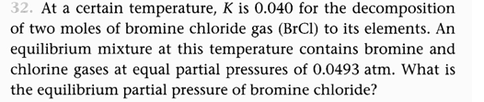
- The equilibrium constant for the reaction H₂ + F₂ <----> 2HF has the value K = 2100 at a particular temperature. When analyzed at equilibrium the concentrations of H₂ and F₂ are found to be 0.0021 M. What is the concentration of HF at equilibrium?

