Energy Conservation Problems
- A 25.9 kg crate is pulled to a height of 15.2 m by a rope over a frictionless pulley. If the crate is dropped what will the velocity of the crate be when it is 10.0 m above the ground? What about when it hits the ground?
- A 3.00 kg ball rolls up a 45.0 frictionless incline. If the ball is moving at 5.75 m/s at the bottom, a) find its initial linear kinetic energy, b) how far up the incline will it roll before coming to rest?
- A 6.75 kg package slides down a circular chute that is 5.0 m above the ground. Its velocity is 7.5 m/s at the bottom, how much energy is lost to friction?
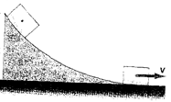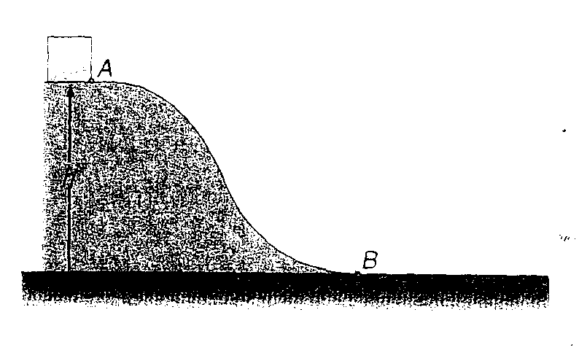
- If the object above slides to a stop in a distance of 3.0 m when it is on the flat portion of the chute, what is the coefficient of friction between the chute and the package?
- A 5.0 kg body is placed at the top of the track, position A, 2.00 m above the base of the track, as shown in the diagram on the right above. (a) Find the total energy of the block. (b) The block is allowed to slide from rest down the frictionless track to position B. Find the velocity of the block at position B. (c) The block moves over the level rough surface where μ_{k} = 0.30. How far will the block move before coming to rest?
- A 1.50 kg block moves along a smooth horizontal surface at 2.00 m/s. The horizontal surface is at a height h₀ above the ground. The block then slides down a rough hill, 20.0 m long, that makes and angle of 30.0° with the horizontal. The coefficient of kinetic friction between the block and the hill is 0.600. How far down the ramp will the block slide before it comes to rest?
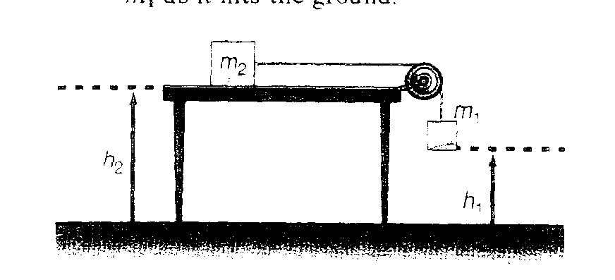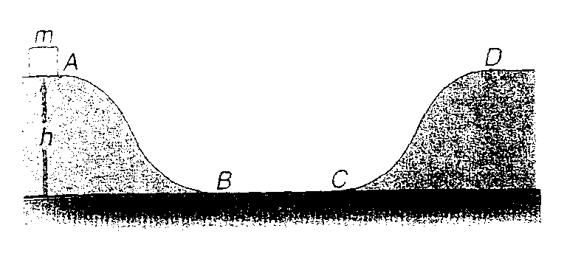
- A 2.00 kg block is placed at the position A on the track that is 3.00 m above the ground. Paths A-B and C-D are frictionless while section B-C is rough with a coefficient of friction of 0.350 and length 1.50 m. (a) Find the total energy of the block at position A. (b) the velocity of the block at point B, (c) the energy lost along path B-C, and (d) how high the block rises along path C-D.
- A 20.0 kg mass is at rest on a rough horizontal surface. It is then accelerated by a net constant force of 8.6 N. After the mass has moved 1.5 m from rest, the force is removed and the mass comes to rest in 2.00m. Determine the coefficient of kinetic friction using conservation of energy principles.

