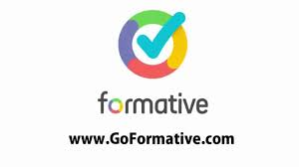
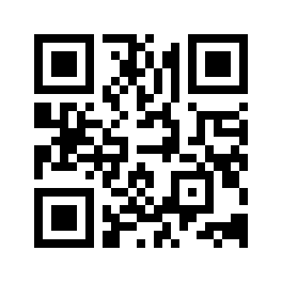

- Navigate to https://goformative.com/ or scan the QR code

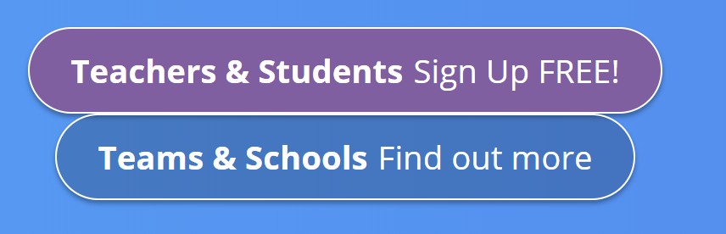
- Click on the Teachers & Students Sign Up FREE tab

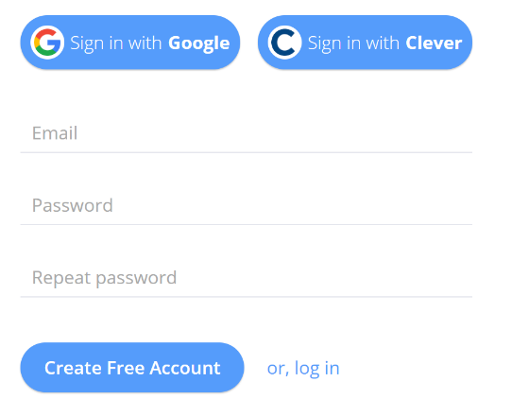
- Create your free account by either Signing in with Google or entering your email and creating a password.

- Click on Create Free Account

- Log in! You should see your personal dashboard.

THE TABS
Formatives
- Lists all the formatives you’ve created.
- Shows the number of students that have taken each formative.
- Links to creating NEW formatives.
- Allows you to organize your formatives into folders.
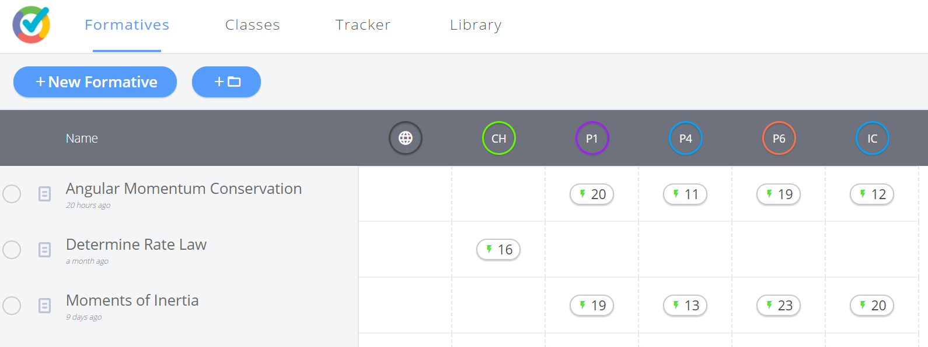

Classes
- Lists all the classes you’ve created
- Shows the number of students who have enrolled in each class.
- Displays the Class Code that students will use to join each class.
- Links to creating new classes as well as adding students to existing classes.
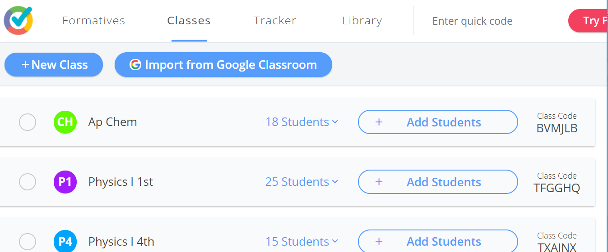

Tracker
- Shows results for students - across all or one select Formative.
- Allows you to monitor all your students or just a particular class using the students tab.
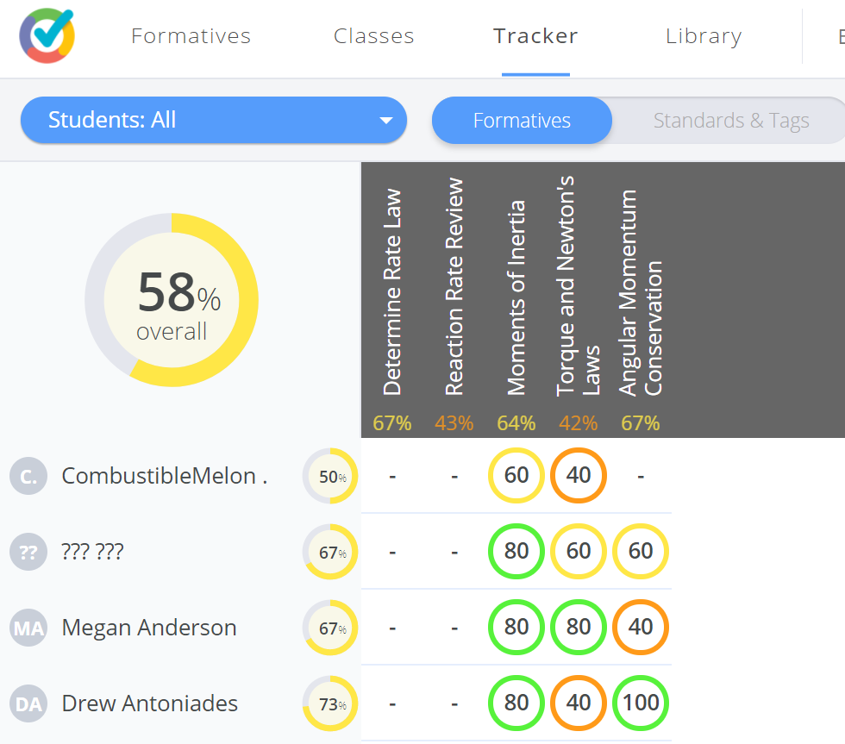
- Has the ability to track learning by standard.

Library
- Allows you to search hundreds of saved formatives - by grade-level and/or subject.
- Click on the blue plus sign on the right of the formative you want to add to your list.
