Creating and Assigning Formatives
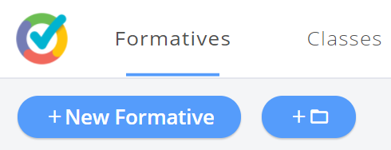
- +New Formative –
- Opens a new window for you to create your own Formative!

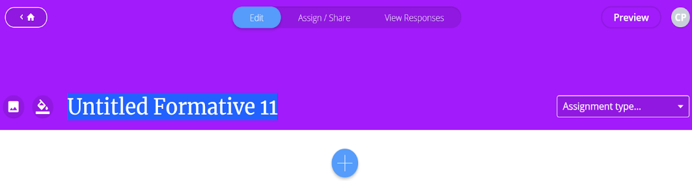
- The blue “+” icon
- Gives you options to add content and questions to your formative.
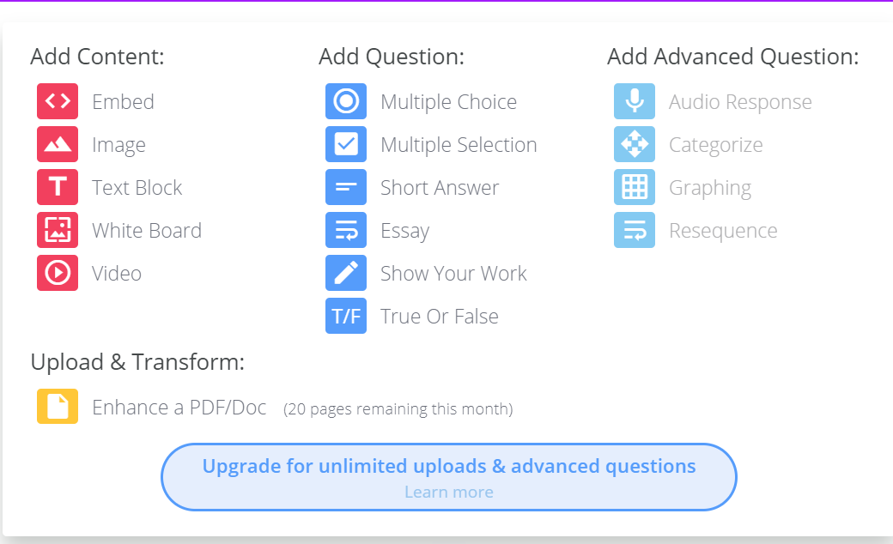

- Add Content – red icons
- Options to add images, video, etc.
- Add Question – blue icons
- Various question type options
Let’s Try It!
- Start with an image.
- A quick and easy way to add an image – Use your snipping tool.
- Use any saved image.
- Click the red image icon and you will see this screen below.
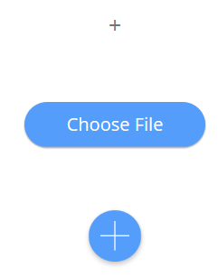
- Select Choose File to navigate to where you saved the image to insert it.
- Below is an example of what appears after you insert the image.

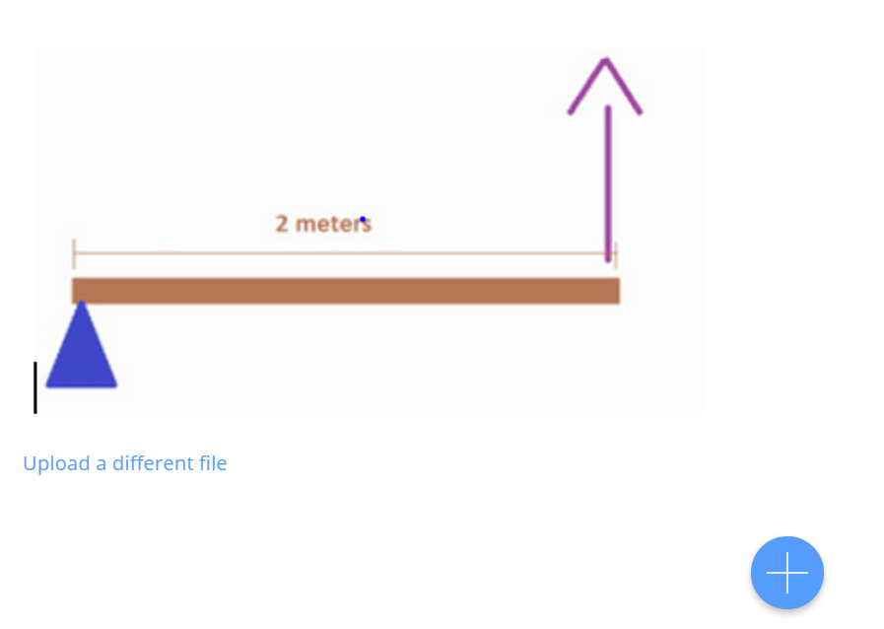
- Click on the blue “+” sign to add a question about this image.

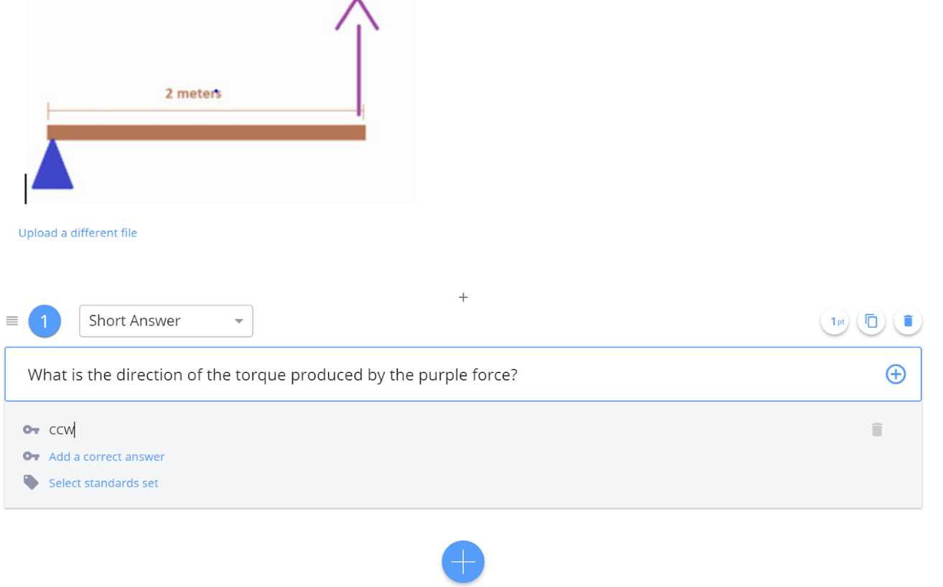

- Enter the text of your question in the box
- Click next to the “Add a correct answer” to enter your answer

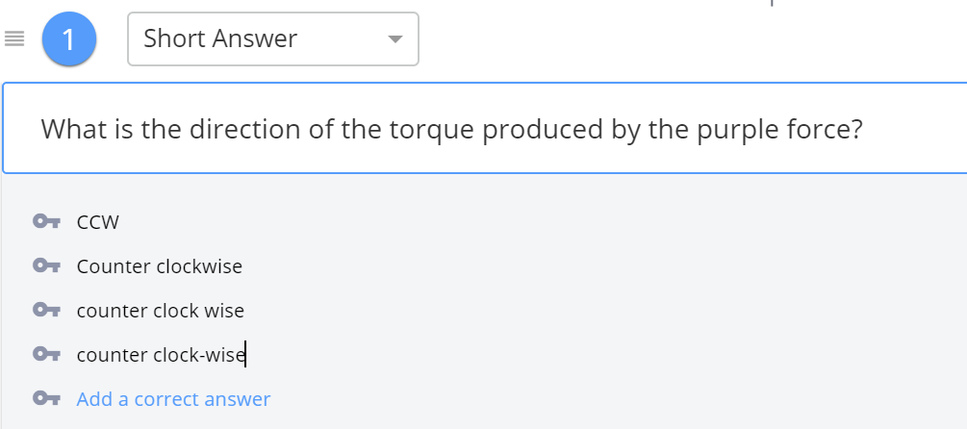
- IF your question could have multiple correct answers or possible ways a student might express the answer - you can add as many additional acceptable answers by continuing clicking “Add a correct answer” and adding other possibilities

- Changes are automatically saved as you create!!!

- If you need to change something in a formative or question - simply click the Edit button at any time.
Assign Formatives

- When you are finished creating your formative just click on the “assign/share” button to adding it to your classes.

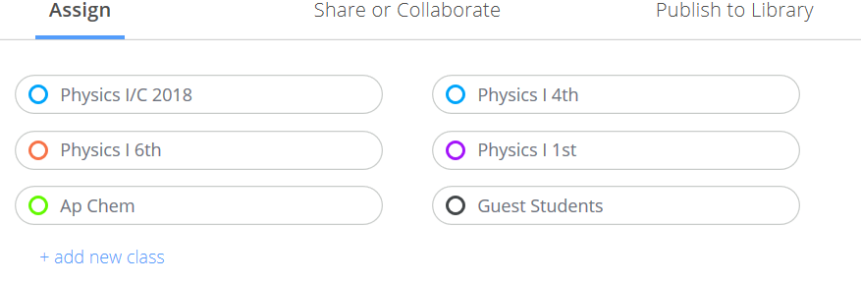
- Select the classes you want to complete this formative

- Then click the blue Assign button at the bottom of the page.

Student Responses
- Click View responses to see student responses to each question.
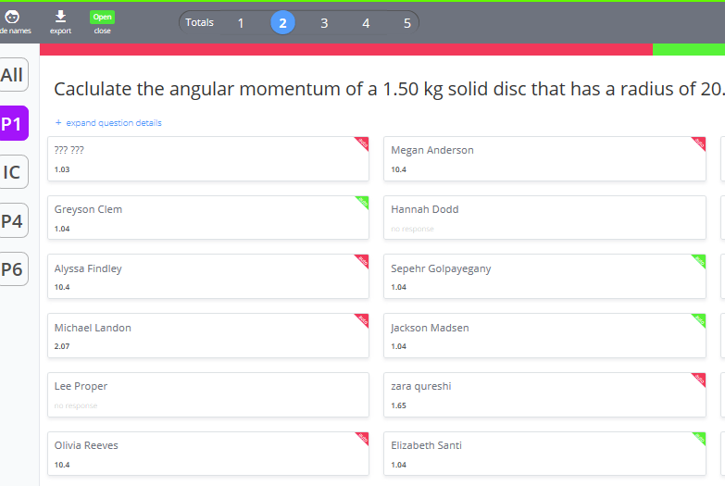
- The numbers in the Totals tab toggle between responses to each question.

- Along the right side you can look at the responses of each class.

