Creating a screencast using Screencast-o-matic
Screencast are an effective way to present material to your student in a flipped model, opening up class time for labs, group problem solving and other activities that may be curtailed using a typical lecture/demo classroom approach.
They are also excellent ways to help students who miss class stay current and can be used to continue class on weather delay days.
Screencast-o-matic is a free service that allows you to create lectures that video anything that happens on your computer screen up to fifteen minutes long. You can then combine these screencasts with problems sets so students can be exposed to material before coming to class, saving time.
Log into screencast-o-matic at this link or https://screencast-o-matic.com/
You should see this screen
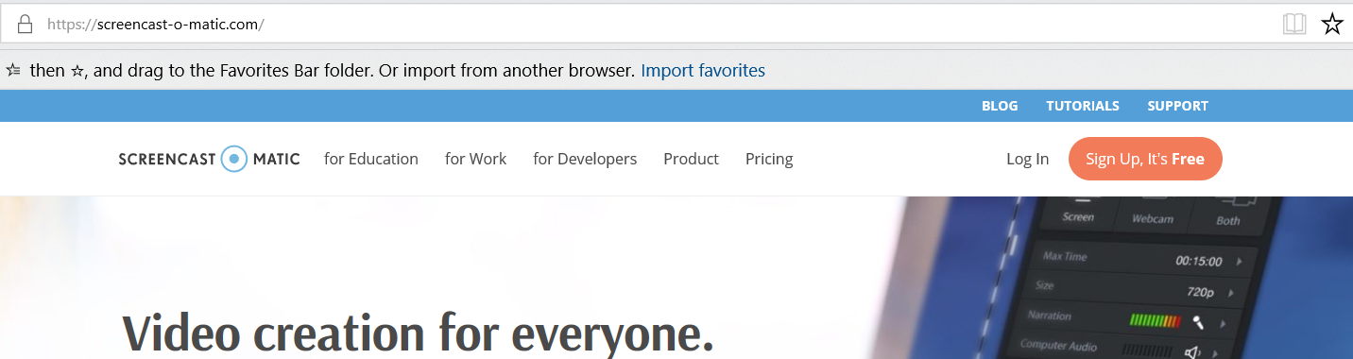
Click on the sign up, its free button
You’ll need to enter your email and verify
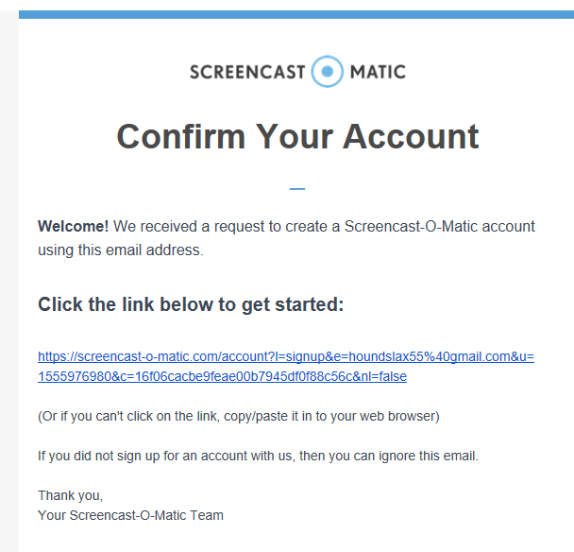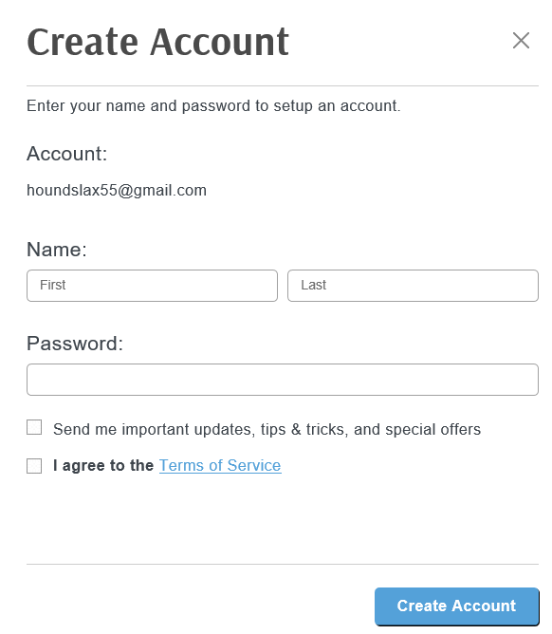

Once you create your account, you will see this page
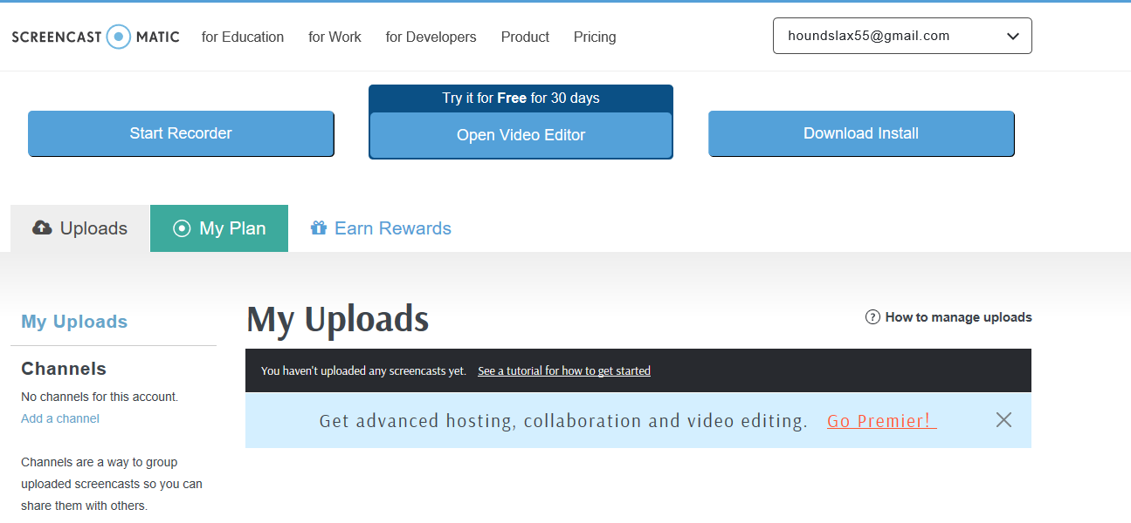
You will need to click the download install button and follow the prompts.
You are now ready to record. Watch the following screencast to show you how to go about creating your screencast. To begin, you will want to put either a power point, or a blank word document up on your screen so that you will be able to type or write with a stylus on your presentation.
When you hit start recorder, you will see the following
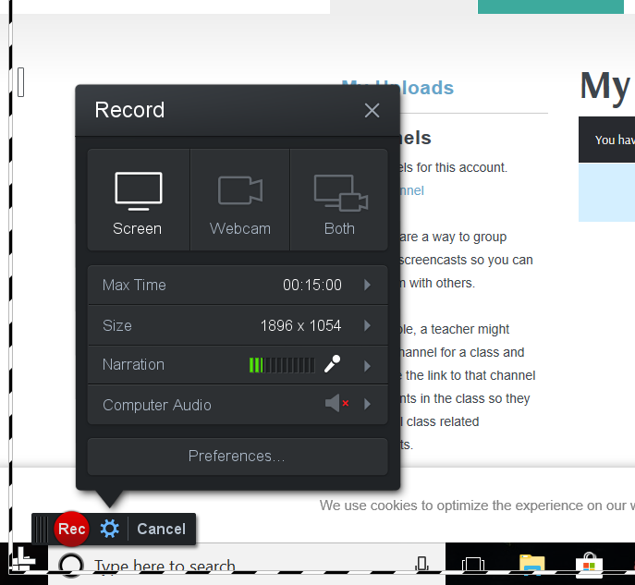
You can adjust the amount of your screen that will be recorded by using the arrows in the corners, top and bottom of the black and white striped box around the edge of your screen. When you hit record there will be a countdown and then you begin your lesson.
When you drag your mouse to an area of the screen or click a button, the area will be highlighted in the cast.
Once you are finished you will be prompted to upload the screencast to screencast-o-matic. When it is finished, you can put it on your blog by embedding, or by posting the link.
If you have any questions or need assistance, feel free to email me or come by my room and I will be glad to help.

