Constant Velocity Particle Model Worksheet 1:
Motion Maps and Position vs Time Graphs
- Given the following position vs time graph, draw a motion map with one dot for each second.
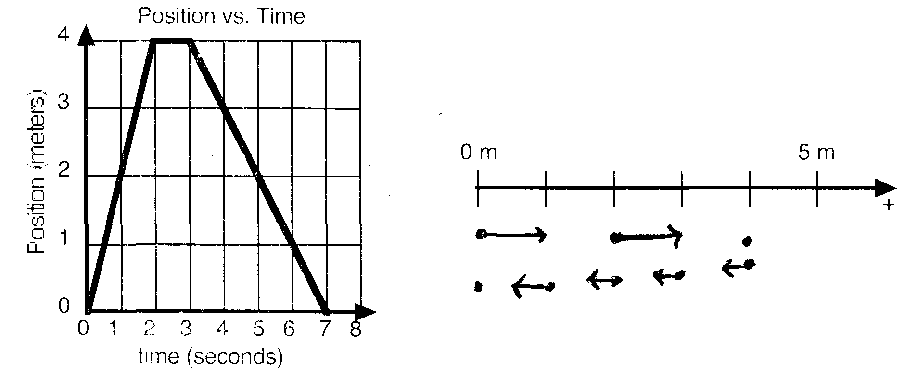
Describe the motion of the object with words:
The object starts at the origin and moves right at 2 m/s for 2 s. I stops for 1 sec and then moves left at 1 m/s for 4 sec where it stops at the origin.
- Given the following motion map, where positions have been recorded with one dot each second, draw a position vs time graph.
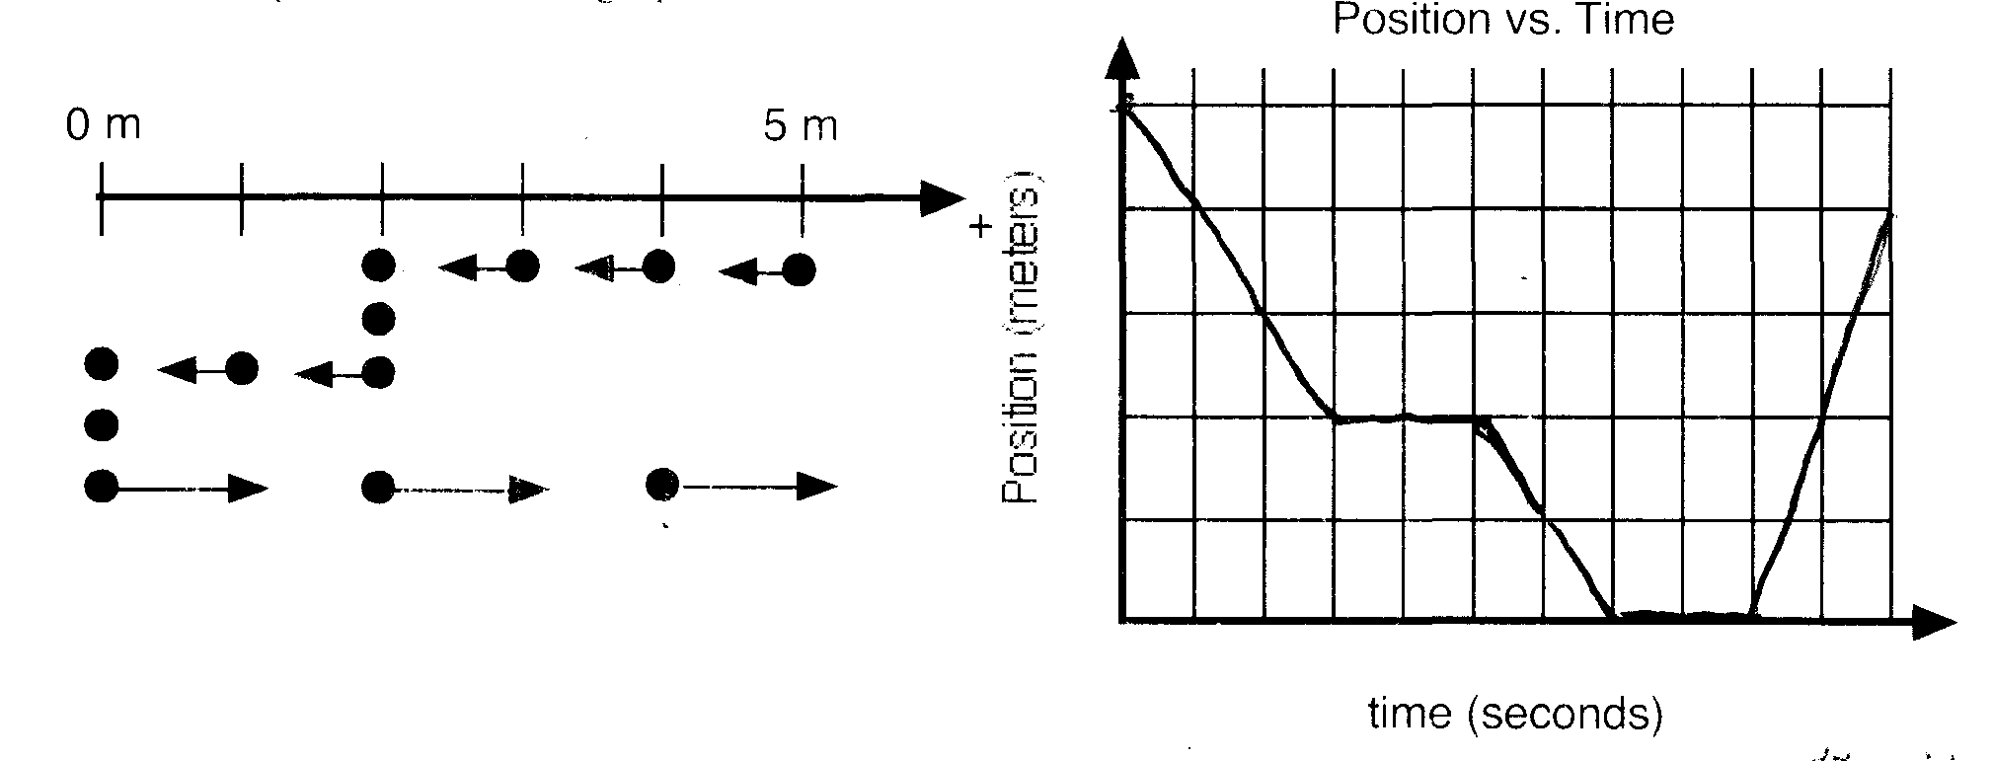

Describe the motion of the object in words:
The object starts 5 m right of the origin and moves left at 1m/s for 3 s. It stops for 2 s and then moves left at 1 m/s for 2 more seconds. The object remains at rest at the origin for 2 s and then moves right at 2 m/s for 2 s.

- Consider the position vs time graph below for cyclists A and B.
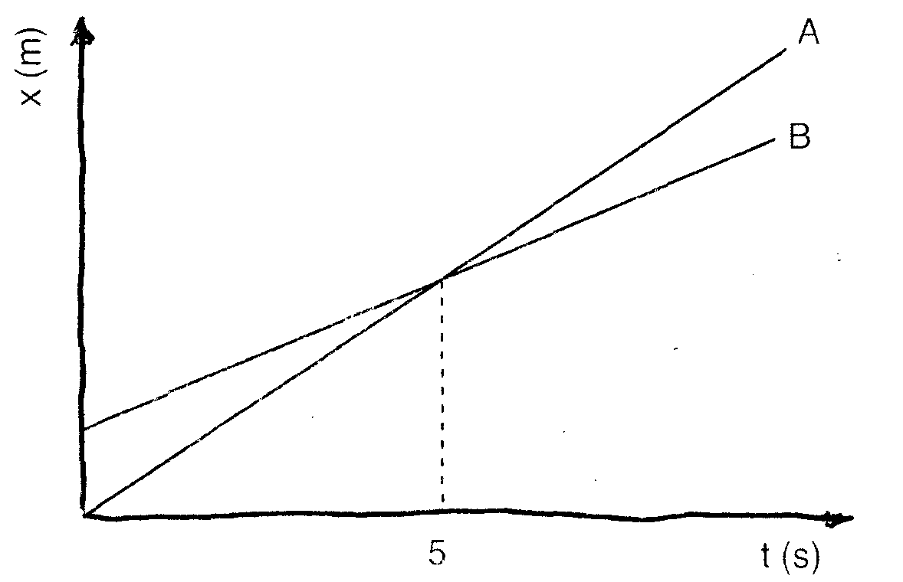
  - Do the cyclists start at the same point? How do you know? If not, which is a head?
No. initial position for B is more positive than A which is at origin.

  - At t = 7 s, which cyclist is a head? How do you know?
A, because the line for A’s position is above B’s line, meaning A is further away from the origin.
  - Which cyclist is travelling faster at t = 3 s? How do you know?
A, the slope of line A is greater than line B, so A is going faster since slope of Pos vs t is speed.
  - Are their velocities equal at any time? How do you know?
No, velocity is equal to slope of the position vs time line and slope A is always greater.
  - What is happening at the intersection of lines A and B?
Cyclist A is overtaking cyclist B and they are at the same position.
  - Draw a motion map for cyclists A and B.
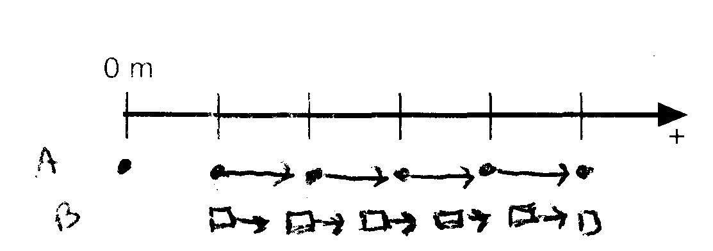

- Consider the position vs time graph for cyclists A and B.
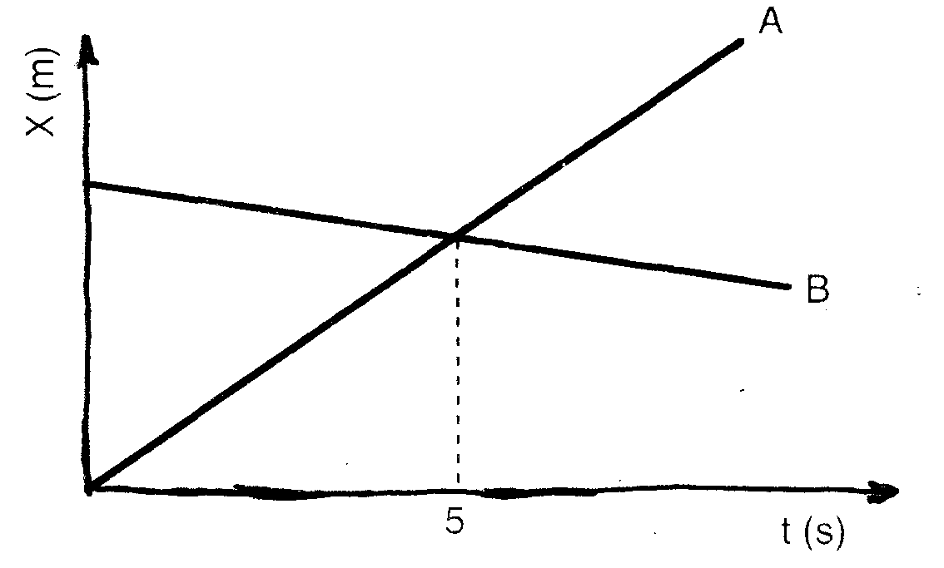
  - How does the motion of cyclist A in this graph compare to that of A in question 3?
It looks the same as they have the same slope
  - How does the motion of cyclist B in this graph compare to that of B in question 3?
This B is moving left, or toward the origin and starts further away from the origin if the scales are even remotely close to the same
  - Which cyclist has the greatest speed? How do you know?
A, has the greatest slope.
  - Describe what is happening at the intersections of lines A and B.
A is passing B and they are moving in opposite directions
  - Which cyclist travelled further in the first 5 s? How do you know?
A has the larger change in position. (Has a bigger slope for a longer time)
  - Draw a motion map for cyclist A and B.
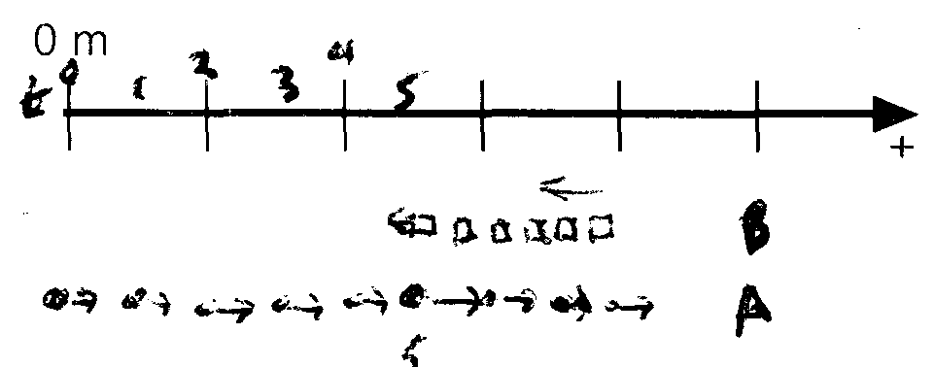

- Consider the difference between displacement and odometer (distance) readings for the following situations.
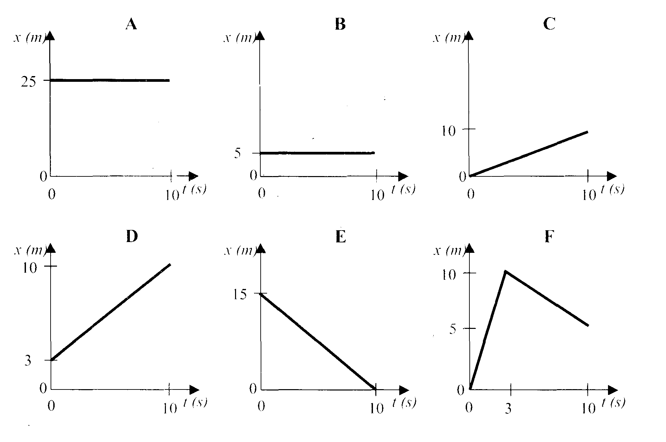
  - Rank the graphs according to which show the greatest displacement from the beginning to the end of the motion.
Greatest 1 _____ 2 _____ 3 _____ 4_____ 5_____ 6 _____ Least
C > D > F > A = B > E
C = + 10, D = + 7, F = + 5, A and B = 0 and E = – 15

  - Rank the graphs according to which show the greatest distance travelled.

Greatest 1 _____ 2 _____ 3 _____ 4_____ 5_____ 6 _____ Least

F = E > C > D > A = B
F and E both 15 m, C 10 m, D 7 m, A and B zero m

- Sketch velocity vs time graphs and motion maps corresponding to the following descriptions of the motion of an object.
