Chem Basics Intro
Chemistry is the study of matter, or the study of the stuff around us and how it all interacts, or reacts, with itself. Fundamentally we observe that sometimes changes occur to matter, (substance that has mass and occupies volume) and these changes are reversible (Ice to water and water back to ice) or not reversible. (Burning gasoline or wood).
Changes that are reversible are usually characterized as Physical Changes and are characterized by doing something “physically” to a sample. Shred it, freeze, melt or boil it, pound it, pull it, stretch it. Physical changes result in basically the same stuff before and after, it has the same properties. (If I take ice, and melt it, heat it up and then cool it off and refreeze, the new ice will be the same as the old ice).
Changes that result in new substances with new physical and chemical properties are categorized as chemical changes. They result in new substances with new physical and chemical properties.
There are a few common indications that a chemical change has occurred: the change in color of something, the release of heat, the production of gases, the production of a solid from mixing solutions, the production of flame or burning something.
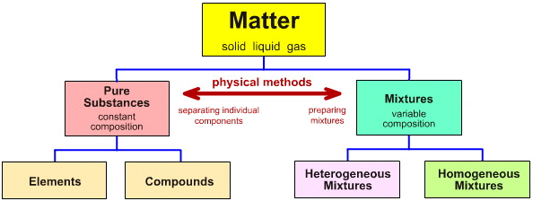
Generally, matter is classified using the above table. Pure substances can be separated or formed only by chemical means. Elements are samples of matter that contain atoms that are all the same, while compounds are samples of matter that have atoms of more than one element chemically joined together in specific ratios.
Mixtures on the other hand are combinations of matter that are separated or formed by physical processes. (I pour sand and sugar into a jar and shake them up to mix them, or I pour Kool-aide into water to make a tasty drink.) I can separate these again by pouring water into the sugar and sand and collecting the water. If I boil the water I get the sugar back and have the sand left by itself. I can get the Kool-aide powder back by boiling away the water. Heterogeneous mixtures are not necessarily uniform in nature. (I can have many different combinations of sugar and sand) but homogeneous mixtures are uniform in composition. The most studied homogeneous mixture is a solution. Homogeneous mixtures do not have to be liquid, but many solutions are. Concrete or cement is an example of a solid, homogeneous mixture, it is a particular combination of rock, fine sand and water. Combinations of metals called alloys are also solid solutions.

Matter is comprised of very small particles called atoms. Our thoughts about the atom have evolved over the past 220 years; from small particles or balls of mass, to small particles that contain smaller parts that are organized in a structure that is somewhat fluid in nature.
Dalton - Circa 1800 – the atom is a small ball of matter that combines in small whole number ratios to form compounds. The atoms of an element are identical to each other and the atoms or each different element are different form all the other elements.
J.J. Thomson - Circa 1880 – using a cathode ray tube and magnetic field was able to determine that the atom contained positive and negative parts – Plum Pudding Model
Thomson also discovered the existence of a neutral particle, the Neutron, a few years later and theorized they were also located in the nucleus.
Ernst Rutherford – began studying effects of radioactive bombardment on sheets of metal. Discovered that the positive parts of the atom were centrally located in a nucleus and that the electrons circulated outside that nucleus. The Nuclear Model
Niels Bohr – Circa 1913 analyzing emission spectrum of samples of gasses (hydrogen first) explained that the electrons were not only outside the nucleus but that they orbited the nucleus in small, discreet orbits based upon energy, like the planets around the sun. – The Planetary Model
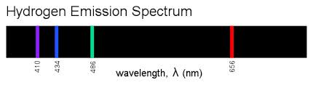
By looking at a bulb filled with hydrogen through a prism, Bohr noticed that there were four distinct colored bands of light. Along with Max Plank, Bohr theorized that the electrons in a Hydrogen atom absorbed energy from the electric current passing through the bulb, and when they absorbed energy they jumped away from the nucleus (positive nuclear charges attract the electrons, so energy is required to separate them). When the electrons jump out, they immediately feel the pull from the nucleus and as they are pulled back in, they release their excess energy. The discreet lines or wavelengths of light are associated with distinct amounts, or bundles or packets of energy which Plank called quanta, or photons. Scientists had thought of energy as flowing almost like water up to this point
The idea that light energy existed as packets or bundles is almost akin to Columbus saying the world was round. The quantized theory of light supported Bohr’s model of the electrons circulating at only certain distances from the nucleus and they absorbed and released energy to move between those orbits. Einstein also helped greatly to bolster this quantized theory.
De Broglie circa 1924 – theorized that the electron, or matter could have wave like properties, just like light had been shown to possess. (He won the Nobel Prize in Physics in 1929 for this theory). This realization combined with the work of Maxwell and Schrodinger modified the idea of the atom into what we call the Quantum- Mechanical model.
The atom contains Protons and Neutrons with electrons that exist outside the nucleus in distinct areas where they are most likely to be found called probability spaces which are referred to as a “cloud”. These areas of probability have various structures and sizes and as electrons are located further from the nucleus, they become more and more complex.

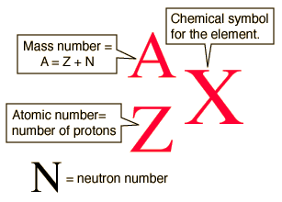
Inside the atom, the two particles that contain mass are the Proton and Neutron. (The electron has a mass, but it is 10⁴ (10,000) times smaller than the Proton or Neutron so it is considered zero. The proton and neutron each have a mass of 1 amu (atomic mass unit). The notation above is used to give information about an atom and tells us which particular isotope it may be. Isotopes are atoms of one element that differ only in the number of Neutrons or their mass. All other aspects of the atom are the same

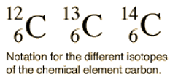
These symbols show us three different atoms of carbon, and show that they differ only in the mass number they are named, “carbon-12, carbon -13 and carbon-14.” Carbon-14 is radioactive and decomposes at a known rate so it can be used to determine the age of old things. (There is a certain amount of carbon 14 in living things, and as it decomposes over time, we can determine how long something has been dead.)
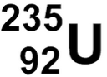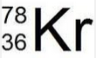
Uranium 235 Krypton 78
For stable atoms, the number of electrons and proton are the same, so the carbon isotopes above all have 6 e⁻ (e⁻ is the symbol for an electron, P⁺ for a proton, and N⁰). The Uranium above contains 92 P⁺ and 92 e⁻ and 143 Nº. The Krypton has 36 P⁺ and 36 e⁻ with 42 N⁰.
This same notation can be used for ions as well (atoms that have lost or gained electrons) an ion with a negative charge has gained electrons. (The number of protons in an atom cannot be changed by regular reactions, only the numbers of electrons.)
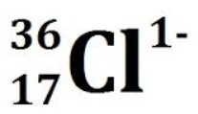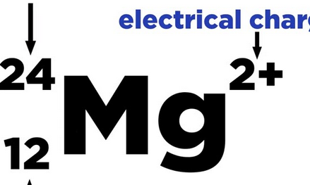
17 P⁺ 18 e⁻ 19 N⁰ 12 P⁺ 10 e⁻ 12 N⁰

The combination of elements to make compounds occurs most often by the exchange of electrons (ionic bonding) or the sharing of electrons, (Covalent bonding). The compounds that are formed are indicated by writing chemical formulas that indicate the ratio of positive ions (cations – pronounced cat ions) and negative ions (anions) in the case of ionic bonds or the formula indicate the actual numbers of atoms of each element in a compound in the case of covalent compounds.
A proper formula for an ionic is written so that the total charge of all the ions present is zero.
A + 1 ion and a – 1 ion would combine in a 1 to 1 ratio. The formula must also express the ratio of ions as the lowest whole number ratio. A relatively easy way to write proper ionic formulas is the criss-cross method of formula writing. With this method, the charge number for the ions become the subscripts of the opposite ion in the formula.
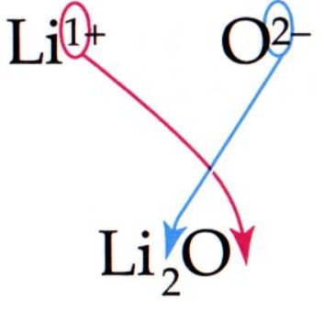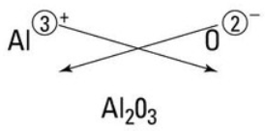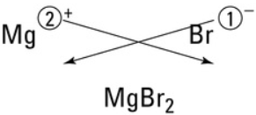
Sometimes the subscripts end up giving you a ratio that is not lowest whole number and they must be reduced to give the proper formula
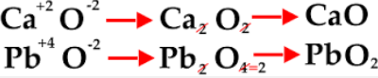
Writing formulas with polyatomic ions can also lead to confusion in the proper formula.
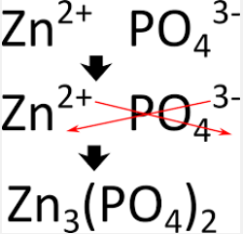
If you just criss-cross the charges you end up with PO₄ ₂ which is confusing. To eliminate confusion use parentheses to enclose the polyatomic ion as shown above. There are 3 Zn⁺² and 2 PO₄⁻³ ions in the proper formula.
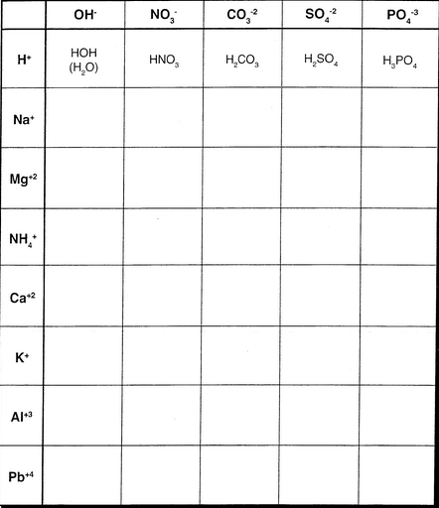
Try the following:
Calcium and Bromide
Sodium and phosphide
Sodium and oxide
Magnesium and bromide
Strontium and chloride

Notice that the nonmetal ions all have ion names that end in –ide.
The polyatomic ions have names the end in –ate, or –ite mostly

To name ionic compounds properly just give the names of the ions present
CaCl₂ – calcium chloride
Sr(OH)₂ strontium hydroxide
Zn₃(PO₄)₂ Zinc phosphate

Some of the transition metal ions (in the middle of the periodic table) may have more than one charge (Fe⁺² or Fe⁺³) it is easy to deal with these when writing a formula from a name iron (II) chloride is the combo of Fe⁺² and Cl⁻¹ FeCl₂, whereas iron (III) chloride would be FeCl₃. The symbols and charges of these multi-state ions must be memorized as not all the Tr Metals have multiple states (See Ion sheet)

Covalent compounds give the actual numbers of atoms in the molecule and we use prefixes to indicate the numbers in the formula when naming the covalent compounds.

CO₂ Carbon dioxide
NO₂ Nitrogen dioxide
SO₃ Sulfur trioxide
N₂O₅ dinitrogen pentoxide (penta – 5)
SF₆ sulfur hexafluoride
P₄O₁₀ tetraphosphorous decoxide
A prefix must always be used to indicate the number of the second atom in the formula and the names end in –ide. If there is more than one of the first atoms, you must use a prefix to indicate how many atoms there are.

Try these:
Sodium hydroxide calcium oxide lithium sulfate

Barium hydroxide Nitrogen dioxide Iron (II) sulfate

Zinc chloride iron (III) oxide ammonium sulfate

Nickel (II) bicarbonate copper (II) nitrate Silver chromate

Potassium permanganate potassium dichromate aluminum hydroxide

Tin(IV) hydroxide dichlorine heptoxide chromium (II) phosphate

Name the following:
AsCl₅ NaMnO₄ PbI₂

Mg(C₂H₃O₂)₂ Al(BrO₃)₃ Al₂(SO₄)₃

Zn(NO₃)₂ Cu(NO₂)₂ CuOH

P₂O₅ MgCO₃ NaHCO₃

PbO₂ NaClO NH₄NO₃

Fe₂(CO₃)₃ SO₃ Na₂SO₃

Mathematics of Chemistry:
When elements or compounds react, they do so in a way that requires the number of atoms of each element to be conserved in the process. (Law of Conservation of Matter)
We use a Balanced Chemical Equation to represent the reaction and the balancing assures that the Conservation Law is met.

(iron metal reacts with chlorine gas to produce iron(II) chloride)
Fe(s) + Cl₂ (g) FeCl₂
Iron metal reacts with Chlorine gas to produce iron (III) chloride
Fe(s) + Cl₂ (g) FeCl₃ (s)
This equation requires the addition of coefficients in front of the reactants and products to satisfy the Law of Conservation of Matter. Notice that the subscripts on the Cl are different on each side. If you change a subscript in a formula, you change the identity of the substance. The Cl₂ (g) is the only way elemental chlorine exists; it is a diatomic element. Due to its high reactivity, chlorine atoms must either react with a metal in an ionic reaction, or share with another chlorine (or nonmetal) atom covalently in order to remain stable. There are 7 elements that behave in this fashion, H₂, N₂, O₂, F₂, Cl₂, Br₂, I₂.
With the reaction above, the Cl₂ reactant and the Cl₃ (in the product) can be balanced by making them each equal 6
Fe (s) + 3Cl₂ (g) 2FeCl₃ (s)
1 atom 6 atoms 2 Fe 6 Cl the 2 here multiplies both the Fe and the 3 Cl atoms
It is similar to algebra 2(x +3) = 2x + 6
Now to balance it totally, I need to multiply the reactant Fe (s) by 2
2 Fe (s) + 3Cl₂ (g) 2 FeCl₃ (s)

Most chemical equations can be balanced by inspection (looking at each side and multiplying one thing, then another until they balance). There are some tricks you will become used to going through, but it is usually straight forward.

Try these:
Potassium iodide + lead (II) nitrate lead (II) iodide + potassium nitrate

Iron (III) chloride +ammonium hydroxide iron (III) hydroxide + ammonium chloride

Iron(III)oxide + carbon iron + carbon monoxide

Aluminum sulfate + calcium hydroxide aluminum hydroxide + calcium sulfate

Aluminum + hydrochloric acid (HCl) aluminum chloride + hydrogen gas (H₂)

Magnesium hydroxide + phosphoric acid (H₃PO₄) magnesium phosphate + water

Copper (II) nitrate + aluminum hydroxide aluminum nitrate + copper (II) hydroxide

Calcium chloride + chromium (III) nitrate calcium nitrate + chromium (III) chloride

Calcium phosphate + sulfuric acid (H₂SO₄) calcium sulfate + H₃PO₄

Sodium hydroxide + calcium nitrate sodium nitrate + calcium hydroxide

Once we have a balanced equation, we can relate the numbers of each reactant and product to each other, and if we know something about the mass of each element in relation to a number of atoms of that element, we can relate masses of reactants and products to each other. We can get between mass of a sample and the number of atoms contained in that mass by using the concept of the mole (mol).
The mole is just a number of atoms, molecules or shoes or bottle rockets or whatever. (like a dozen is 12, or a gross is 144, a mole is just a really, really big number of things.)
One mole is = 6.02 x 10²³ things.
One mole is 6.02 x 10²³ atoms of sodium, or 6.02 x 10²³ atoms of chlorine.
- mol of NaCl contains 1 mol of Na atoms and 1 mol of Cl atoms.
Now, here is the greatest thing ever. It turns out that 1 mole of an element (6.02 x 10²³ atoms of an element) has a mass in grams that is equal to the atomic mass from the periodic table.
For Na 1.0 mol Na = 22.99 g of Na, and one mol Cl = 35.45 g of Cl.
On mol C = 12.00 g C etc. So looking at the question below.
How many grams of silver chloride can be produced from the reaction of 25.0 g of silver nitrate with excess (meaning there is more than enough to react with all 25.0 g of silver nitrate) sodium chloride?
NaCl (aq) + AgNO₃ (aq) AgCl (s) + NaNO₃ (aq)
In order to relate one species to another in a reaction, we must know how many moles of each thing we are dealing with. We can convert grams of AgNO₃ to moles
X mol AgNO₃ = 25.0 g AgNO₃ (1 mol AgNO₃/169.88 g AgNO₃) = 0.147 mol AgNO₃
(1mol AgNO₃ = 1 Ag + 1 N+ 3 (O) = 107.87 + 14.01 + 3(16.00) = 169.88 g/mol)

Now according to the equation, 1 mole of AgNO₃ makes 1 mol of AgCl so the moles of AgCl produced should be = moles of AgNO₃ or 0.147 mol AgCl
X g AgCl = 0.147 mol AgCl (143..32 g AgCl/mol AgCl) = 21.06 g AgCl
This amount is the theoretical yield of the reaction. (The amount we should get under perfect conditions. You will NEVER produce this much as no reaction is 100% efficient.)
Here the ratio in the equation was 1:1 but that can change with each reaction.
How many grams of aluminum hydroxide can be produced from the reaction of 15.5 g of sodium hydroxide with excess aluminum chloride (forms aluminum hydroxide and sodium chloride)
3NaOH (aq) + AlCl₃ (aq) Al(OH)₃ (s) + NaCl (aq)
15.5 g NaOH (1 mol NaOH/40.00 g NaOH) = 0.3875 mol NaOH
X g Al(OH)₃ = 0.3875 mol NaOH(1 mol Al(OH)₃/3 mol NaOH) = 0.129 mol Al(OH)₃
0.129 mol Al(OH)₃ (78.00 g Al(OH)₃/1 mol Al(OH)₃) = 10.08 g Al(OH)₃
Relating and calculating amounts of different species in reactions is called Stoichiometry and it a fundamental concept used throughout the year in AP Chemistry
Try these:
How many grams of Lead (II) iodide do you get from the reaction of 35 .00 g of potassium iodide with excess lead (II) nitrate?
Potassium iodide + lead (II) nitrate lead (II) iodide + potassium nitrate

What about if you have 35.00 g of lead (II) nitrate with excess potassium Iodide?

If you have 15.5 g of H₂SO₄ reacting with excess calcium phosphate according to the reaction below, how many grams of calcium sulfate can you produce?

Calcium phosphate + sulfuric acid (H₂SO₄) calcium sulfate + H₃PO₄

How many grams of calcium sulfate would be required to react with this 15.5 g of
H₂SO₄?
Other uses of the Mole
The mole concept can also be used to determine the percent composition of a compound. (Find the percent by mass of each element in a compound) The percent composition should be consistent for a compound, every time.
Na₂CO₃ assume 1 mol of the compound. That means:
2 mol Na 2(22.99 g) = 45.98 g Na
1 mol C 1(12.00 g) = 12.00 g C
3 mol O 3(16.00 g) = 48.00 g O
The percent by mass of Na would be the (mass of Na/total mass) x 100%
(45.98gNa/105.98 g tot) 100 = 43.39 % Na
(12.00 g C/105.98 g tot) 100 = 11.32 % C
(48.00 g O/105.98 g tot) 100 = 45.29 % O
Try
KmnO₄

Al₂(SO₄)₃

The mole can also be used to help determine the empirical (lowest whole number ratio) formula for a compound if we are given or can determine the masses of known elements.
A sample of ascorbic acid contains 4.092 g of C, 0.458 g of H and 5.450 g of O. Determine the empirical formula for ascorbic acid.
- Convert grams of each element to moles of each element
- Find the molar ration of each element relative to one of the elements
- Make sure the ratio is all smallest whole numbers
4.092 g of C/12.00g/mol C = 0.3410 mol C
0.458 g H/1.008 g/mol H = 0.4544 mol H
5.450 g O/16.00 g/mol O = 0.3406 mol O (Don’t round these mole values)
To find the smallest ratio divide each mole value by the smallest mole value.
0.3410/0.3406 = 1.001 C:O
0.4544/0.3406 = 1.333 H:O
0.3406/0.3406 = 1.00 O:O
Notice here how the H:O ratio is 1.33:1 we need to find a coefficient that we can multiply by 1.333 to yield a whole number. In this case, 3(1.33) = 4.0
We must also multiply each of the other ratios by 3.0 so we end up with
3 mol C, 4 mol H and 3 mol O C₃H₄O₃ this is the empirical formula
The actual, true or molecular formula for this compound can be found from the idea that the actual formula must be a whole number multiple of the empirical formula
And that multiplier can be found if we know the molar mass of the compound.

Ascorbic acid has a molar mass of about 176 g/mol
(The mass of C₃H₄O₃) X = 176
(88 g) (X) = 176 so X = 2 and the actual formula is 2(C₃H₄O₃) or C₆H₈O₆
If we are given percent composition, assume 100 g of the compound and those percentages become masses of each element so you can convert to moles, find mole ratio and find the empirical formula.

A compound contains 39.90% C, 6.70 % H and 53.4 % O and has a molecular mass of 60.0 amu. Determine the empirical and molecular formula of this compound.

Limiting reactants - Earlier we did stoichiometry with a mass of one reactant known and an excess of the other reactant, meaning all of the known reactant was consumed, stopping the reaction. More often than not, we will be given a mass each reactant and will be asked to determine the yield the reaction. In this case, we must determine which of the reactants will be used up and limit the reaction. It sort of like if I have eggs, sugar and flour I can make cookies until one of them runs out. I have to look at the recipe, (the equation) to determine how many eggs, cups of sugar and cups of flour are required to make 2 dozen cookies. Then I can figure out which ingredient I will run out of first.

If I have 16.99 g of silver nitrate dissolved in water and add 16.5 g or calcium chloride to the mixture, how much silver chloride can I produce?
CaCl₂ (aq) + 2AgNO₃ (aq) Ca(NO₃)₂ + 2AgCl

There are a couple different methods that can be used to determine the limiting reactant. Generally, we can just determine yield of one of the products from each reactant, and the reactant that produces the least amount of product is the limiting reactant. Since we are asked to determine the amount of a silver chloride, it simplifies the problem because we don’t have to decide which one to pick.
16.99 g of AgNO₃ (1 mol AgNO₃/169.98 g AgNO₃) (2 AgCl/2AgNO₃) = 0.100 mol AgCl
8.50 g CaCl₂ (1 mole CaCl₂/110.98 g CaCl₂) (2 AgCl/ 1 CaCl₂) = 0.153 mol AgCl
The calculations above show that the max amount of AgCl that can be produced is
0.100 mol and that comes from the complete reaction of the 16.99 g of AgNO₃. The AgNO₃ is the limiting reactant and the amount of AgCl produced is 0.100 mol or
(0.100 mol AgCl)(143.32 g AgCl/1 mol AgCl) = 14.33 g AgCl
Another common question would be to see how much of the excess reactant is left over. To do that, determine how much CaCl₂ is required to react with all the AgNO₃
0.100 mol AgNO₃ (1 CaCl₂/2 AgNO₃) = 0.0500 mol CaCl₂
0.0500 mol CaCl₂ (110.98 g CaCl₂/ mol CaCl₂) = 5.55 g CaCl₂ used and
8.50 – 5.55 = 2.95 g CaCl₂ in excess, or left over.

