Calculate K from EQ concentrations
- Ammonium iodide dissociates reversibly to ammonia and hydrogen iodide if heated to 400 °C. NH₄I (s) NH₃ (g) + HI(g). Some ammonium iodide is placed in a flask and heated to 400°C. If the total pressure in the flask when equilibrium is established is 705 mm Hg, what is the value of K_{p} (when partial pressures are expressed in atmospheres)?
- PCl₅ PCl₃ + Cl₂ the gaseous reaction was examined at 250°C. At Equilibrium [PCl₅] = 4.2 x 10⁻⁵⁻ M, [PCl₃] = 1.3 x 10⁻² M, and [Cl₂] = 3.9 x 10⁻³ M. Calculate Kc for the reaction.
- A 6.00 L container contains 0.222 mol of PCl₃, 0.0189 mol of PCl₅ (g) and 0.1044 mol of Cl₂ (g) at equilibrium. Calculate K_{c} for the reaction:
PCl₃ (g) + Cl₂(g) PCl₅ (g).
- A reaction vessel at 491 °C contained 0.0812 M H₂, 0.0344 M I₂ and 0.357 M HI. Assume the substances are at equilibrium and calculate the value for K_{c} at 491 °C given the reaction: H₂ (g) + I₂ (g) 2 HI (g).
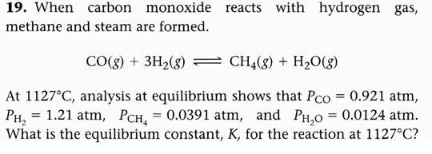
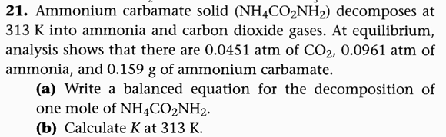
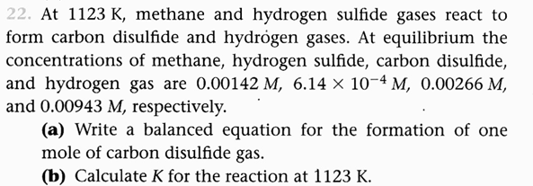
- The following equilibrium pressures at a certain temperature were observed for the reaction 2NO₂ (g) <----> 2 NO (g) + O₂ (g). P_{NO2} = 0.55 atm, P_{no} = 6.5 x 10⁻⁵ atm P_{O2} = 4.5 x 10⁻⁵ atm. Calculate the value of K_{p} at this temperature.
- The following equilibrium pressures were observed at a certain temperature for the reaction N₂ (g) + 3H₂ (g) <----> 2 NH₃ (g). P_{NH3} = 0.031 atm, P_{N2} = 0.85 atm, P_{H2} = 0.0031 atm. Calculate K_{p} for this reaction at this temperature.
- At 25°C K_{c} = 3.7 x 10⁻⁹ for the reaction CO (g) + Cl₂ (g) <----> COCl₂ (g). Calculate K_{p} for this reaction.

