Blocks and cords on Inclines
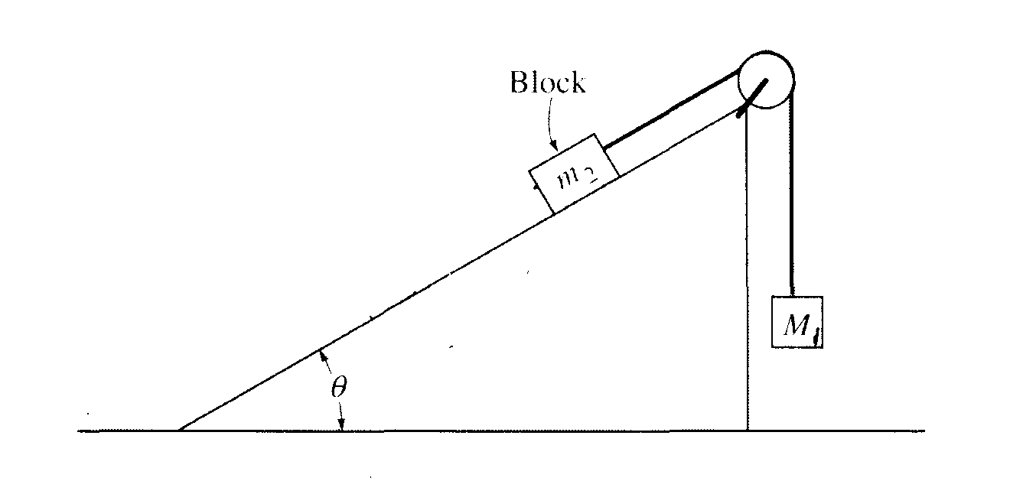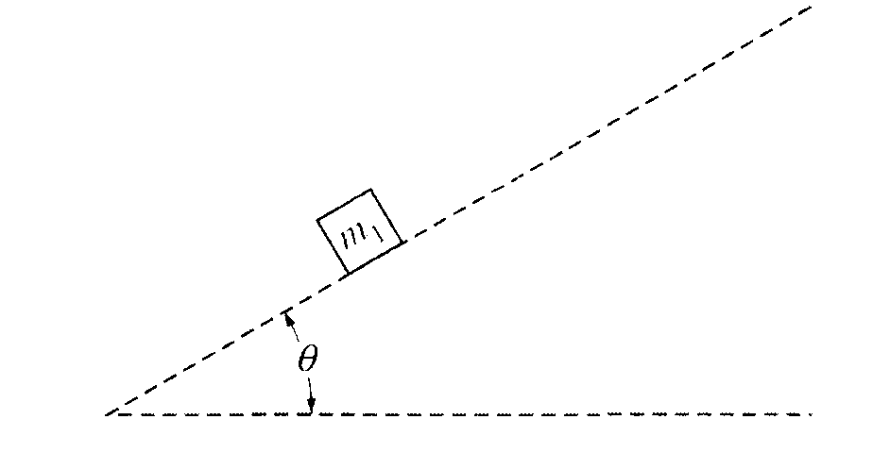

- Two blocks are arranged on an incline as shown above. Block 1 is hanging in the air and has a mass of 2.5 kg and block 2 is on an incline where Θ = 30° and has a mass of 4 kg. Determine the magnitude and direction of the acceleration of block 2 on the incline.
- If the coefficient of friction between block 2 and the plane is 0.15, and the masses of the blocks are: M₁ = 8 kg, m₂ = 3.5 kg, determine the acceleration of block 2 on the incline if Θ = 40°.
- If μ_{k} between block 2 and the incline is 0.30 and it has a mass of 4.5 kg, determine the acceleration of the blocks if the mass of block 1 is 10 kg if Θ = 60°. If the string breaks, and block 2 slides down the incline, determine the velocity of block 2 after it has travelled a distance of 2.5 m down the ramp.
- If there is no friction on the incline, and block 2 has a mass of 3.5 kg and Θ = 35°, determine the mass required to allow block 2 to slide down the incline at constant velocity.

