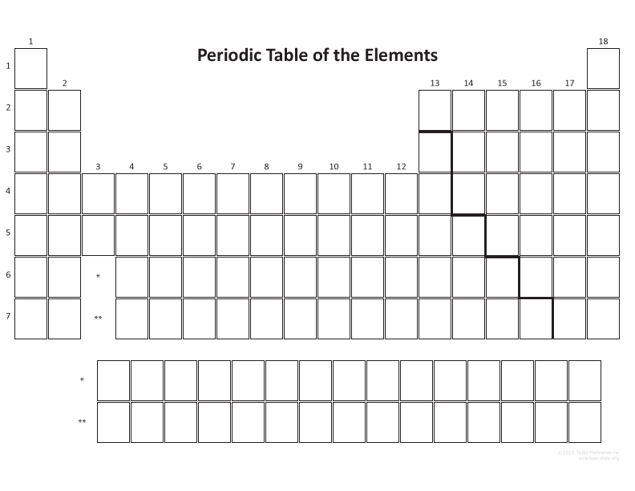
Blank Periodic Table

