Angular Momentum Conservation Examples
- A 2.0 kg particle is moving at 4.5 m/s due east along an east-west line. What is the angular momentum of the particle (Magnitude and direction) at a point 6.0 m due north of the particle? What about a point 6.0 m due south of the particle? What about at a point 6.0 m due east of the particle?
Angular momentum of a point particle is: L = mvr sin Θ.
6 m due north: 2.0 kg (4.5m/s)6.0 m)(sin 90) = 54 kg m²/s (upward)
6 m due south: 54 kg m²/s (down)
6 m due east: 0 kg m²/s (sin 0 = 0)
- You stand on a frictionless platform that is rotating at and angular speed of 1.5 rev/s. Your arms are outstretched, and you hold a heavy weight in each hand. The moment of inertia of you, the extended weights and the platform is 6.0 kg∙ m². When you pull the weights in toward your body, the moment of inertia decreases to 1.8 kg∙m². What is the resulting angular speed of the platform? What is the change in rotational kinetic energy of the system?
L_{o} = L_{f} = Iω_{o} = Iω_{f} 6.0 kg ∙m² (1.5 rev/s) /1.8 kg∙ m² = ω_{f} = 5 rev/s

- An ice Skater has a mass of 58 kg. (Her body is 50 kg and each arm is 4.0 kg) She has a rotational velocity of 1.5 rev/s when her arms are out stretched. What will her rotational velocity be, in rev/s, when she pulls her arms in next to her body? (Assume her body has a cylindrical radius of 0.20 m and her arms are 1.0 m long).
There is no external torque acting on the skater, so L_{i} = L_{f} and Iω_{out} =Iω_{in}
Initially, her initial moment of inertia is:
I = I_{body} + I_{armsout} = ½ mr²_{body} + 2[ 1/3 m L²] (a rod pivoting at one end)
I_{arms} _{out} = (0.5)(50 kg)(0.2)² + 2(1/3(4.0)(1)² =
1.0 kg∙ m² + 2.67 kg∙ m² = 3.67 kg∙m²
I_{arms in} = I_{body} + I_{arms in} = 1.0 kg∙m² + 2(1/3 (4.0 kg)(0.20)² = 1.32 kg∙ m²
For the conservation of momentum, I_{out} ω_{out} = I_{in} ω_{in} so
ω_{in} = (I_{out}/I_{in})ω_{out} = 3.67/1.32(1.5rev/s) = 4.2 rev/s

- A particle is attached to a string 2.0 m long and swings in a circle with a velocity of 6.0 m/s. The string is wrapped around a peg and the radius decreases as the mass swings. Find the amount of string that will be wrapped around the peg when the velocity of the mass is 20 m/s.

I_{o} ω_{o} = I_{f} ω_{f} I_{o} = mR² and ω_{o} = v/R = 3 rad/s
Iω_{f} = I_{f} = mr₂² and ω_{f} = v₂/r₂
mR²(v/R) = mvR = mr₂² (v/r₂) = mvr₂
r₂ = mvR/(mv₂) = vR/v₂ = 6m/s(2m)/20 m/s = 0.6m so 1.4 m of string is wrapped up.
Two balls, one of mass 1 kg and one of mass 2 kg, are confined to move in a circular track. They move at an equal velocity, v, in opposite directions on the track and collide at a point. The two balls stick together. What is the magnitude and direction of the velocity of the balls after the collision, in terms of v?
- Two balls, one of mass 1 kg and one of mass 2 kg, are confined to move in a circular track. They move at an equal velocity, v, in opposite directions on the track and collide at a point. The two balls stick together. What is the magnitude of the velocity of the balls after the collision in terms of v?
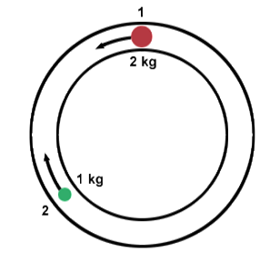
L₂ = mr²ω = 2r²ω = 2r²v/r = 2vr; L₁ = mr²ω = 1r²v/r = vr
ΔL = L₂ – L₁ (since they move in opposite directions
ΔL = 2vr - vr = vr
After they collide: L = mr²ω = 3r²(v_{f}/r) = 3v_{f}r
Setting L_{o} = L_{f} vr = 3v_{f}r or v/3 = v_{f}
- A skater spinning at 32.0 rad/s with her arms and leg extended outward. In this position her moment of inertia with respect to the vertical axis about which she is rotating is 45.6 kg∙m². She pulls her arms and leg in close to her body changing her moment of inertia to 17.5 kg∙m². What is her new angular velocity?
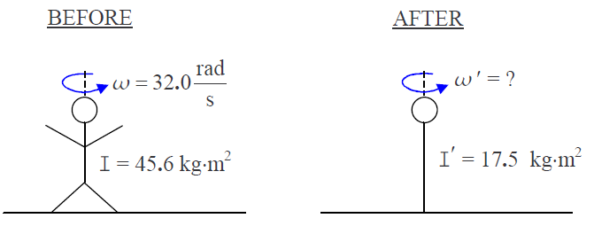
I_{o}ω_{o} = I_{f}ω_{f}; ω_{f} = (I_{o}/I_{f})ω_{o} = (45.6/17.5)(32.0 rad/s) = 83.4 rad/s

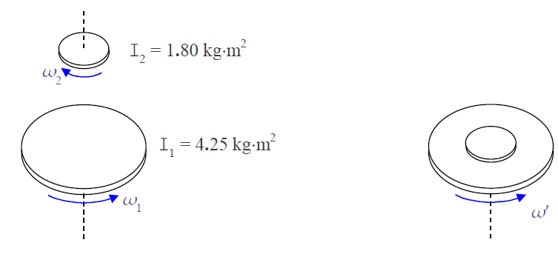
- A horizontal disc of rotational inertia 4.25 kg∙m² with respect to its axis of symmetry is spinning counterclockwise about its axis of symmetry, as viewed from above, at 15.5 rev/s on a frictionless massless bearing. A second disc, of rotational inertia 1.80 kg∙m² with respect to its axis of symmetry, spinning clockwise as viewed from above about the same axis (which is also its axis of symmetry) at 14.2 rev/s, is dropped on top of the first disc. The two discs stick together and rotate as one about their common axis of symmetry at what new angular velocity (in rad/s)?

15.5 rev/s (2Π rad/rev) = 97.39 rad/s
14.2 rev/s(2Π rad/rev) = 89.22 rad/s
L_{o} = L_{f}
I₁ω₁ + I₂ω₂ = (I₁ + I₂)ω’
4.25 kg∙m²( – 97.39 rad/s) + 1.80 kg∙m²(89.22 rad/s) = (6.05 kg∙m²) ω’
(– 413.9 + 160.0)/6.05 kg∙m² =ω’ = – 41.9 rad/s (CCW)

- NASA planned to put a satellite into a circular orbit around Pluto, but something went awry and the satellite ended up in an eliptical orbit around the dwarf planet. At its nearest point to the planet, 6 x 10⁶ m the satellite has a velocity of 9000 m/s. find the vleocity of the satellite at its farthest point from Pluto, 2 x 10⁷ m.

I₁ω₁ = I₂ω₂ ; mv₁r₁ = mv₂r₂ so
v₂ = v₁(r₁/r₂) = 9000 (6 x 10⁶/2 x 10⁷) = 2700 m/s

